

**BaliStuti** **– A Web-based e-Commerce Made in Bali**

BIT304 FINAL YEAR PROECT II

E1800191 – Ni Putu Indah Winda Pangestika

Submitted to the

FACULTY OF COMPUTING AND DIGITAL TECHNOLOGY

(SCHOOL OF INFORMATION AND COMMUNICATION TECHNOLOGY)

In partial fulfilment of the requirements

for the degree of

BACHELOR OF INFORMATION TECHNOLOGY (HONS)

HELP UNIVERSITY

FEBRUARY 2022

# **Abstract**

In this modern era that uses technology as it is today, digitizing all work is very helpful for many people, because it is more efficient, real-time and easy. Especially since the rise of Covid-19 cases, which has forced people to move from inside their homes and reduce physical activity outside the home, so that tourism areas that rely on tourist visits and regional tourism are also heavily affected because they cannot carry out their activities normally. Learning from the incident, BaliStuti tried to rise from the limitations that required tourists and customers to come to offline stores to make buying and selling transactions by creating web-based e-commerce to make it easier for customers to choose, view, place orders and buy the products offered. With e-commerce competitors that have been researched, BaliStuti offers a lot of convenience in transacting. Not just an ordinary buying and selling transaction, BaliStuti provides a chatbot feature so customers can ask in detail about the product they are interested in without having to contact the store via email. BaliStuti also provides services that make it easier for customers such as providing convenience in choosing a variety of payment methods, so that customers do not need to adjust to the methods provided by BaliStuti. Ease of delivery of goods using trusted shipping methods, and the flexibility of customers to request the product they want themselves, such as colour, material, size, model and so on. With the digitization of the BaliStuti store, it is hoped that loyal customers who have used products from BaliStuti since the beginning can access the latest products and buy products without having to come to the island of the gods, especially for customers who come from outside Bali and abroad. And with the BaliStuti web-based e-commerce, it is hoped that it can include more new buyers.

# **Declaration**

I hereby declare that the report presented here as part of the requirement of BIT304 is original and no parts of this report had been plagiarised from any other resources unless those indicated with proper referencing. This report will be the property of HELP University and cannot be distributed in any form without the written consent of HELP University.

Student Names:



Ni Putu Indah Winda Pangestika

Date: May 12th, 2022

# **Acknowledgement**

First and foremost, we would like to express our thankfulness and gratitude to God Almighty. Although there were some obstacles, it was because of His permission and grace that we were able to complete this Final Project 1 successfully and on time. We thank Mr. Yudi Agusta and Ms. Anitha Velayutham for all the assistance, instruction, advice and help during the work on this BIT 304 subject. We also thank the academic staff of ITB STIKOM BALI who have helped us in providing support so that we could get to this point. We are also very grateful to each other of us (project member) for the excellent cooperation in compiling the final project so that all problems encountered can be resolved properly. Lastly, we would like to thank our family and friends who have provided both moral and material support so that we can pass all the obstacles smoothly. This project would not have been successful without the help of all of you, thank you.

**Table of Content**

**Abstract** i

**Declaration** ii

**Acknowledgement** iii

**List of Table** vii

**List of Figure** viii

**List of Symbol and Abbreviation** x

**CHAPTER 1: PROPOSAL** 1

**1.1 Introduction** 1

**1.2 Company Background** 1

**1.3 Issues with Current System** 2

**1.4 Benefits and Constraints of Proposed System** 3

**1.5 Project Description** 4

**1.6 Project Aims and Objectives** 7

**1.7 Project Scope** 8

**1.8 Software and Hardware Requirements** 8

**1.9 Development Methodology** 9

**CHAPTER 2: PROJECT MANAGEMENT PLAN** 10

**2.1 Introduction** 10

**2.2 Work Breakdown Structure** 10

**2.3** **Work Item List** 13

**2.4 Risks Management** 16

**2.4 Gantt Chart** 17

**CHAPTER 3: REQUIREMENT ANALYSIS** 19

**3.1 Introduction** 19

**3.2 Requirements Summary** 19

**System Architecture Diagram/Network Diagram** 22

**3.3 Functional Requirements** 22

**3.3.1 Use Case Diagram** 27

**3.3.2 High-Level Use Cases** 28

**3.3.3** **Class Diagram** 32

**3.3.4 Wireframe Design** 33

**3.4 Non-Functional Requirements** 40

**3.4.1 Technical Requirements** 40

**3.4.2 Usability Requirements** 41

**3.4.3 Reliability Requirements** 43

**3.4.4 Security Requirements** 44

**CHAPTER 4: ITERATIONS** 45

**4.1 Introduction** 45

**4.2 Iteration 1** 46

**4.2.1 Introduction** 46

**4.2.2 Purpose** 46

**4.2.3 Context** 47

**4.2.4 Schedule of Iteration Workflows** 48

**4.2.5 Iteration Schedule Breakdown** 49

**4.2.6 Resource Summary** 51

**4.2.7 Evaluation Criteria** 51

**4.2.8 Analysis and Design Artefacts** 52

**4.2.9 Implementation and Testing** 65

**4.2.10 Iteration Review and Evaluation** 90

**4.3 Iteration 2** 91

**4.3.1 Introduction** 91

**4.3.2 Purpose** 92

**4.3.3 Context** 92

**4.3.4 Schedule of Iteration Workflows** 92

**4.3.5 Iteration Schedule Breakdown** 92

**4.3.6 Resource Summary** 92

**4.3.7 Evaluation Criteria** 92

**4.3.8 Analysis and Design Artefact** 92

**4.3.9 Implementation and Testing** 92

**4.3.10 Iteration Review and Evaluation** 92

**4.4 Iteration 3** 93

**4.4.1 Introduction** 94

**4.4.2 Purpose** 94

**4.4.3 Context** 94

**4.4.4 Schedule of Iteration Workflows** 94

**4.4.5 Iteration Schedule Breakdown** 94

**4.4.6 Resource Summary** 94

**4.4.7 Evaluation Criteria** 94

**4.4.8 Analysis and Design Artefact** 94

**4.4.9 Implementation and Testing** 94

**4.4.10 Iteration Review and Evaluation** 94

**CHAPTER 5: CONCLUSION** 95

**5.1 Introduction** 95

**5.2 Challenges, Limitations and Problems** 95

**5.3 How Solve the Problem** 95

**Bibliography** 97

**Appendix A: Gantt Charts** 98

**Appendix B: Progress Report** 99

**Appendix C: Supervisor Meeting Report** 107

**Appendix D: Minutes of Meetings** 114

**Appendix E: Project Evaluation** 121

# **List of Table**

**Table 1. 1 Software and Hardware Requirements** 8

**Table 2. 1 Work Breakdown Structure** 10

**Table 2. 2 Work Item List** 13

**Table 2. 3 Risks Management** 16

**Table 2. 4 Milestone** 17

**Table 3. 1 High Level Use Case Sign Up** 28

**Table 3. 2 High Level Use Case for Forget Password** 28

**Table 3. 3 High Level Use Case for Manage Profile Company** 29

**Table 3. 4 High Level Use Case for Manage Item in Product Catalogue** 29

**Table 3. 5 High Level Use Case for Search Item** 29

**Table 3. 6 High Level Use Case for Request Custom Item** 30

**Table 3. 7 High Level Use Case for View Recently Viewed Product** 30

**Table 3. 8 High Level Use Case for Live Chat** 30

**Table 3. 9 High Level Use Case for Manage Order** 31

**Table 3. 10 High Level Use Case for Read Status Transaction** 31

**Table 3. 11 High Level Use Case for View History of All Transaction** 31

**Table 3. 12 High Level Use Case for Log Out** 32

**Table 3. 13 BaliStuti Colour Scheme** 43

**Table 4. 1 Iteration Plan** 45

**Table 4. 2 Iteration Workflow Schedule** 48

**Table 4. 3 Iteration 1 Plan Task Breakdown for Sign Up** 49

**Table 4. 4 Iteration 1 Plan Task Breakdown for Log In** 49

**Table 4. 5 Iteration 1 Plan Task Breakdown for Forget Password** 49

**Table 4. 6 Iteration 1 Plan Task Breakdown for View Product Catalogue** 50

**Table 4. 7 Iteration 1 Plan Task Breakdown for View Detail Product** 50

**Table 4. 8 Iteration 1 Plan Task Breakdown for Log Out** 50

**Table 4. 9 Resource Summary** 51

**Table 4. 10 Expanded Use Case for Sign Up** 53

**Table 4. 11 Expanded Use Case for Forget Password** 54

**Table 4. 12 Expanded Use Case for Log Out** 55

**Table 4. 13 Contract for Sign Up** 56

**Table 4. 14 Contract for Forget Password** 57

**Table 4. 15 Contract for Forget Password** 58

**Table 4. 16 Database Design Table for User** 59

**Table 4. 17 Database Design Table for Password_Ressets** 59

**Table 4. 18 Database Design Table for Product** 59

**Table 4. 19 Database Design Table for Gallery** 60

**Table 4. 20 Database Design Table for Categories** 61

**Table 4. 21 Unit Test Plan – Sign Up** 68

**Table 4. 22 Unit Test Plan – Forget Password** 75

**Table 4. 23 Unit Test Plan – Log Out** 82

**Table 4. 24 System Testing – Sign Up** 84

**Table 4. 25 System Testing – Forget Password** 85

**Table 4. 26 System Testing – Log Out** 86

**Table 4. 27 Iteration Plan 2** 91

**Table 4. 28 Iteration Plan 3** 93

# **List of Figure**

**Figure 1. 1 BaliStuti Architecture Network Diagram** 7

**Figure 2. 1 Gantt Chart** 17

**Figure 3. 1 Architecture Network Diagram** 22

**Figure 3. 2 Use Case Diagram** 27

**Figure 3. 3 Class Diagram** 32

**Figure 3. 4 Wireframe Design Sign Up** 33

**Figure 3. 5 Wireframe Design Forgot Password** 33

**Figure 3. 6 Wireframe Design Manage Profile Company** 34

**Figure 3. 7 Wireframe Design Manage Item in Product Catalogue** 34

**Figure 3. 8 Wireframe Design Manage Item in Product Cataloque Continue** 35

**Figure 3. 9 Wireframe Design Search Item** 35

**Figure 3. 10 Wireframe Design Request Custom Item** 36

**Figure 3. 11 Wireframe Design View Recently Viewed Product** 36

**Figure 3. 12 Wireframe Design Live Chat** 37

**Figure 3. 13 Wireframe Design Manage Order** 37

**Figure 3. 14 Design Manage Order Continue** 38

**Figure 3. 15 Design Manage Order Continue** 38

**Figure 3. 16 Wireframe Design View Status Transaction** 38

**Figure 3. 17 Wireframe Design View History of All Transaction** 39

**Figure 3. 18 Wireframe Design Log Out** 39

**Figure 3. 19 BaliStuti Logo Design** 42

**Figure 4. 1 Iteration Plan** 46

**Figure 4. 2 Analysis Class Diagram** 52

**Figure 4. 3 System Sequence Diagram for Sign Up** 56

**Figure 4. 4 System Sequence Diagram for Forget Password** 57

**Figure 4. 5 System Sequence Diagram for Log Out** 58

**Figure 4. 6 Database Design** 58

**Figure 4. 7 BaliStuti Structural Design** 62

**Figure 4. 8 BaliStuti Home Page** 63

**Figure 4. 9 BaliStuti Sign Up Page** 64

**Figure 4. 10 BaliStuti Forget Password Page** 64

**Figure 4. 11 BaliStuti Log Out View** 65

**Figure 4. 12 BaliStuti Database User** 66

**Figure 4. 13 BaliStuti Database Password_Reset** 66

**Figure 4. 14 BaliStuti Database Products** 66

**Figure 4. 15 BaliStuti Database Gallery** 67

**Figure 4. 16 BaliStuti Database Category** 67

**Figure 4. 17 User input the valid data in sign up form provided** 72

**Figure 4. 18 System send the verification link through email** 72

**Figure 4. 19 Email sent by the BaliStuti system** 73

**Figure 4. 20 After doing the verification, system will direct user to the login page** 73

**Figure 4. 21 Invalid data inputted by user (blank fields & password under 8 characters)** 74

**Figure 4. 22 Invalid Data Inputted by User (using the taken email)** 74

**Figure 4. 23 Valid Email Address Input** 79

**Figure 4. 24 Success Link Sent Notification** 79

**Figure 4. 25 Email reset password receive** 80

**Figure 4. 26 Valid Data Inputted (reset password)** 80

**Figure 4. 27 Invalid Data Inputted by User (using the unregistered email)** 81

**Figure 4. 28 Invalid Data Inputted by User (password less than 8 characters)** 81

**Figure 4. 29 Log Out Click Button** 83

**Figure 4. 30 Directed to Home Page** 83

**Figure 4. 31 Responsive Bootstrap Code** 86

**Figure 4. 32 Home Page with the fiture** 87

**Figure 4. 33 Reliability** 88

**Figure 4. 34 BaliStuti’s System Security Using Log Out** 89

**Figure 4. 35 BaliStuti’s System needed strong character to make a the password** 89

**Figure 4. 36 Burndown Chart** 90

List of Symbol and Abbreviation

IDE Integrated Development Environment

COVID-19 Corona Virus Disease

OS Operating System

HTML Hypertext Markup Language

RAM Random Access Memory

WBS Work Breakdown Structure

PSBB Pembatasan Sosial Berskala Besar (Large-Scale Social Restrictions)

COD Cash On Delivery

MySQL Structured Query Language

PHP Hypertext Pre-processing

# **CHAPTER 1: PROPOSAL**

## **1.1 Introduction**

Due to the ongoing Covid-19 pandemic, many people have lost their jobs. Many businesses went out of business and lost their livelihoods. Especially the Balinese people who are very dependent on the tourism sector. Not only Bali, but the country of Indonesia was also affected by a terrible impact that not only came from the health sector but also had an impact on the economy of its people. The difficulty of the situation was exacerbated by the people around who still only relied on conventional businesses to open physical shops.

BaliStuti in the web form are trying to continue the existing business so as not to depend on customers who have been coming to conventional stores which have often closed due to the PSBB programmed by the Indonesian government to reduce the number of virus spreads. In addition, BaliStuti want to continue to provide job opportunities for the surrounding community especially for handicraftsman and tailors which had stopped.

With the development of this web-based BaliStuti e-commerce, there will no longer be a barrier problem for shoppers who want to view, request, chat with store admins and buy the latest products. BaliStuti’s website is designed to be user-friendly so that it can reach all people who use it.

## **1.2 Company Background**

BaliStuti was founded by the parents of Dewa Ayu Nyoman Widya Astuti in 1998. At first, this business was a small shop in Legian, Double Six beach. This business is growing bigger and bigger so that they are able to produce their own clothes in their own garments. However, at the beginning of 2020, this business was increasingly dimming due to the effects of the corona virus which was increasingly spreading throughout the world. Then, based on the opportunity given, now on the subject of BIT304, BaliStuti’s developer made the decision to develop the business so that it can be based online and it is no longer limited to place and circumstances. BaliStuti’s developers, Ni Putu Indah Winda Pangestika and Dewa Ayu Nyoman Widya Astuti are also considering all aspects of developing this business so that it can benefit our workers who are forced to be laid off due to the deteriorating business.

Then, in the end, the desire to provide opportunities for loyal customers and new customers to be able to customize the clothes and handicrafts that our company provide to the tastes they want. BaliStuti want to give a pleasant impression when shopping at online and offline stores by developing a site that is easy to use and simple to operate.

## **1.3 Issues with Current System**

There are several e-Commerce sites similar to BaliStuti, which only focus on one brand and only have 1 seller. An example found was the SOUQ store which has an official store in Seminyak, Bali. However, some of the things founded lacking were limitations in the design and materials they offer limited in what they produce. Then, bali-crafts.com, which does not focus on its website shopping site, as evidenced by the difficulty of ordering some products using the available features. Then, the shortcoming found next was that these two stores had limitations in the number of purchases of their products.

There are also weaknesses that encountered from the manual system. In running a manual business, wait for buyers who come become a habit that must, whether there are or not, offline stores must remain open because customers who come are uncertain. In addition, to communicate with customers, the offline store system also has to record orders on paper which are often lost or damaged. Then, what is more important now is that everyone is putting forward technology to make their business easier, people can easily shop, choose goods or request items they want just by staying at home. For this reason, BaliStuti want to try to develop a system where the customer or seller can comfortably transact without the barrier factors mentioned above.

## **1.4 Benefits and Constraints of Proposed System**

With the vulnerabilities discovered in section 1.3, BaliStuti would like to complement those vulnerabilities with new features that will develop in website-based. By using the BaliStuti shopping website, the company want to offer a shopping experience with authentic Balinese products that can be customized and arranged according to the customer's wishes. BaliStuti are not stuck with new products that we release and universal sizes which may not be suitable for some people. BaliStuti give freedom to customers about how many items they want to order and buy. In the other words, there is no limit in ordering items, because BaliStuti have workers who has the experience in making 1 or dozens of types of clothes and garments that will speed up the process of processing orders. BaliStuti also provide a chat feature so that customers can easily correct orders or ask questions directly related to the products displayed on our website.

However, with all the benefits mentioned, there are still some constraints exist in the system that currently developed. Even so, over time, the system will continue to develop through maintenance and updates that will continue to be carried out, but for now there are still constraints exist due to circumstances and times that have been determined from the start where BaliStuti are still unable to apply the COD system (Cash on Delivery) in the transaction process that our company are working on. BaliStuti are still unable to determine the price and compensation that will cover losses for both the consumer and us as the seller. Then, another constraint is there are also some problems in applying the language settings that should be on our website so that both admins and customers can freely translate conversations if there are some words that are difficult to understand. However, instead BaliStuti want to provide a shopping experience that would be difficult to obtain through our competitors' websites so that customers can shop comfortably.

## **1.5 Project Description**

BaliStuti is a web-based e-commerce that provides the best offers to customers who love Balinese products while also having their own unique tastes. BaliStuti prioritizes Balinese products such as sarong, summer dress, shorts, crochet, statue, utensil, accessories and Custom Items. There are two types of users who will use this website, the first is the admin who will manage the website account and carry out activities such as updating items in the storefront, updating store profiles, keeping books of all transactions that occur, or answering questions from customers in the chat feature. Then the second user is a customer who will be able to make transactions with processes such as viewing the displayed product, adding the desired product on the chart, making a request for a product, having discussions with the admin on the live chat feature, making transactions, selecting shipping, viewing the status of the transaction. towards product purchases, and reviewing products that have been purchased. The system will also be able to view information about other users, view order details, display the checkout page and display the home page.

Here is the main feature of BaliStuti in detail:

* **Sign Up:** Customers can register / sign up to create their own accounts for the first time
* **Log In:** Both customers and admins can log in into their account
* **Forget Password:** Both customers and admins can recreate their own password if they forget their own by send an email.
* **View Profile Company:** Both customer and admin can view the company’s profile to find out the description and item provided that company has filled in their profile.
* **Manage Profile Company:** Admin can manage company’s profile by editing some information or picture in profile Company
* **View Product Catalogue:** Both Customers and Admin can view product in the catalogue so Customer can pick one of their favourite and admin can check the product that they already edit.
* **Manage Item in Product Catalogue:** Admin can manage item in the product catalogue like create, add, update, and delete the wanted item.
* **View Detail Product:** Both Customer and Admin can view the detail product by click on the image of product to see any description about the product such as size, colour available, detail price and etc.
* **View Recently Viewed Product:** Customer can view the recent product based on their last activity in the list of product catalogue.
* **Search Item:** Customer can search their wanted product if they feel lazy to scroll down or search in manual method
* **Request Custom Item:** If Customer cannot find their desired product or feeling or feel that something is lacking in the design, size or colour of an available product, they can customize the product they want or request a new product.
* **Live Chat:** Both customers and admins can have a chat in live chat feature to discuss about the product or anything that customer wants.
* **Notification:** Admin can receive the notification about the requested product form customer, and the customer can get a notification from admin whether the requested they sent before accepted/rejected.
* **Add to Cart:** Customer can add the item they want to the cart feature provide
* **Manage Order:** Admin can determine product customised price, accept transaction, or give an update for status transaction
* **View Status Transaction:** Customer can view the status of transaction they made whether it already processed or not
* **Payment Gateway:** Customer can choose the method to pay for all the products they want to buy
* **Shipping:** Customer can choose to use which shipping they want
* **Convert Currency in Total Payment:** Total payments in Indonesian rupiah will be converted into dollars so buyers from outside Indonesia can know directly the amount they have to pay
* **Review Item:** Customer can review on every item so every new customer will know the review of this products.
* **View History of All Transaction:** Admin can view all transaction that customer already made
* **Convert History of All Transaction to Excel:** Admin can use this feature to get the history of all transaction that has been made in one day, one week or one month.
* **View User Profile Information:** Both customers and admin can view information about other users they want to know
* **View Order Details:** Both customers and admin can see the order details they want to know / confirm
* **Check Out Page:** Customers can see the checkout page which will display the details of the product they want to buy along with the total price
* **Home Page:** Both customers and admin can see their home page in BaliStuti system
* **Log Out:** Both Customer and Admin can do a log out from their account

In the process of working on the BaliStuti Project for Final Project 2, we added a use case. The additions are: View User Profile Information, View Order Details, Checkout Page and Home Page. The reason we add to the existing use cases is because in the development process, we found that these use cases were useful in the shopping process carried out in the BaliStuti system. For example, View User Profile Information will help other users to view customer profile details such as name and so on as identification, View Order Details to view details of orders that have been made, Checkout Page which will display the products to be purchased, how much, the price of each. each product, along with the total price to be paid by the customer. Then lastly, the Home Page to see the products offered by BaliStuti along with products that have been seen by customers so that, if they are satisfied with the product and want to buy again, the customer can easily find it. Or if the customer accidentally leaves the site, the user can easily find the item he just saw.

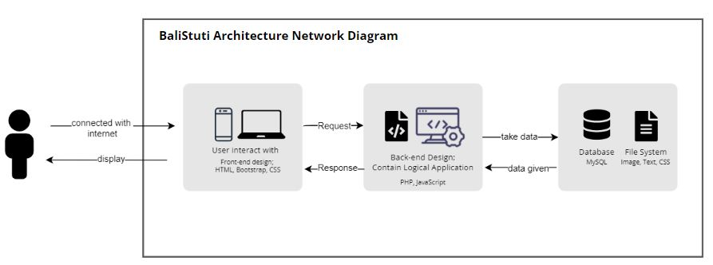

**Figure 1. 1 BaliStuti Architecture Network Diagram**

## **1.6 Project Aims and Objectives**

The purpose of this website-based e-commerce project is to make it easier to sell products in our physical stores so that they don't just depend on buyers who come. Now, buyers and potential buyers can view and order the products they want just through the screen of their device. In addition, BaliStuti’s aim to reduce the unemployment rate around us so that they have income again during a pandemic that cannot be predicted when it will end.

Besides aims, there are several objectives that we will also mention, which consist of:

* To create a user-friendly website so that it can cover most of the people who use it.
* To provide information related to the products we have
* To facilitate buyers who want to inquire further about product details or ordering
* To facilitate buyers regarding easier payments
* To facilitate buyers who want to request a product from our store
* To provide job opportunities for those in need to become employees in our business

## **1.7 Project Scope**

BaliStuti is a web-based e-commerce offering high quality handcrafted and authentic Balinese products. BaliStuti provides a platform that can be accessed by customers and admins, below is the scope of BaliStuti:

* Customers can see product recommendations displayed on the website's home page according to the last activity they did
* Customers can choose the goods they like or request the product they are interested in
* Customers can choose or enter the style they want through the page provided
* Admin and customers can discuss in the chat feature
* Admin can confirm the order submitted by the customer
* Customers can pay through the payment gateway that has been provided
* Admin and Customers can see the status of the product being transacted
* Admin can get reports of all transactions made by all customers in some time

## **1.8 Software and Hardware Requirements**

**Table 1. 1 Software and Hardware Requirements**

|  |  |  |  |  |  |
| --- | --- | --- | --- | --- | --- |
| **No** | **Item** | **Usage** | **Qty.** | **Cost (Rp)** | |
| **Hardware** | | | | | |
| **1** | Asus VivoBook A442U | To develop, test the system and create document | 1 | Available | |
| **2** | Lenovo Laptops | To develop, test the system and create document | 1 | Available | |
| **3** | EPSON Printers | To print documentation paper | 1 | Available | |
| **4** | Wi-Fi and Internet Quota | Internet Connection | 2 | Rp.350.000, - | |
| **Software** | | | | | |
| **5** | Windows 10 | Operating System for Laptops | - | Available | |
| **6** | Laravel 8 | To develop back-end system | - | Available | |
| **7** | Framework Bootstrap | To design the front-end system | - | Available | |
| **8** | Visual Paradigm Online | To create wireframe, chart, diagram, etc. |  |  | |
| **8** | Microsoft Word 2019 | To create the document | - | Available | |
| **9** | Microsoft Power Point | Create all the presentation | - | Available | |
| **10** | XAMPP | To create the localhost web store and server | - | Available | |
| **11** | MySQL | To create the database | - | Available | |
| **12** | Web Browser (Chrome and Microsoft Edge) | To test and open BaliStuti website | - | Available | |
|  | Git Hub Desktop | To Collaborate all the work with team member | - | Available | |
|  | Telegram Ver.8.5.4 | To Communicate with team member | - | Available | |
| **Others** | | | | | |
| **13** | Printer Ink | Ink for the printers | - | Rp. 130.000, - | |
| **14** | Paper | Paper for printing documents | - | Rp. 300.000, - | |
| **Estimated Project Cost** | | | | | Rp. 480.000, - |

## **1.9 Development Methodology**

Development Methodology is a series of processes used to develop systems. Methodology is a framework in which each team member can plan, process and execute assigned work. The selection of Iterative Methodology is because this type of method allows developers to adjust, improve and review every process on a project that is carried out in stages until finally a product is created from the results of these adjustments.

Iterative Methodology has some of the most basic phases, namely: planning, analysis, implementation, testing and evaluation. By using this method, the opportunity to evaluate all the developments that the developer has made in the process will be easier to obtain and more suitable to be applied to projects that have a relatively shorter time.

However, the weakness that founded in the iterative methodology is that each iteration must be based on the previous iteration so that it requires a fairly strong analysis.

# **CHAPTER 2: PROJECT MANAGEMENT PLAN**

## **2.1 Introduction**

The Project Management Plan is very useful in the process of developing a project, here the Project Management Plan is useful for explaining how the project will be implemented and how each project member will carry out the assigned tasks effectively through the schedule and progress that will be shown on the Gantt Chart. So that each project member will know what part of his work is, when it is done and how far the progress has been. In the Project Management Plan, we also use a Work Breakdown Structure (WBS) which will be the basis for creating a Gantt Chart. WBS will show details of each activity that must be done based on the duration of its work, here each project member will know the milestones in the schedule made. Then there will be a Work Item List that shows the ownership of each individual task, as well as the priority level of the task they must work on. And, the next is Risk Management which will help each team member to prepare for all risks that will occur by identifying each risk, analysing and how to respond to each risk that may occur. Then the last is the Gantt Chart.

## **2.2 Work Breakdown Structure**

**Table 2. 1 Work Breakdown Structure**

|  |  |  |  |  |
| --- | --- | --- | --- | --- |
| **Phases and Activities** | **Start Date** | **End Date** | **Duration in Days** | **Number of Resources (hours)** |
| 1. **Initiating**     1. Discuss & Determine the Project Theme    2. Initial Discussion Via Online Meeting with Supervisor    3. Project Theme Consultation via Online Meeting with Supervisors    4. Development of Project Outline    5. Project Outline Submission | **02/14/2022**  02/14/2022  02/19/2022  02/22/2022  02/23/2022  02/25/2022 | **02/25/2022**  02/19/2022  02/19/2022  02/22/2022  02/24/2022  02/25/2022 | 6  1  1  2  0 | 48  8  1  16  0 |
| 1. **Planning**    1. Development of Project Plan 2. Development of Company Background 3. Development of Aims & Objectives 4. Development of Project Scope 5. Development of Methodology    1. Chapter I: Submission of Project Plan    2. Development of Literature Review    3. Submission of Literature Review    4. Develop Project Management 6. Work Breakdown Structure Creation 7. Work Item List Creation 8. Development of Risk Management 9. Development of Baseline Gantt Chart    1. Chapter II: Submission of Project Management    2. Interim Presentation | **02/26/2022**  02/26/2022  02/28/2022  03/01/2022  03/02/2022  03/04/2022  03/05/2022  03/11/2022  03/12/2022  03/14/2022  03/15/2022  03/16/2022  03/18/2022  03/19/2022  04/02/2022 | **04/02/2022**  02/28/2022  03/01/2022  03/02/2022  03/04/2022  03/04/2022  3/10/2022  03/11/2022  03/14/2022  03/15/2022  03/16/2022  03/18/2022  03/18/2022  03/30/2022  04/02/2022 | 3  2  2  3  0  6  0  3  2  2  3  0  12  0 | 24  16  16  24  0  48  0  24  16  16  24  0  60  0 |
| 1. **Executing** 2. Preparation of Interim Presentation 3. Interim Presentation    1. Development of Requirement Analysis 4. Development of Functional & Non-Functional Requirements 5. Development of Use Case Diagram    1. Chapter III: Submission of Requirement Analysis    2. Development of Class Diagram    3. Development of Sequence Diagram    4. Development of Database Design    5. Development of Structural Design    6. Development of Design User Interface    7. Development of Prototype I    8. Testing Prototype    9. Chapter IV: Submission of Iteration I | **04/03/2022**  04/03/2022  04/08/2022  04/16/2022  04/17/2022  04/18/2022  04/20/2022  04/21/2022  04/22/2022  04/24/2022  04/27/2022  04/29/2022 | **04/28/2022**  04/08/2022  04/15/2022  04/16/2022  04/18/2022  04/20/2022  04/21/2022  04/22/2022  04/23/2022  04/26/2022  04/28/2022  04/29/2022 | 6  8  0  2  3  2  2  2  3  2  0 | 48  64  0  16  24  16  10  17  24  16  0 |
| 1. **Closing**    1. Preparation of Final Report Documentation    2. Submission of Final Report    3. Preparation of Final Presentation    4. Final Presentation | **04/30/2022**  04/30/2022  05/13/2022  05/14/2022  05/21/2022 | **05/20/2022**  04/12/2022  05/13/2022  05/20/2022  05/21/2022 | 13  0  7  0 | 104  0  56  0 |
| 1. **Introduction to BIT 305** 2. **Revision of The Report Documentation** 3. **Execution of Iteration 2** 4. Development of Prototype 2 5. Prototype 2 Producing 6. Interim Presentation 7. Development of Iteration 2 8. Development of Chapter V 9. Analysis and Design of Artifact 10. Submission of Chapter V 11. Development of Chapter VI 12. Submission of Chapter VI 13. Infographic Poster Design Creation | **10/04/2022**  **10/05/2022**  **10/21/2022**  10/21/2022  10/29/2022  11/09/2022  11/11/2022  11/16/2022  11/14/2022  11/28/2022  11/30/2022  12/13/2022  12/14/2022 | **04/10/2022**  **10/20/2022**  **12/16/2022**  10/28/2022  11/08/2022  11/09/2022  11/15/2022  11/26/2022  11/16/2022  11/28/2022  12/12/2022  12/13/2022  12/16/2022 | 8  11  0  5  11  3  0  13  0  3 | 64  88  0  40  88  24  0  104  0  24 |
| 1. **Closing for BIT 305**     1. Development of Project Review    2. Preparation of Final Documentation Report    3. Submission of Final Report    4. Preparation of Final Presentation    5. Final Presentation | **12/16/2022**  12/16/2022  12/21/2022  12/30/2022  12/30/2022  01/02/2023 | **01/02/2023**  12/20/2022  12/29/2022  12/30/2022  01/01/2023  01/02/2023 | 5  9  0  3  0 | 40  72  0  24  0 |

In the work of Final Project 2 BIT 305, additions or updates to the Work Breakdown Structure will be carried out based on the schedule given in the subject of Final Project 2. Then, the Work Item List will also be updated based on the planned activities and time in the Work Breakdown Structure to balance the activities and processing time.

## **Work Item List**

**Table 2. 2 Work Item List**

|  |  |  |  |  |
| --- | --- | --- | --- | --- |
| **Name/Description** | **Priority (High/Low/ Medium)** | **State (Completed/ In Progress / Not Completed)** | **Assigned To** | **Effort Estimated (Hours)** |
| **Initiating** | | | | | |
| Initial Discussion Via Online Meeting with Supervisor | High | Completed | Indah & Dewa Ayu | 2 |
| Discuss & Determine the Project Theme | High | Completed | Indah & Dewa Ayu | 8 |
| Project Theme Consultation via Online Meeting with Supervisors | High | Completed | Indah & Dewa Ayu | 1 |
| Development of Project Outline | High | Completed | Indah & Dewa Ayu | 16 |
| Project Outline Submission | High | Completed | Indah & Dewa Ayu | 0 |
| **Planning** | | | | | |
| Project Plan: Development of Company Background | High | Completed | Indah & Dewa Ayu | 24 |
| Development of Aims & Objectives | High | Completed | Indah & Dewa Ayu | 16 |
| Development of Project Scope | High | Completed | Indah & Dewa Ayu | 16 |
| Development of Methodology | High | Completed | Indah & Dewa Ayu | 24 |
| Chapter I: Submission of Project Plan | High | Completed | Indah & Dewa Ayu | 0 |
| Development of Literature Review | High | Completed | Indah & Dewa Ayu | 35 |
| Submission of Literature Review | High | Completed | Indah & Dewa Ayu | 0 |
| Project Management:  Work Breakdown Structure Creation | Medium | Completed | Indah & Dewa Ayu | 24 |
| Work Item List Creation | Medium | Completed | Indah & Dewa Ayu | 16 |
| Development of Risk Management | High | Completed | Indah & Dewa Ayu | 16 |
| Development of Baseline Gantt Chart | High | Completed | Indah & Dewa Ayu | 24 |
| Chapter II: Submission of Project Management | High | In Progress | Indah & Dewa Ayu | 0 |
| Preparation of Interim Presentation | High | In Progress | Indah & Dewa Ayu | 60 |
| Interim Presentation | High | In Progress | Indah & Dewa Ayu | 0 |
| **Executing** | | | | | |
| Development of Requirement Analysis: Develop functional & non-functional requirement | High | In Progress | Indah & Dewa Ayu | 48 |
| Development of Use Case Diagram | Medium | In Progress | Indah & Dewa Ayu | 64 |
| Chapter III: Submission of Requirement Analysis | High | In Progress | Indah & Dewa Ayu | 0 |
| Development of Class Diagram | Medium | In Progress | Indah & Dewa Ayu | 16 |
| Development of Sequences Diagram | Medium | In Progress | Indah & Dewa Ayu | 24 |
| Development of Database Design | Medium | In Progress | Indah & Dewa Ayu | 16 |
| Development of Structural Design | Medium | In Progress | Indah & Dewa Ayu | 10 |
| Development of Design User Interface | Medium | In Progress | Indah & Dewa Ayu | 17 |
| Development of Prototype 1 | High | In Progress | Indah & Dewa Ayu | 24 |
| Testing Prototype | High | In Progress | Indah & Dewa Ayu | 16 |
| Chapter IV: Submission of Iteration 1 | High | In Progress | Indah & Dewa Ayu | 0 |
| **Closing** | | | | | |
| Preparation of Final Report Documentation | High | In Progress | Indah & Dewa Ayu | 104 |
| Submission of Final Report | High | In Progress | Indah & Dewa Ayu | 0 |
| Preparation of Final Presentation | High | In Progress | Indah & Dewa Ayu | 72 |
| Final Presentation | High | In Progress | Indah & Dewa Ayu | 0 |

## **2.4 Risks Management**

Every project that is carried out must have risks, as well as the BaliStuti project. With the creation of Risk Management, it will be very helpful for developers to identify risks that may occur so that each team member is able to overcome them.

**Table 2. 3 Risks Management**

|  |  |  |  |
| --- | --- | --- | --- |
| **Risk** | **Potential Impact on Project Success**  **L/M/H** | **Likelihood of Occurrence**  **L/M/H** | **Mitigation Plan / Strategy** |
| Limited in (broken or unavailable) connection makes it difficult to contact other project members | M | H | Look for the closest available connection, such as a public library that provides free Wi-Fi, or you can buy the cheapest data package first. |
| Hardware damage caused by malfunctions or viruses that delay work progress or lose data | H | M | Always perform backups of important data so that problems can be reduced when there is a hardware problem or a virus. So, the data can still be accessed through any hardware. |
| One of the project members is get sick, so it delays the progress of project work | H | L | Do each task earlier than the due date, so that if you suddenly fall ill, other project members can help cover tasks that have not been done |
| There are other jobs being done at the same time, thereby reducing the quality of work | M | H | Perform good scheduling management so that schedules do not collide with one another and can harm many parties. Make sure to always be contacted so that all risks can be found a way out. |
| Lack of knowledge or experience in developing a program | M | M | Self-taught, looking for various learning resources or learning from experienced friends so that they can know the basic and advanced ways of web-based programming |

## **2.5 Gantt Chart**

We used the Gantt Project to create a Gantt Chart for the BaliStuti project. Our team works everyday even if it is the weekend. There are Initiating Task, Planning, Executing and Closing task. The initiation of the BIT 304 Final Project-1 was carried out on February 14, 2022, where we have started to discuss the theme of the project we want to work on, followed by an initial discussion with the supervisor on January 19, 2022. The project will end on May 21, 2022 according to with the schedule set by Help University. With the creation of a Gantt Chart, each of our activities will be scheduled and the progress shown. We can also compare the schedule that has been set in advance and the realization that we do.

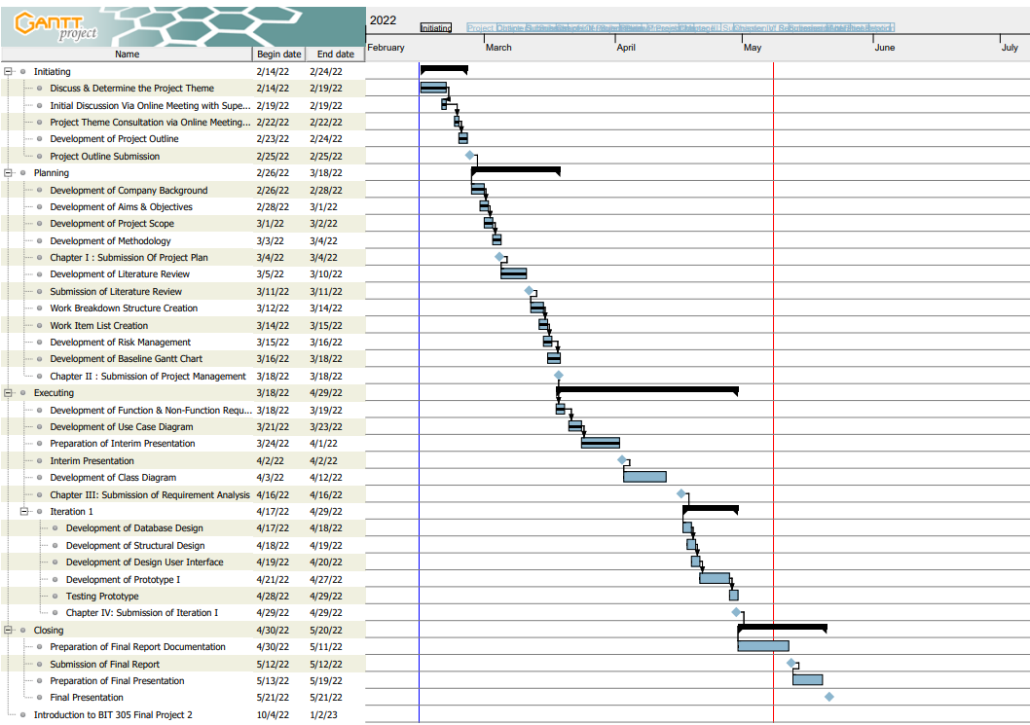

**Figure 2. 1 Gantt Chart**

**Table 2. 4 Milestone**

|  |  |  |
| --- | --- | --- |
| Milestone | Task | Estimated Time of Completion |
| Project Outline Submission | Initiating | February 25th 2022 |
| Chapter I: Submission of Project Plan | Planning | March 4th 2022 |
| Submission of Literature Review | Planning | March 11th 2022 |
| Chapter II: Submission of Project Management Plan | Planning | March 18th 2022 |
| Interim Presentation | Executing | April 2nd 2022 |
| Chapter III: Submission of Requirement Analysis | Executing | April 16th 2022 |
| Chapter IV: Submission of Iteration I | Executing | April 29th 2022 |
| Submission of Final Report | Closing | May 13th 2022 |
| Final Presentation | Closing | May 21st 2022 |

# **CHAPTER 3: REQUIREMENT ANALYSIS**

## **3.1 Introduction**

Requirements Analysis is a stage part of the information design that contains what must be met before heading to the development/coding stage of a system development. This stage will assist in analysing, describing and identifying how the system will be developed so that the flow is known, as well as what developers and users need. Thus, this stage will play an important role in achieving the success of the system being developed because it contains the information needed during the development process. The purpose of the Requirements Analysis stage is to help developers ensure that everything needed in the development process has been met, so that developers can create a system that is not confusing and has a clear flow.

In this Requirement Analysis chapter, functional and non-functional summaries and identification of the function of each feature as well as the user interface design (wireframe) of the BaliStuti web-based e-commerce will be included. Functional Requirements include use case diagrams as a mapping of the features our system provides, high-level use cases which will explain detailed descriptions of the attached use cases, user interface design (wireframe) which will provide a description of how the system will be designed, class diagrams, and database table design. While non-Functional requirements will describe the requirements needed in the system itself to ensure that the system runs well and in accordance with the expectations of users and testers. Non-functional requirements include Technical Requirements that related to software and hardware requirements so that the development process and the use process can run smoothly, Usability Requirements, Reliability Requirements and Security Requirements.

## **3.2 Requirements Summary**

BaliStuti is a web-based e-commerce that aims to facilitate buyers from various regions and countries so that the process of buying and selling goods provided by BaliStuti becomes easier and more enjoyable. On this platform, there are two types of users who will be able to access the functions provided by BaliStuti, namely Admin and Customer.

Admin, is the person who will manage the company profile and items in the product catalogue so that customers can see a description of the company and a list of items available at BaliStuti. Admins also have access to live chat if there are questions about certain items that customers want to know about, Manage Order that allow admins to determine prices for products that have been customized by customers, accept transactions or provide the latest transaction status regarding the items they want to buy, then from all transactions made in the specified time period, the admin will be able to see all the history of transactions made on the BaliStuti platform to then convert it to Excel so that it can be used as a sales report. Then the Customer, can sign up, login and use the forget password function so that the form for filling in the new password will be sent to the email, just like the admin. Customers can do a company profile view, product catalogue view, product detail view, view recently viewed product, search item that makes it easy for customers to find the items they want to buy by doing a direct search or sorting by price or product category, requesting custom items according to their needs or customer’s preferences, live chat, add items to cart, view transaction status, access payment gateways so that payments become easier, select shipping, convert total purchases to dollars so that customers from other countries can quickly find out how much they have to pay, reviewing the items that customers has already pay, and finally both admins and customers can log out if they want to leave the website.

Below is the main function provided by BaliStuti:

* **Sign Up and Log In**

Both users, namely Admin and Customer, can register to create a new account and then log in to access each user's dashboard.

* **View Recently Viewed Product**

The customer can be able to view the recent product based on their last activity in the list of product catalogue. Products that have been seen by customers before will be recorded with session technology and then displayed again with a list of product catalogue in the customer's dashboard.

* **View Detail Product**

The customer can see in detail, read a description of the material, colour and size that is loaded as well as some information related to the product. This feature will allow the customer to find out the details before making a payment or making customizations if there are unwelcome deficiencies in the product.

* **Request Custom Item**

The customer will be able to make customizations related to materials, colours, models, patterns, sizes and additional decorations according to customer requests. Customization can be done by writing a description or uploading an image of a sample product that they want to apply to the product that BaliStuti has already provided. The admin will decide whether the customization can be done or not and will determine the additional costs related to the customization.

* **Live Chat Feature**

The customer can contact the BaliStuti admin via the live chat feature if there are several things that need to be asked about a product, which maybe the customer is not clear with the description listed. Admins can immediately reply to chats sent by customers during store operating hours and discuss until clarity is created that will satisfy customers.

* **Manage Order**

The admin can decide whether to accept or reject the transaction that the customer wants to make based on the results of the customization or based on the existing stock. After the admin manages the transaction in question, the notification will be immediately received by the customer.

* **Payment Gateway**

The customer can choose which shipping service they will use to send the product they have purchased to the address the customer has listed.

As we stated in the Project Description in Chapter 1, about adding some use cases, we also need to make changes to the Requirement Summary. Because the changes made in the form of adding use cases will also have an impact on the Functional Requirements, Use Case Diagrams, High-Level Use Cases, System Sequence Diagrams, and the Structural Design of the BaliStuti system. The addition of the Use Case consists of: View User Information will provide access to users to view other user profile details, View Order Details will display order details needed to ensure orders have been made, Checkout Page which displays order details before continuing the process towards payment and shipping, as well as the Home Page which will display the system's BaliStuti homepage.

### **System Architecture Diagram/Network Diagram**



**Figure 3. 1 Architecture Network Diagram**

## **3.3 Functional Requirements**

Functional Requirements are requirements needed to meet the needs of BaliStuti users, both Admin and Customer. The following are functions that can be used by BaliStuti users:

* **Sign Up**

This function is used by customers who do not have an account on the BaliStuti website. The form for filling in the full name, email address, phone number, address, password is a column to confirm the password.

* **Log In**

This function can be used by BaliStuti users who have created an account on the BaliStuti website. Users will be given a screen to fill in the email address and password form. If you enter your email and password correctly, the system will display the customer/admin dashboard. But if it's wrong, then the system will display a notification

* **Forget Password**

This function can be used by all BaliStuti users who enter the wrong password due to forgetting the password that was previously created. Users must enter their email address and change their password so they can access the BaliStuti website.

* **View Profile Company**

This function allows BaliStuti users to see a description of the company and what new items they provide.

* **Manage Profile Company**

This function allows the admin to change every detail, inserting some picture or update the latest news about the company that will be displayed on the Company Profile.

* **View Product Catalogue**

This function is used by customers who want to see what products BaliStuti has to offer as a whole.

* **View Detail Product**

This function allows the customer to see the details of the materials and colors contained in the product image along with a detailed description of the product.

* **Manage Item in Product Catalogue**

This function can be used by admins so that it allows admins to add, update, and delete any new products or products that are required to be displayed on the BaliStuti website.

* **Search Item**

This function allows customers to search for the desired product by typing the product name so that the system will display the product in question.

* **Request Custom Item**

This function can be used by customers who want specific changes to the product of interest. The system will provide a page to customize a product starting from the material, colour, size, style, model and motif so that it is in accordance with what the customer wants.

* **View Recently Viewed Product**

This function will provide an experience for customers to review what they have just seen using session technology. Session technology is used to record all activities carried out by customers on the BaliStuti website.

* **Live Chat**

This function is used by customers and admins who want to consult about a product that may be unclear and want to know more information. The process of communicating is made easier because it is done in real time during working hours.

* **Add to Cart**

This function is used to make it easier for customers to buy products in different categories and in different quantities so that payment and delivery can be made one time at a time.

* **Manage Transaction**

This function gives access to the admin to determine the price that must be paid by the customer for the item they want to customize. The admin can also accept or reject transactions which they consider BaliStuti can or can't do regarding product customization, and other factors.

* **Notification**

This function will be accepted by the customer and sent by the related admin about the product ordered so that the customer knows the updates and information related to the transaction they are doing.

* **Payment Gateway**

This function makes it easier for customers to make payments. Customers are given the choice to use what method of payment for the desired product on the BaliStuti website. By using this function, customers can choose to use bank transfers, payments at the nearest outlets or electronic wallets.

* **View Status Transaction**

This function allows the customer to see which stage the transaction has reached. The transaction stages are divided into several parts, namely the payment stage, the packing stage, and the delivery stage.

* **Convert Currency in Total Payment**

This function will make it easier for customers outside Indonesia, especially western countries because they convert to US Dollars to determine the amount to be paid without having to contact the BaliStuti admin again to verify currency-related payments.

* **Shipping**

This function will be provided for customers who have made transactions and want to use the shipping method by which party. This function will provide offers related to the services they provide.

* **Review Item**

This function can be accessed by customers to provide reviews related to the desired product. The form to fill out the review is located at the very bottom after accessing product details.

* **View History of All Transaction**

This function allows the admin to see every transaction that has been made by the customer within the desired timeframe. Later, the use of this function will be used for the preparation of transaction reports for the BaliStuti’s company.

* **Convert the History of All Transaction to Excel**

This function will allow admin to convert every transaction to excel format. This will make it easier for companies to store archives related to transaction history on the BaliStuti website.

* **Log Out**

This function will allow admins and customers to leave the BaliStuti website or exchange accounts, so that both customers and admins can log in to the BaliStuti website using other accounts.

* **View User Profile Information**
* **View Order Detail**
* **Check Out Page**
* **Home Page**

### **3.3.1 Use Case Diagram**

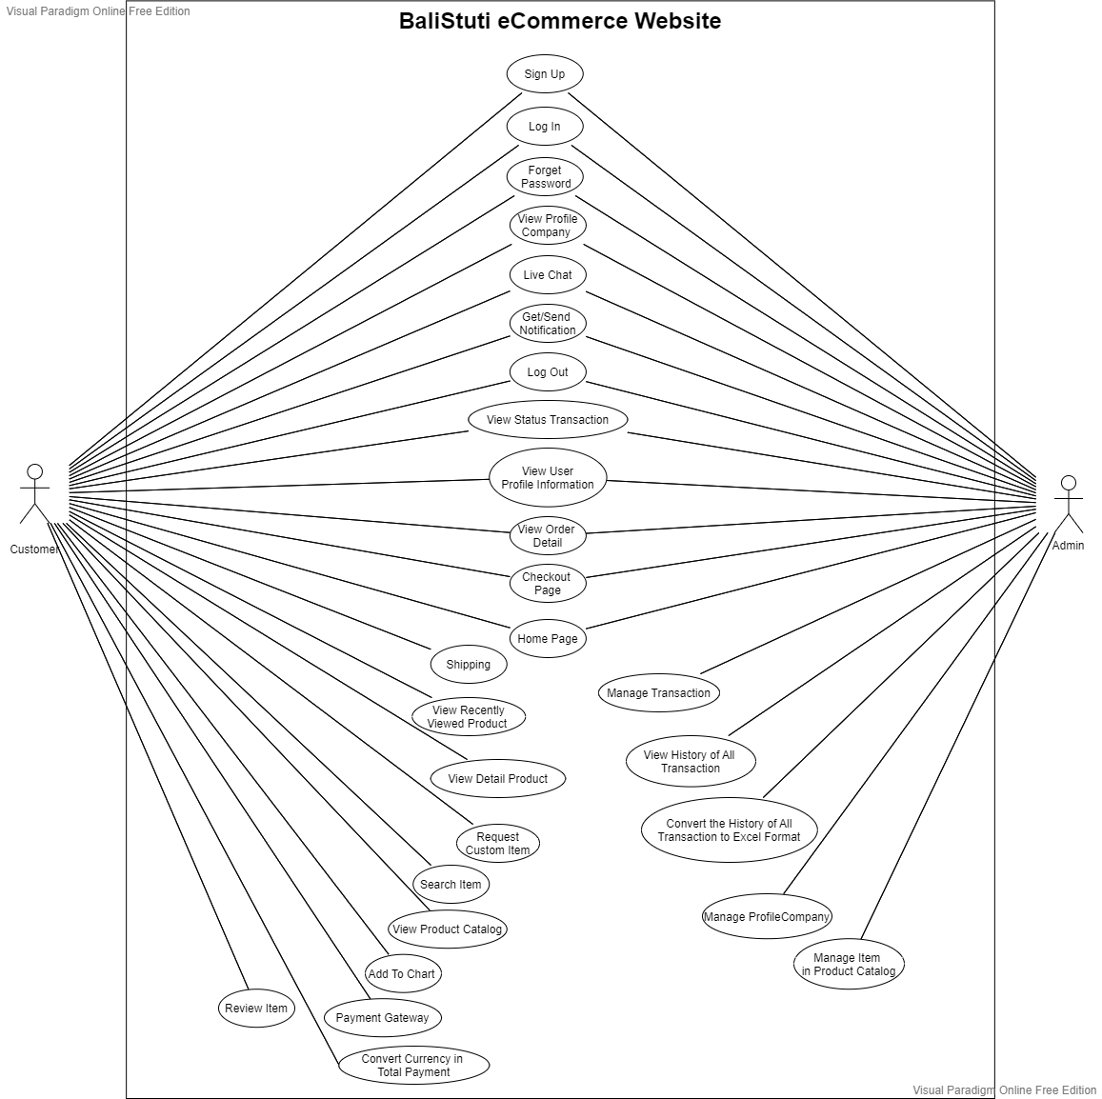

**Figure 3. 2 Use Case Diagram**

### **3.3.2 High-Level Use Cases**

**Table 3. 1 High Level Use Case Sign Up**

|  |  |
| --- | --- |
| **Use Case 1** | **Sign Up** |
| Goal in Context | To facilitate customers who do not have an account and have the desire to access the features of the BaliStuti website as a whole |
| Primary Actors  Secondary Actors | Customer  - |
| Description | Customers can sign up by filling in a number of personal data in the form fields provided to create an account. After filling in your personal data, the system will send a verification message via email. Customers are expected to activate the account by verifying via email. And after customer verifying the activation account, then there will be a link provided to log in to the BaliStuti’s website. |

**Table 3. 2 High Level Use Case for Forget Password**

|  |  |
| --- | --- |
| **Use Case 3** | **Forget Password** |
| Goal in Context | To help customers in accessing the Bali Stuti website when they forget their password, and change or reset the password so that they can remember it in the next time |
| Primary Actors  Secondary Actors | Customer  - |
| Description | Customers need to input the email used when registering their account on the BaliStuti website. Then the system will send a message to the customer's email as verification, and a column will be provided to fill in the new password and confirm the new password. |

**Table 3. 3 High Level Use Case for Manage Profile Company**

|  |  |
| --- | --- |
| **Use Case 5** | **Manage Profile Company** |
| Goal in Context | Admin can make edits (read and update) related to the information included regarding the BaliStuti company description which will be displayed on the website. |
| Primary Actors  Secondary Actors | Admin  - |
| Description | Admin can make edits with the functions provided by the BaliStuti website to fill in descriptions and information that will be displayed on the website page. |

**Table 3. 4 High Level Use Case for Manage Item in Product Catalogue**

|  |  |
| --- | --- |
| **Use Case 8** | **Manage Item in Product Catalogue** |
| Goal in Context | Admin can make a change for item in the catalogue |
| Primary Actors  Secondary Actors | Admin  - |
| Description | Admins can add, edit, delete and view products in detail in the Product feature. Product additions can be done if BaliStuti wants to add their newest products, product editing can be done if there are errors related to product additions, and product deletion can be done if the product is not possible to be reproduced. |

**Table 3. 5 High Level Use Case for Search Item**

|  |  |
| --- | --- |
| **Use Case 9** | **Search Item** |
| Goal in Context | To help customer in finding the product they want |
| Primary Actors  Secondary Actors | Customer  - |
| Description | Customers can search for the product they want by typing the product name in the search field provided. Customers can also filter products according to the price they want or choose products from categories that have been provided. |

**Table 3. 6 High Level Use Case for Request Custom Item**

|  |  |
| --- | --- |
| **Use Case 10** | **Request Custom Item** |
| Goal in Context | To facilitate customers who want to customize the products they want |
| Primary Actors  Secondary Actors | Customer  - |
| Description | Customers can customize the products they want to change. The customization has facilitated its own page so that customers can easily express their intentions with the image upload feature and text fields so that customers can freely describe their intentions. |

**Table 3. 7 High Level Use Case for View Recently Viewed Product**

|  |  |
| --- | --- |
| **Use Case 11** | **View Recently Viewed Product** |
| Goal in Context | Customers can see what products they have seen before on the customer dashboard |
| Primary Actors  Secondary Actors | Customer  - |
| Description | Customers can see the products they have seen before, as well as the products they saw after logging out on the home page along with the product catalogue. |

**Table 3. 8 High Level Use Case for Live Chat**

|  |  |
| --- | --- |
| **Use Case 12** | **Live Chat** |
| Goal in Context | Both customers and admins can communicate using the live chat feature |
| Primary Actors  Secondary Actors | Admin & Customer  - |
| Description | If there is something the customer wants to discuss about products, customization, costs and shipping, BaliStuti facilitates users to communicate using the live chat feature. Customers can immediately get answers until they are satisfied during store working hours. |

**Table 3. 9 High Level Use Case for Manage Order**

|  |  |
| --- | --- |
| **Use Case 14** | **Manage Order** |
| Goal in Context | Admin can manage the transaction made by customer |
| Primary Actors  Secondary Actors | Admin  - |
| Description | In transactions that have been made by the customer regarding the item that they want to customize, the customer will wait for the admin's decision to estimate whether BaliStuti can follow up on the transaction or not. And if admin accept the transaction, the notification about how much the product’s cost will also inform along with the status transaction.  Admin will also can enter receipt number of transaction, updating status and others related to managing the transaction made by customers. |

**Table 3. 10 High Level Use Case for Read Status Transaction**

|  |  |
| --- | --- |
| **Use Case 17** | **View Status Transaction** |
| Goal in Context | Customer can view the status of their transaction |
| Primary Actors  Secondary Actors | Customers  - |
| Description | Customers can see the status listed on the system for the transactions they just made. In this feature, customers can check whether their transaction is being processed by the store, or is already in the shipping process. |

**Table 3. 11 High Level Use Case for View History of All Transaction**

|  |  |
| --- | --- |
| **Use Case 21** | **View History of All Transaction** |
| Goal in Context | To let the admin, know how many and the detail transactions happen at the specified time |
| Primary Actors  Secondary Actors | Admin  - |
| Description | The admin can see the flow of transactions that are happening at the specified time so that the admin can easily make reports for the company about the sales that have occurred. With this feature, admins can confirm every transaction that occurs because they already have evidence. |

**Table 3. 12 High Level Use Case for Log Out**

|  |  |
| --- | --- |
| **Use Case 23** | **Log Out** |
| Goal in Context | To allow both admin and customer to log out from the system |
| Primary Actors  Secondary Actors | Admin & Customers  - |
| Description | Admin and customer can logging out and end their session from the system. |

### **Class Diagram**

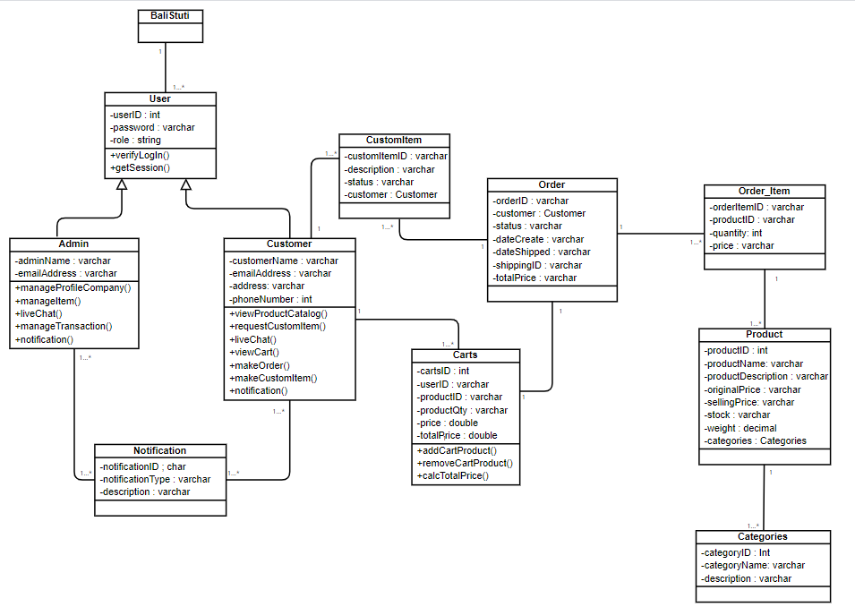

**Figure 3. 3 Class Diagram**

### **3.3.4 Wireframe Design**

* Sign Up

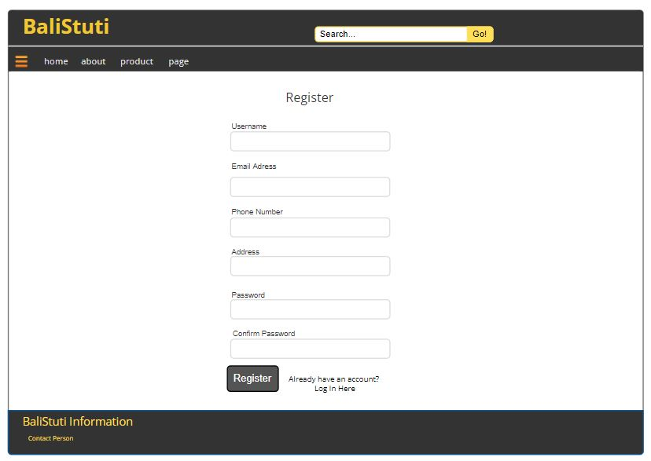

**Figure 3. 4 Wireframe Design Sign Up**

* Forget Password

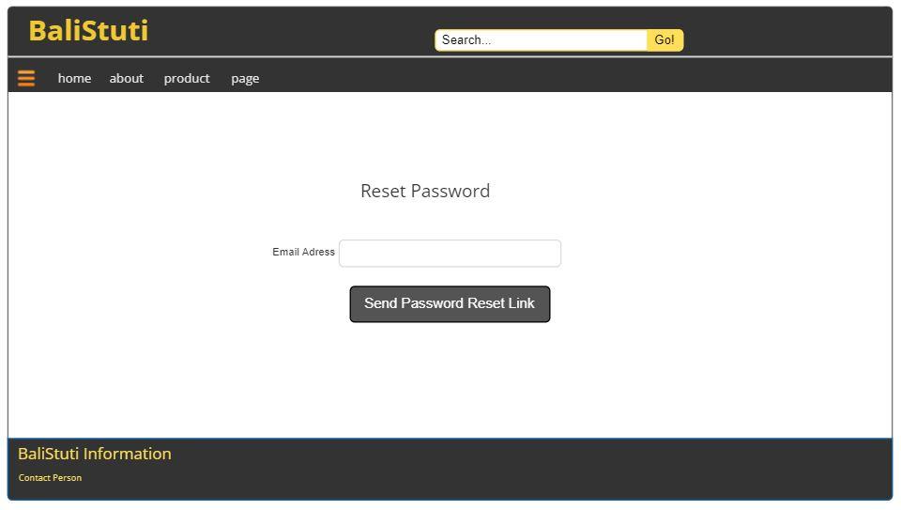

**Figure 3. 5 Wireframe Design Forgot Password**

* Manage Profile Company

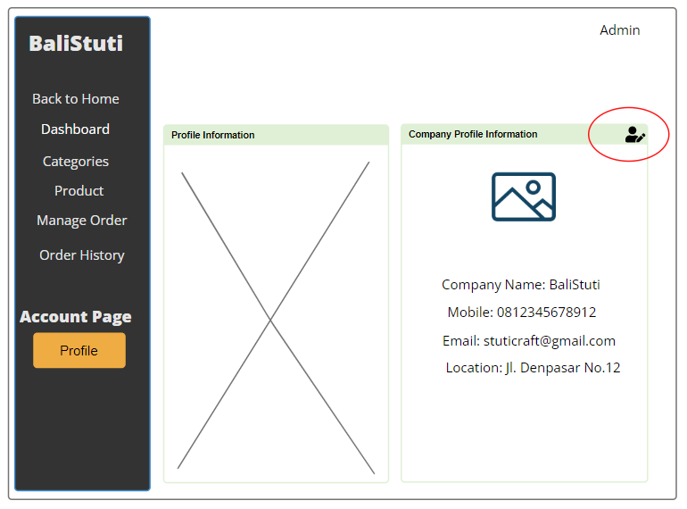

**Figure 3. 6 Wireframe Design Manage Profile Company**

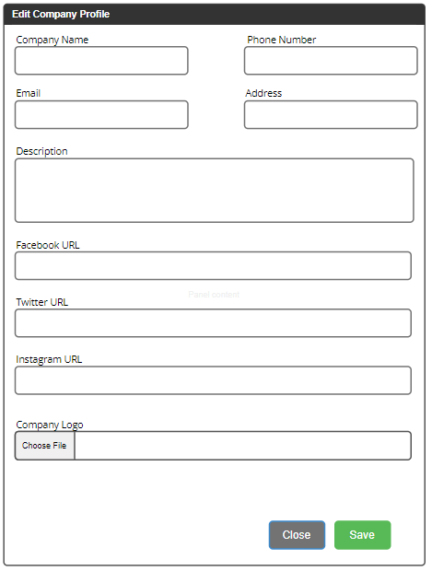

* Manage Item in Product Catalogue

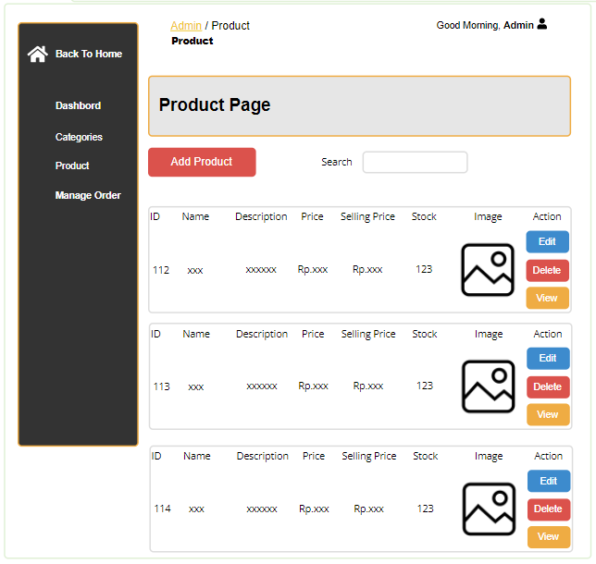

**Figure 3. 7 Wireframe Design Manage Item in Product Catalogue**

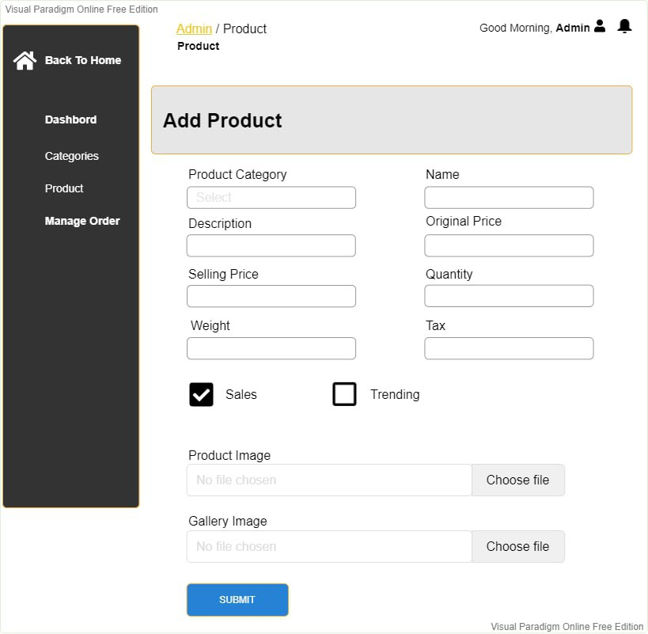

**Figure 3. 8 Wireframe Design Manage Item in Product Cataloque Continue**

* Search Item

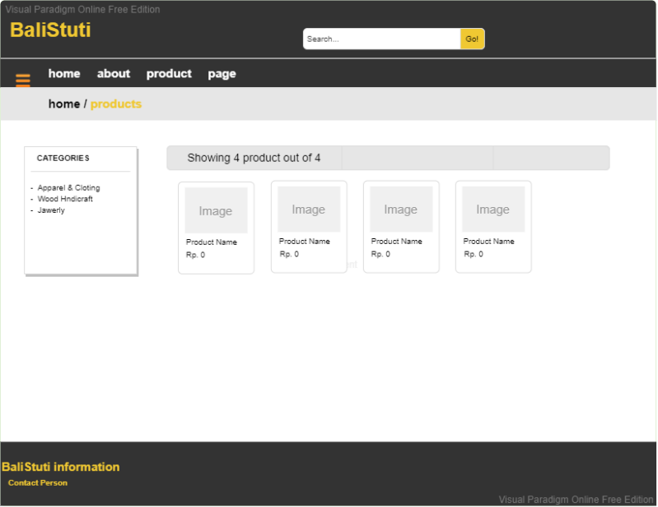

**Figure 3. 9 Wireframe Design Search Item**

* Request Custom Item

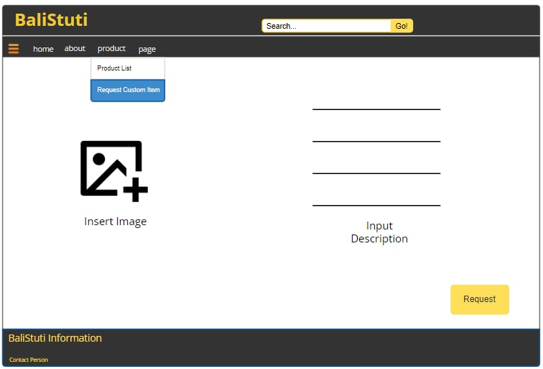

**Figure 3. 10 Wireframe Design Request Custom Item**

* View Recently Viewed Product

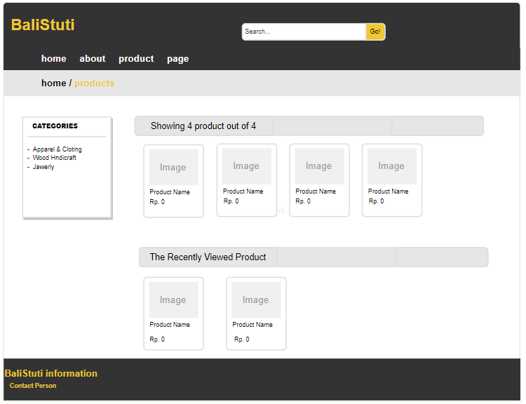

**Figure 3. 11 Wireframe Design View Recently Viewed Product**

* Live Chat

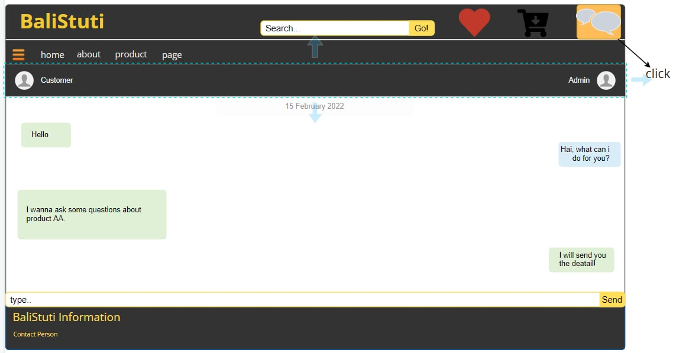

**Figure 3. 12 Wireframe Design Live Chat**

* Manage Order

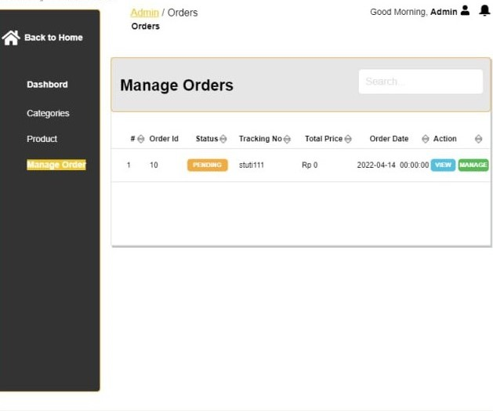

**Figure 3. 13 Wireframe Design Manage Order**

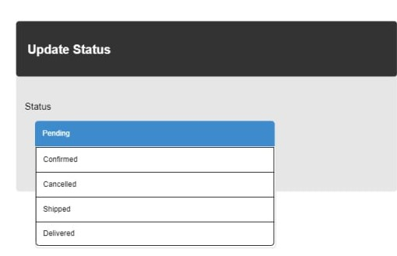

**Figure 3. 14 Design Manage Order Continue**

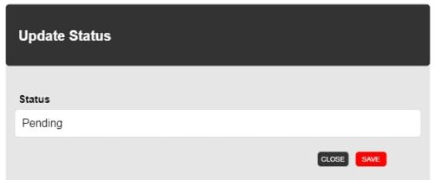

**Figure 3. 15 Design Manage Order Continue**

* View Status Transaction

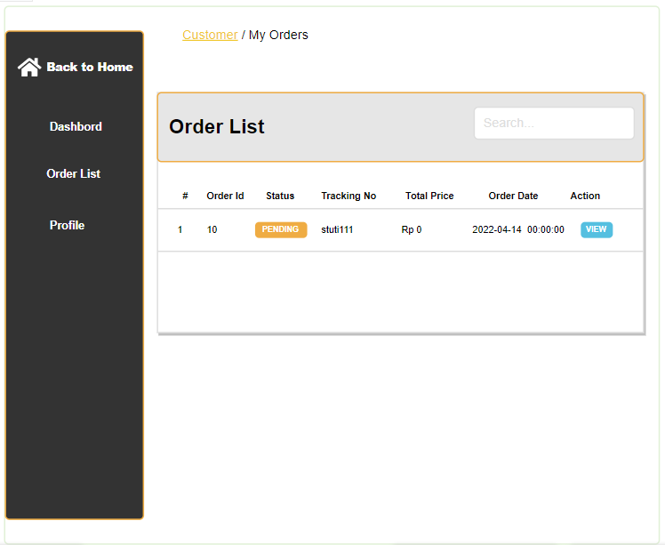

**Figure 3. 16 Wireframe Design View Status Transaction**

* View History of All Transaction

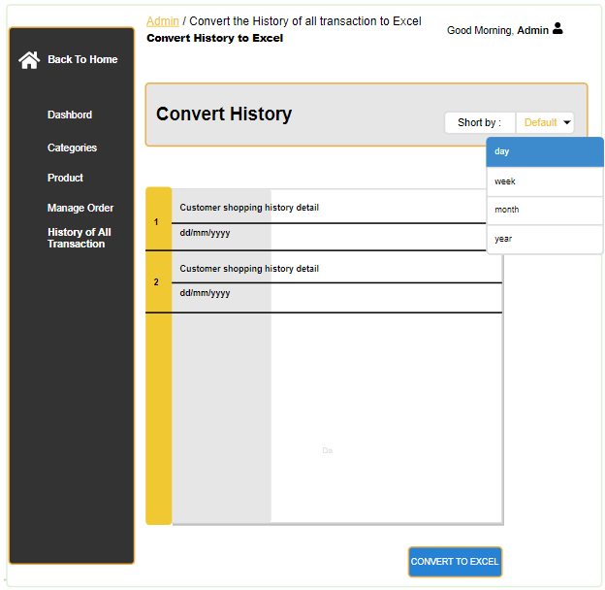

**Figure 3. 17 Wireframe Design View History of All Transaction**

* View Order Detail



* View User Profile Information
* Log Out

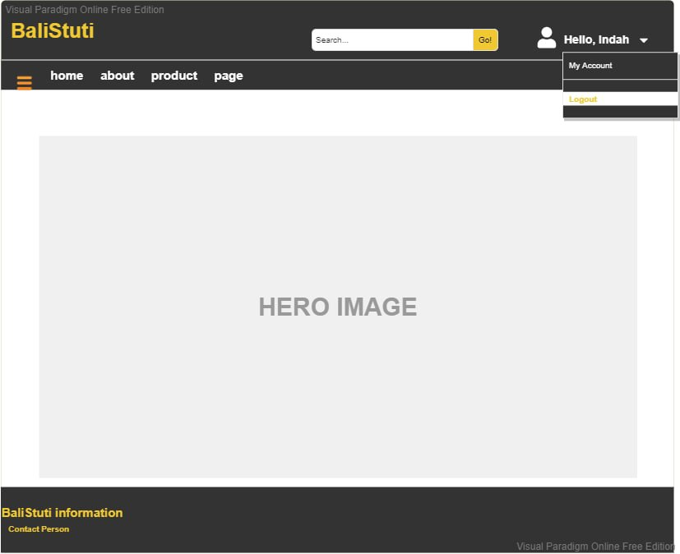

**Figure 3. 18 Wireframe Design Log Out**

## **3.4 Non-Functional Requirements**

### **3.4.1 Technical Requirements**

The technical requirements needed in developing the BaliStuti system are divided into requirements needed by BaliStuti developers and requirements needed by users so that they can access the BaliStuti website. The technical requirements will include operational characteristics related to hardware, software and environment for developing and using the BaliStuti system. Below are the technical requirements that must be met by BaliStuti's system developer and BaliStuti's user:

* **Technical Requirements for BaliStuti’s developers**

To develop e-commerce web-based, what BaliStuti's developers need is a code editor software for coding the system, namely Laravel 8, then a local host server XAMPP which also includes MySQL phpMyAdmin. For front end coding we use Bootstrap frameworks and Visual Paradigm Online to create diagrams, sequences and others. We also use browser tools like Google Chrome and Microsoft Edge.

1. **Operating System Requirements**

The ideal operating system for developing systems for Windows users is the Windows 10 version, but the minimum usage is Windows 7 and above. Then, for mobile devices, Android version 7.1.1 should be used.

1. **System Requirements**

The recommended system requirements are 4GB of RAM for 64-bit versions of Windows with an Intel i5 processor or above and a 512GB HDD for more spacious storage.

1. **Screen Resolution**

The screen resolution required by developers can vary greatly according to the abilities and needs of developers, but because BaliStuti uses a responsive web-based application, all devices with different resolution coverage will not be a problem. However, it is still recommended to use a PC with a resolution of 1280 x 1024 or greater and a mobile phone with a screen of 640 x 1136 or greater.

1. **Browser Requirements**

The recommended browser tools for BaliStuti application development are Google Chrome and Microsoft Edge with the latest versions. For mobile use, using the default browser and google chrome will be enough.

* **Technical Requirements for BaliStuti’s users**

Below are some of the requirements that must be met by users/customers in order to access the BaliStuti site with a better shopping experience because for some reason, the features provided by BaliStuti may not work if the user does not use adequate requirements. And of course, the most needed requirement to access BaliStuti website is an internet.

1. **System Requirements**

The recommended system requirement to be able to access the BaliStuti website is to use a browser such as Google Chrome, Microsoft Edge, Mozilla Firefox, or a PC default browser that is capable and is the latest version with 2GB RAM for the 64bit Windows version, 512 HDD and uses Intel Pentium 4 for the processor.

1. **Screen Resolution**

The BaliStuti web-based e-commerce site has been designed to use a responsive design so it doesn't need to have a minimum resolution value because it can adjust to the user's screen resolution.

### **3.4.2 Usability Requirements**

Usability Requirements are the most needed part in an effort to facilitate user convenience in using a website that is not confusing to develop. A good website will have the advantage of making users feel comfortable and familiar with every feature provided by the website. This will be a plus point because users will prefer to use tools that are easy to use and efficient but also have a good appearance to support the activities they want to do on the website. For this reason, BaliStuti e-commerce web-based wants to provide a pleasant shopping experience for customers who use it. We consider the following factors as a benchmark for developing our website:

* User Friendliness

This application website must be user friendly, which means that the user must be familiar with each feature and not confused in using each button that appears. The system should be simple, work well, clear and attractive at the same time. And all of the function must run well as the expected output.

* Responsiveness

The system must be responsive to the various screens used by the user. Because BaliStuti website users can come from any circle, the devices must be also varied.

* Clear from the Error

The system must be error-free, moreover BaliStuti provides a transaction-related system so that it will be very vulnerable to data loss if there are still bugs during lagging development.

* Clear System Process Flow

All processes provided by the system must be clear and uncluttered. The transaction process requires a clear, structured and systematic flow system so that users will not feel confused when using the BaliStuti website.

The following is the logo from the BaliStuti website and the color scheme that will be used in the system:



**Figure 3. 19 BaliStuti Logo Design**

**Table 3. 13 BaliStuti Colour Scheme**

|  |  |
| --- | --- |
| **Colour** | **Hex Code of the Colour** |
|  | #E2E2E2 |
|  | #2B2B2B |
|  | #171717 |
|  | #FFFFFF |
|  | #D29C32 |
| #d43454 color image | #D43454 |

### **3.4.3 Reliability Requirements**

BaliStuti defines Reliability Requirement as a necessity where the system can be relied on by the user without the need to worry about several factors such as errors or bugs found during transactions or termination of service without notification to customers. Our systems, have the possibility to perform upgrades or maintenance. And the maintenance process will BaliStuti notify when it is carried out so that customers know when they can access the BaliStuti website again. Apart from that, BaliStuti will be accessible at any time for 24 hours as long as the user has a good quality internet connection so that users can rely on the platform we provide whenever they feel they need it or want to access it.

### **3.4.4 Security Requirements**

Security Requirements greatly impact how BaliStuti website users will assess their security and trust in using the system. Moreover, in this case, BaliStuti is a system in which buying and selling transactions occur related to money and customer personal data. To be able to create an account at BaliStuti so that customers can continue the transaction process, several additional steps are needed, such as verifying via email, so that the system can ensure that the user is the same user. In addition, the log out feature serves to secure the data on the system so that it cannot be accessed by other users on certain occasions. Then, creating strong passwords is necessary to avoid hacking with relatively low passwords. BaliStuti requires users to create a password that is more than 8 words, using uppercase letters and special characters or numbers so that it will increase its security level.

# **CHAPTER 4: ITERATIONS**

## **4.1 Introduction**

The iteration section is the stage where each system development process is carried out to produce the final product from several predetermined use cases. In the BaliStuti e-commerce website system, the division of the iteration cycle that has been set for the BIT 304 & BIT 305 subjects is three iteration cycles. The first iteration is the iteration with the shortest processing time because it will be carried out at the very end of Final Project 1 (BIT 304). BaliStuti developers have a fairly short time to work on this Iteration 1, therefore, it was decided to develop 6 use cases consisting of Sign Up, Log In, Forget Password, View Product Catalogue, View Product Details and Log Out.

We chose a fairly simple use case because outside of system development, we needed to do some initial work as a complement to our report such as database design, structural design and so on. Only then in Iterations 1 & 2 we can focus on developing further Use Cases. Based on our system development methodology, namely Iterative Methodology, we have a favourable opportunity to make some changes to the parts that require a change. When we do a consultation and our supervisor recommends changes to some parts because in the Iterative Methodology, we have flexibility in developing the BaliStuti system, then we can make the change easily.

**Table 4. 1 Iteration Plan**

|  |  |  |  |
| --- | --- | --- | --- |
| **Iteration** | **Use Cases** | **Proposed Started Date** | **Proposed End Date** |
| 1 | Sign Up | 21st April 2022 | 21st April 2022 |
| 1 | Log In | 22nd April 2022 | 22nd April 2022 |
| 1 | Forget Password | 24rd April 2022 | 24th April 2022 |
| 1 | View Product Catalogue | 25th April 2022 | 25th April 2022 |
| 1 | View Detail Product | 27th April 2022 | 28th April 2022 |
| 1 | Log Out | 28th April 2022 | 28th April 2022 |
| 2 | Manage Item in Product Catalogue | 4th October 2022 | 7th October 2022 |
| 2 | View Profile Company | 8th October 2022 | 9th October 2022 |
| 2 | Manage Profile Company | 9th October 2022 | 11th October 2022 |
| 2 | Search Item | 12th October 2022 | 14th October 2022 |
| 2 | Request Custom Item | 15th October 2022 | 20th October 2022 |
| 2 | View Recently Viewed Product | 21st October 2022 | 23rd October 2022 |
| 2 | Add To Cart | 24th October 2022 | 28th October 2022 |
| 2 | Manage Order | 29th October 2022 | 1st November 2022 |
| 3 | Live Chat | 2nd November 2022 | 6th November 2022 |
| 3 | Payment Gateway | 7th November 2022 | 12th November 2022 |
| 3 | Convert Currency in Total Payment | 12th November 2022 | 14th November 2022 |
| 3 | View Status Transaction | 15th November 2022 | 17th November 2022 |
| 3 | Review Item | 17th November 2022 | 20th November 2022 |
| 3 | Shipping | 20th November 2022 | 29th November 2022 |
| 3 | View History of All Transaction | 30th November 2022 | 2nd December 2022 |
| 3 | Convert History of All Transaction to Excel | 3rd December 2022 | 10th December2022 |
| 3 | Notification | 11th December 2022 | 20th December 2022 |

## **4.2 Iteration 1**

### **4.2.1 Introduction**

The basic goals for the Iteration 1 of Final Project 1 (BIT 304) are to succeed in developing, running and testing the use cases that we have planned to work on in this Iteration 1, namely Sign Up, Log In, Forget Password, View Product Catalogue, View Product Details and Log Out. The goal in Iteration 1 also ensures that the six use cases that will be developed can run according to their functions, run as expected and meet their functional and non-functional requirements. Iteration 1 will start on April 17, 2022 and will end on April 29, 2022. While the development of the prototype will be carried out on April 21 to April 27 2022 and for further testing on April 28, 2022. Below is a Gantt Chart that contains the related date of Iteration 1:

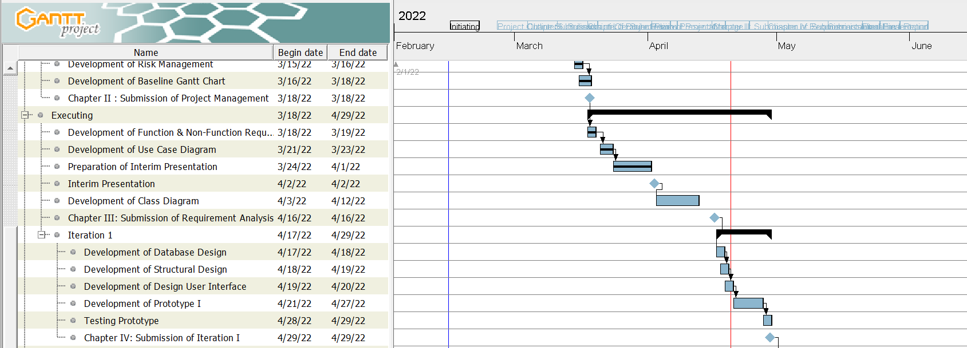

**Figure 4. 1 Iteration Plan**

### **4.2.2 Purpose**

The completion of an iteration consists of several phases consisting of four phases, namely the Analysis phase where the developer must analyse several system requirements, then the Design phase where this phase can be carried out after carrying out the analysis phase so that the design made is in accordance with the scheme applied to the system, then the implementation phase where the coding and all implementation of the results of the analysis and design will be carried out, and the last is the testing phase where the implementation results will go through the testing phase to determine the feasibility of a final result. In Iteration 1, the development of several parts of the BaliStuti e-commerce website system began. This indicates that the initial system worked on in Iteration 1 is a contribution given to the completion of the Milestone. With the completion of Iteration 1, chapter 4 of the final project 1 will also be completed and milestones will be created, and then after the completion of chapter 4, the next stage will be carried out based on the calendar that was given at the beginning of the work on Final Project 1.

### **4.2.3 Context**

The Iteration Plan that was developed fits the overall project plan in terms of the methodology we use in the process of developing the BaliStuti system. We have seen many changes for the better regarding the reports we are working on and the system we have developed based on the suggestions and feedback provided by our supervisor. The methodology that we use, namely the Iterative methodology, allows us to return to the previous step to be corrected if there are any section that needed to be corrected in the development so as to increase flexibility in developing the system in a better direction. Therefore, we only need to focus on the deadline that has been determined for the submission of Chapter 4 Iteration 1, which is April 29, 2022. We also assess the suitability of the project plan in the software and hardware requirements section that we need to develop the system and make reports related to this Iteration 1, all hardware and software written are tools that we need and of course we use in the development process.

### **4.2.4 Schedule of Iteration Workflows**

The development of each use case in Iteration 1 has several risks that may occur. Like when one of the project members gets sick because of a congenital illness that might hinder some work so strict time management is needed. In the process of working on each chapter, each team member tries to complete the given task within the given calendar to avoid any risks that could occur. Below is the Schedule of Iteration 1 Workflows. The specified date has been discussed with the team members in order to avoid some of the risks mentioned above, which may result in delayed scheduling. Considering these risks, we also prioritize simpler use cases to be completed in Iteration 1 so that more complex or difficult use cases can be done in Iteration 2 or 3 with a longer processing time.

**Table 4. 2 Iteration Workflow Schedule**

|  |  |  |  |
| --- | --- | --- | --- |
| **Workflow** | **Start Date** | **End Date** | **Duration (days)** |
| **Use Case: Sign Up** |  |  |  |
| Analysis | 21st April 2022 | 21st April 2022 | 1 |
| Design | 21st April 2022 | 21st April 2022 | 1 |
| Implementation | 21st April 2022 | 21st April 2022 | 1 |
| Testing | 21st April 2022 | 21st April 2022 | 1 |
| **Use Case: Log In** |  |  |  |
| Analysis | 22nd April 2022 | 22nd April 2022 | 1 |
| Design | 22nd April 2022 | 22nd April 2022 | 1 |
| Implementation | 22nd April 2022 | 22nd April 2022 | 1 |
| Testing | 22nd April 2022 | 22nd April 2022 | 1 |
| **Use Case: Forget Password** |  |  |  |
| Analysis | 23rd April 2022 | 23th April 2022 | 2 |
| Design | 23rd April 2022 | 23th April 2022 | 2 |
| Implementation | 24rd April 2022 | 24th April 2022 | 2 |
| Testing | 24rd April 2022 | 24th April 2022 | 2 |
| **Use Case: View Product Catalogue** |  |  |  |
| Analysis | 25th April 2022 | 25th April 2022 | 2 |
| Design | 25th April 2022 | 25th April 2022 | 2 |
| Implementation | 25th April 2022 | 25th April 2022 | 2 |
| Testing | 25th April 2022 | 26th April 2022 | 2 |
| **Use Case: View Detail Product** |  |  |  |
| Analysis | 27th April 2022 | 28th April 2022 | 2 |
| Design | 27th April 2022 | 28th April 2022 | 2 |
| Implementation | 27th April 2022 | 28th April 2022 | 2 |
| Testing | 27th April 2022 | 28th April 2022 | 2 |
| **Use Case: Log Out** |  |  |  |
| Analysis | 28th April 2022 | 28th April 2022 | 1 |
| Design | 28th April 2022 | 28th April 2022 | 1 |
| Implementation | 28th April 2022 | 28th April 2022 | 1 |
| Testing | 28th April 2022 | 28th April 2022 | 1 |

### **4.2.5 Iteration Schedule Breakdown**

**Table 4. 3 Iteration 1 Plan Task Breakdown for Sign Up**

| **Task Name** | **Start** | **Finish** | **Assigned To** |
| --- | --- | --- | --- |
| **Use Case (Sign Up)** |  |  |  |
| **1.1 Analysis** |  |  |  |
| * + 1. Analysis of Sign Up | 21st April 2022 | 21st April 2022 | Indah |
| * 1. **Design** |  |  |  |
| 1.2.1 Designing the Sign-Up Interface | 21st April 2022 | 21st April 2022 | Indah |
| **1.3 Implementation** |  |  |  |
| 1.3.1 Implementation of Sign-Up | 21st April 2022 | 21st April 2022 | Indah |
| **1.4 Testing** |  |  |  |
| 1.4.1 Testing of Sign Up | 21st April 2022 | 21st April 2022 | Indah |

**Table 4. 4 Iteration 1 Plan Task Breakdown for Log In**

| **Task Name** | **Start** | **Finish** | **Assigned To** |
| --- | --- | --- | --- |
| **Use Case (Log In)** |  |  |  |
| **1.1 Analysis** |  |  |  |
| * + 1. Analysis of Log In | 22nd April 2022 | 22nd April 2022 | Dewa Ayu |
| * 1. **Design** |  |  |  |
| 1.2.1 Designing the Log-In Interface | 22nd April 2022 | 22nd April 2022 | Dewa Ayu |
| **1.3 Implementation** |  |  |  |
| 1.3.1 Implementation of Log-In | 22nd April 2022 | 22nd April 2022 | Dewa Ayu |
| **1.4 Testing** |  |  |  |
| 1.4.1 Testing of Log In | 22nd April 2022 | 22nd April 2022 | Dewa Ayu |

**Table 4. 5 Iteration 1 Plan Task Breakdown for Forget Password**

| **Task Name** | **Start** | **Finish** | **Assigned To** |
| --- | --- | --- | --- |
| **Use Case (Forget Password)** |  |  |  |
| **1.1 Analysis** |  |  |  |
| * + 1. Analysis of Forget Password | 23rd April 2022 | 23rd April 2022 | Indah |
| * 1. **Design** |  |  |  |
| 1.2.1 Designing the Forget Password Interface | 23rd April 2022 | 23rd April 2022 | Indah |
| **1.3 Implementation** |  |  |  |
| 1.3.1 Implementation of Forget Password | 24th April 2022 | 24th April 2022 | Indah |
| **1.4 Testing** |  |  |  |
| 1.4.1 Testing of Forget Password | 24th April 2022 | 24th April 2022 | Indah |

**Table 4. 6 Iteration 1 Plan Task Breakdown for View Product Catalogue**

| **Task Name** | **Start** | **Finish** | **Assigned To** |
| --- | --- | --- | --- |
| **Use Case (View Product Catalogue)** |  |  |  |
| **1.1 Analysis** |  |  |  |
| * + 1. Analysis of View Product Catalogue | 25th April 2022 | 25th April 2022 | Dewa Ayu |
| * 1. **Design** |  |  |  |
| 1.2.1 Designing the View Product Catalogue Interface | 25th April 2022 | 25th April 2022 | Dewa Ayu |
| **1.3 Implementation** |  |  |  |
| 1.3.1 Implementation of View Product Catalogue | 26th April 2022 | 26th April 2022 | Dewa Ayu |
| **1.4 Testing** |  |  |  |
| 1.4.1 Testing of View Product Catalogue | 26th April 2022 | <date> | Dewa Ayu |

**Table 4. 7 Iteration 1 Plan Task Breakdown for View Detail Product**

| **Task Name** | **Start** | **Finish** | **Assigned To** |
| --- | --- | --- | --- |
| **Use Case (View Detail Product)** |  |  |  |
| **1.1 Analysis** |  |  |  |
| * + 1. Analysis of View Detail Product | 27th April 2022 | 27th April 2022 | Dewa Ayu |
| * 1. **Design** |  |  |  |
| 1.2.1 Designing the View Detail Product Interface | 27th April 2022 | 27th April 2022 | Dewa Ayu |
| **1.3 Implementation** |  |  |  |
| 1.3.1 Implementation of View Detail Product | 28th April 2022 | 28th April 2022 | Dewa Ayu |
| **1.4 Testing** |  |  |  |
| 1.4.1 Testing of View Detail Product | 28th April 2022 | 28th April 2022 | Dewa Ayu |

**Table 4. 8 Iteration 1 Plan Task Breakdown for Log Out**

| **Task Name** | **Start** | **Finish** | **Assigned To** |
| --- | --- | --- | --- |
| **Use Case (Log Out)** |  |  |  |
| **1.1 Analysis** |  |  |  |
| * + 1. Analysis of Log Out | 28th April 2022 | 28th April 2022 | Indah |
| * 1. **Design** |  |  |  |
| 1.2.1 Designing the Log Out Interface | 28th April 2022 | 28th April 2022 | Indah |
| **1.3 Implementation** |  |  |  |
| 1.3.1 Implementation of Log Out | 28th April 2022 | 28th April 2022 | Indah |
| **1.4 Testing** |  |  |  |
| 1.4.1 Testing of Log Out | 28th April 2022 | 28th April 2022 | Indah |

### **4.2.6 Resource Summary**

**Table 4. 9 Resource Summary**

|  |  |  |  |  |
| --- | --- | --- | --- | --- |
| **No** | **Resources** | **Usage** | **Quantity** | **Cost** |
| **Hardware** | | | | |
| 1 | Laptop Asus VivoBook A4424 (Windows 10) | Development, testing the system and report documentation of web application | 1 computer | 0 (computers available) |
| 2 | Laptop Lenovo (Windows 10) | Development, testing the system and report documentation of web application | 1 computer | 0 (computers available) |
| 3 | Xiaomi Mi 8 Smartphone | Testing the system (responsive test via mobile) | 1 smartphone | 0 (smartphone available) |
| 4 | Xiaomi Redmi Note 9 Smartphone | Testing the system (responsive test via mobile) | 1 smartphone | 0 (smartphone available) |
| **Software** | | | | |
| 5 | Laravel | Project development & testing of front-end code | 1 platform | 0 |
| 6 | Framework Bootstrap | Project development & testing of back-end code | 1 platform | 0 |
| 7 | Visual Paradigm Online | Create diagrams, charts & designing wireframe for the projects | Free source | 0 |
| 8 | Microsoft Word 2019 | Project creating the document for BaliStuti report | 1 platform | 0 |
| 9 | Selenium | Project tools for testing | 1 platform | 0 |
| **Human Resources** | | | | |
| 10 | Project Team Member | Conduct training to introduce this system to team members | 1 expert | 0 |

### **4.2.7 Evaluation Criteria**

The success criteria that BaliStuti team members will evaluate for this Iteration will be consist of three criteria. The first criteria, the iteration will be successful if we meet the deadline that was scheduled in the beginning of developing BaliStuti project, which is April 29, 2022. We consider the timeliness to make a report on the system that will be developed & tested in Iteration 1 is one of the success criteria that must be met. The second criterion is the success in developing the system project and passing the system in the testing process so that a final product will meets expectations is produced. The success of the system in accordance with the expectations predicted by the developer, is a priority for success in working on the BaliStuti web-based e-commerce project. The fulfilment of the final documentation report of the system that has been developed will also contribute to the success of iteration 1. Then, the last criteria is that each functional and non-functional requirement that has been written previously in chapter III - Requirement Analysis, is in accordance with the final results that BaliStuti project member has developed.

### **4.2.8 Analysis and Design Artefacts**

#### **Analysis Class Diagram**



**Figure 4. 2 Analysis Class Diagram**

#### **Expanded Use Case**

**Table 4. 10 Expanded Use Case for Sign Up**

|  |  |  |
| --- | --- | --- |
| **Use Case Name** | **Sign Up** | |
| **Goal in Context** | To allowed the guest or unregistered customer to create an account and register their data on the BaliStuti system so that they can access the full features provided in the website. | |
| **Primary Actor**  **Secondary Actor** | Customer  - | |
| **Typical Course of Event** | | |
| **Actor Action** | | **System Response** |
| 1. The sign-up use case will begin when the user clicks on the "register" button located in the right corner header, when entering the BaliStuti home page | | 1. The system will immediately display a form for signing up which consists of: name, email address, phone number, address, password and confirm password. |
| 1. The user must fill in the requested personal data on the form provided correctly and completely and the click on the “register” button | | 1. The system will send a verification message containing an activation button and a link that will directly connect the user to the BaliStuti website to the customer via the email that the customer entered in the registration form. |
| 1. The user must activate the account by clicking the activation button that has been sent by the system via email and must click the activation link before 24 hours, so that the account can be immediately activated and ready to use | | 1. The system will activate account and user will be able to access all the feature that BaliStuti has already provided. |
| **Alternative Course Event** | | |
| **Line 3a.** If the user already has an account with the same email, the system will display a notification that the email has been used by another account  **Line 3b.** If the user creates a password that is less than 8 characters, the system will display a notification "The Password must be at least 8 characters" | | |

**Table 4. 11 Expanded Use Case for Forget Password**

|  |  |  |
| --- | --- | --- |
| **Use Case Name** | **Forget Password** | |
| **Goal in Context** | To allow customers to get the new password for their account because of forgetting their old password | |
| **Primary Actor**  **Secondary Actor** | Customer  - | |
| **Typical Course of Event** | | |
| **Actor Action** | | **System Response** |
| 1. The forget password use case begin when the customer forget their old password and click on the “forget password” provided. | | 1. The system will direct the user to the change password page and a form will appear that contain the email address |
| 1. The customer must fill the form provided | | 1. System will send the password reset link to the email that customer already submitted |
| 1. Customer has to click the link and fill the form in the aim to get the new password. Such as filling the email address, new password, confirm password and then click on the reset button. | | 1. The system will configure and save changes that occur in changing passwords |
| **Alternative Course Event** | | |
| **Line 3a.** If the email address inputted by customer is not connected with any account that registered in BaliStuti system, the the notification “can’t find the user with that email address” will appear.  **Line 5a.** if user didn’t click on the “reset password” on email for 60 minutes, then the link will be expired | | |

**Table 4. 12 Expanded Use Case for Log Out**

|  |  |  |
| --- | --- | --- |
| **Use Case Name** | **Log Out** | |
| **Goal in Context** | To allow customers and admin to log out from BaliStuti website and end their session | |
| **Primary Actor**  **Secondary Actor** | Customer & Admin  - | |
| **Typical Course of Event** | | |
| **Actor Action** | | **System Response** |
| 1. The Log Out use case begin when the user click on the greeting text with the profile icon in the top right corner of the website | | 1. System will show the drop-down menu that contain a couple choice: My Account & Log Out |
| 1. User must click on the “Log Out” button | | 1. The system will direct to the home page and end the session of user. |
| **Alternative Course Event** | | |
| **-** | | |

#### **System Sequence Diagram**

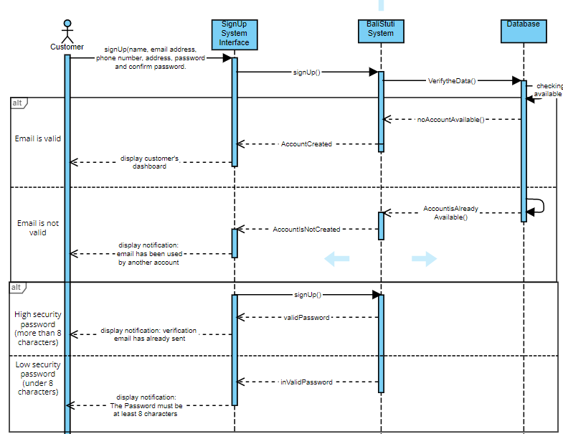

**Figure 4. 3 System Sequence Diagram for Sign Up**

**Table 4. 13 Contract for Sign Up**

|  |  |
| --- | --- |
| **Cross References** | **Sign Up for Customer** |
| **Operation** | SignUp (name, email address, phone number, address, password, confirm password) |
| **Responsibility** | To allow customer to create new account |
| **Pre-Condition** | * Email address submitted by customer must valid (not registered yet) * Password must have a high security with more than 8 characters |
| **Post-Condition** | Customer successfully create their account |

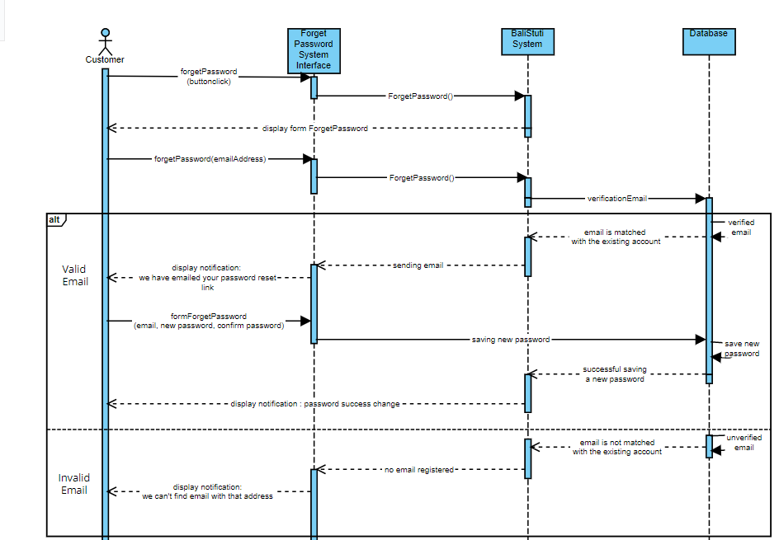

**Figure 4. 4 System Sequence Diagram for Forget Password**

**Table 4. 14 Contract for Forget Password**

|  |  |
| --- | --- |
| **Cross References** | **Forget Password** |
| **Operation** | Forget Password (email address) |
| **Responsibility** | To allow admin to reset and get a new password for the forgotten old password |
| **Pre-Condition** | * User must has already had an email that connected with an account |
| **Post-Condition** | Customer will be able to log in with the new password |

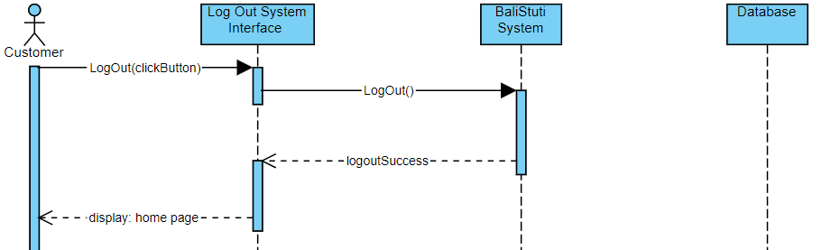

**Figure 4. 5 System Sequence Diagram for Log Out**

**Table 4. 15 Contract for Forget Password**

|  |  |
| --- | --- |
| **Cross References** | **Log Out** |
| **Operation** | Log Out (click button) |
| **Responsibility** | To allow user to exit or end their session in the BaliStuti website |
| **Pre-Condition** | * User must has already had an account / registered their self in BaliStuti website * User must has already log in to the BaliStuti website |
| **Post-Condition** | Customer will be able to logout / exit from BaliStuti website |

#### **Database Design**

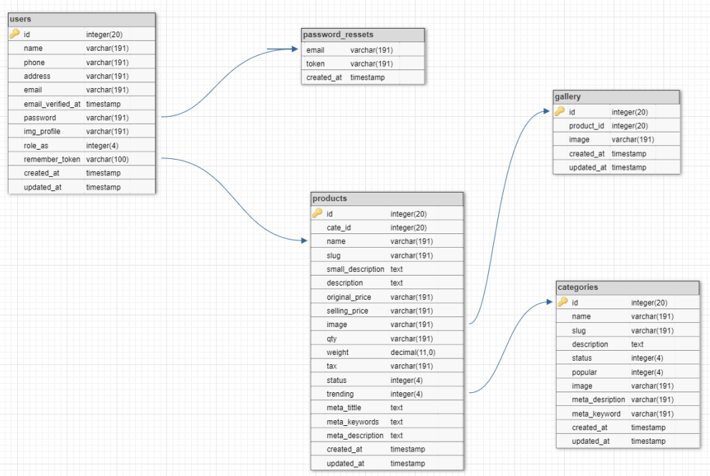

**Figure 4. 6 Database Design**

**Table 4. 16 Database Design Table for User**

|  |  |  |  |  |
| --- | --- | --- | --- | --- |
| Key | Column Name | Data Type | Allow Null | Length |
| PK | Id | bigInt | No | 20 |
|  | Name | Varchar | No | 191 |
|  | Phone | Varchar | No | 191 |
|  | Address | Varchar | No | 191 |
| FK | Email | Varchar | No | 191 |
|  | Email_verified_at | timestamp | Yes |  |
|  | Password | Varchar | No | 191 |
|  | Img_profile | Varchar | No | 191 |
|  | Role_as | tinyInt | No | 4 |
|  | Remember_token | Varchar | Yes | 100 |
|  | Created_at | timestamp | Yes |  |
|  | Update_at | timestamp | Yes |  |

**Table 4. 17 Database Design Table for Password_Ressets**

|  |  |  |  |  |
| --- | --- | --- | --- | --- |
| Key | Column Name | Data Type | Allow Null | Length |
| FK | Email | Varchar | No | 191 |
|  | Token | Varchar | No | 191 |
|  | Created_at | timestamp | Yes |  |

**Table 4. 18 Database Design Table for Product**

|  |  |  |  |  |
| --- | --- | --- | --- | --- |
| Key | Column Name | Data Type | Allow Null | Length |
| PK | Id | bigInt | No | 20 |
|  | Cate_Id | bigInt | No | 20 |
|  | Name | Varchar | No | 191 |
|  | Slug | Varchar | No | 191 |
|  | Small_description | mediumext | No |  |
|  | description | longtext | No |  |
|  | Original_price | Varchar | No | 191 |
|  | Selling_price | Varchar | No | 191 |
|  | image | Varchar | No | 191 |
|  | qty | Varchar | No | 191 |
|  | weight | Decimal | No | 11,0 |
|  | tax | Varchar | No | 191 |
|  | status | Tinyint | No | 4 |
|  | trending | Tinyint | No | 4 |
|  | Meta_tittle | Mediumtext | No |  |
|  | Meta_keywords | Mediumtext | No |  |
|  | Meta_description | Mediumtext | No |  |
|  | Created_at | timestamp | Yes |  |
|  | Update_at | timestamp | Yes |  |

**Table 4. 19 Database Design Table for Gallery**

|  |  |  |  |  |
| --- | --- | --- | --- | --- |
| Key | Column Name | Data Type | Allow Null | Length |
| PK | Id | Bigint | No | 20 |
|  | Product_id | Bigint | No | 20 |
|  | Image | varchar | No | 191 |
|  | Created_at | Timestamp | Yes |  |
|  | Update_at | timestamp | Yes |  |

**Table 4. 20 Database Design Table for Categories**

|  |  |  |  |  |
| --- | --- | --- | --- | --- |
| Key | Column Name | Data Type | Allow Null | Length |
| PK | Id | bigInt | No | 20 |
|  | Name | Varchar | No | 191 |
|  | Slug | Varchar | No | 191 |
|  | Description | longtext | No |  |
|  | Status | Tinyint | No | 4 |
|  | Popular | Tinyint | No | 4 |
|  | image | Varchar | No | 191 |
|  | Meta_title | Varchar | No | 191 |
|  | Meta_description | Varchar | No | 191 |
|  | Meta_keywords | Varchar | No | 191 |
|  | Created_at | timestamp | Yes |  |
|  | Update_at | timestamp | Yes |  |

#### **Structural Design**

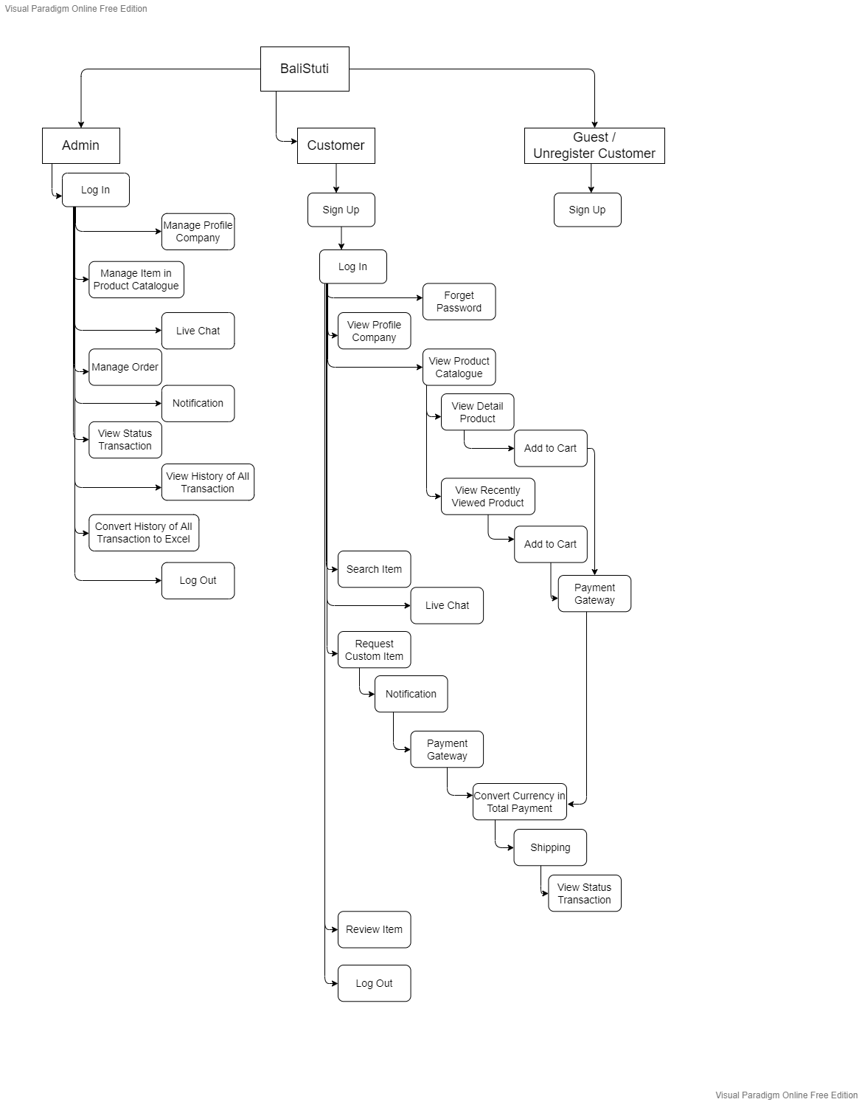

**Figure 4. 7 BaliStuti Structural Design**

#### **User Interface Design**

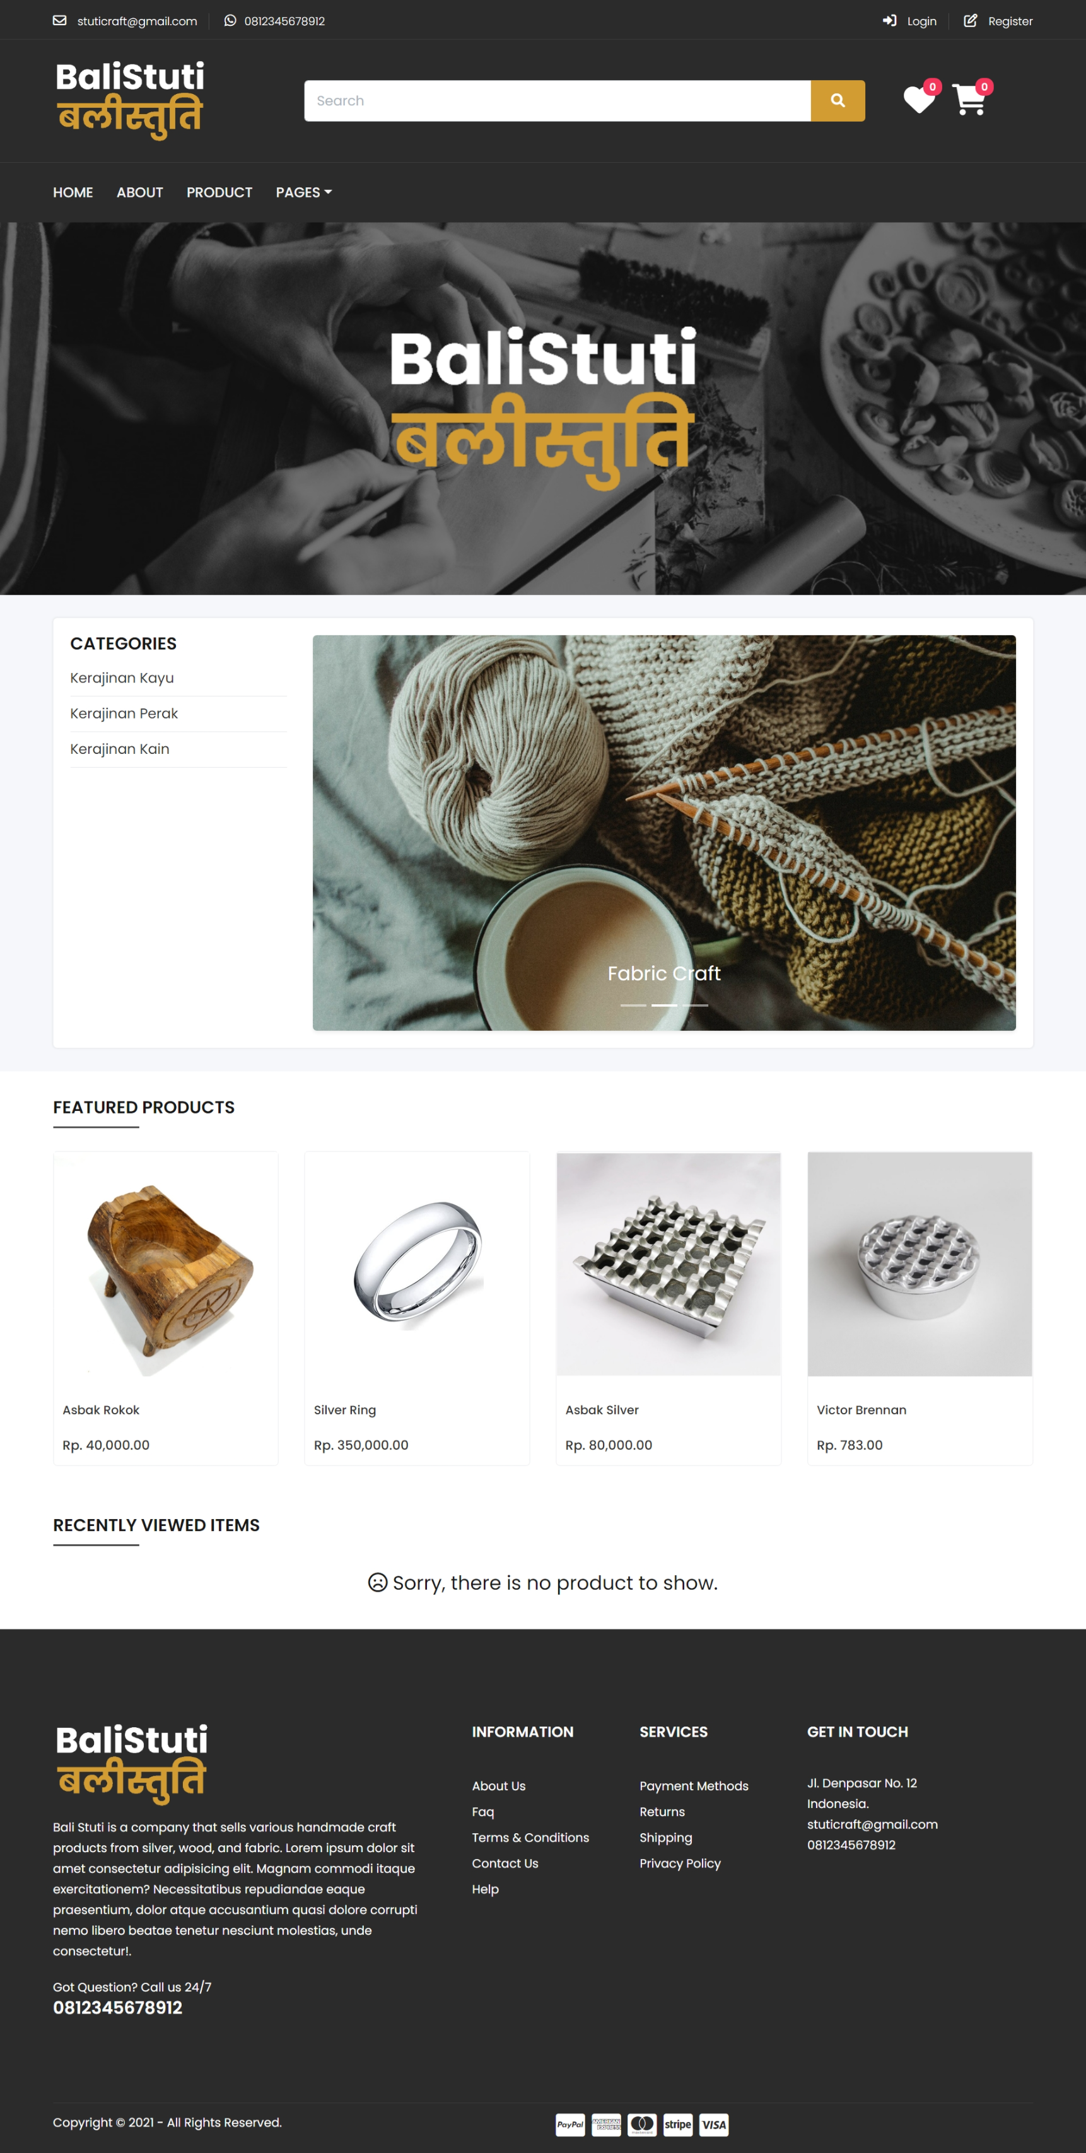

**Figure 4. 8 BaliStuti Home Page**

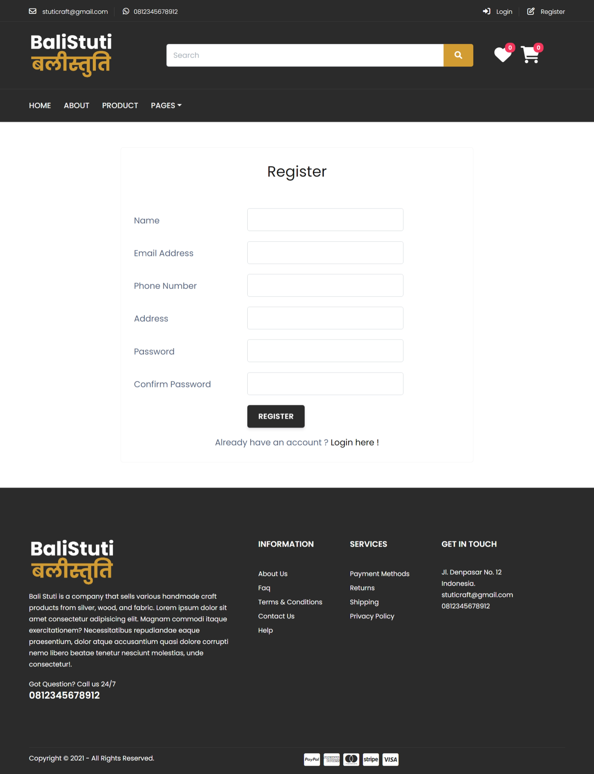

**Figure 4. 9 BaliStuti Sign Up Page**

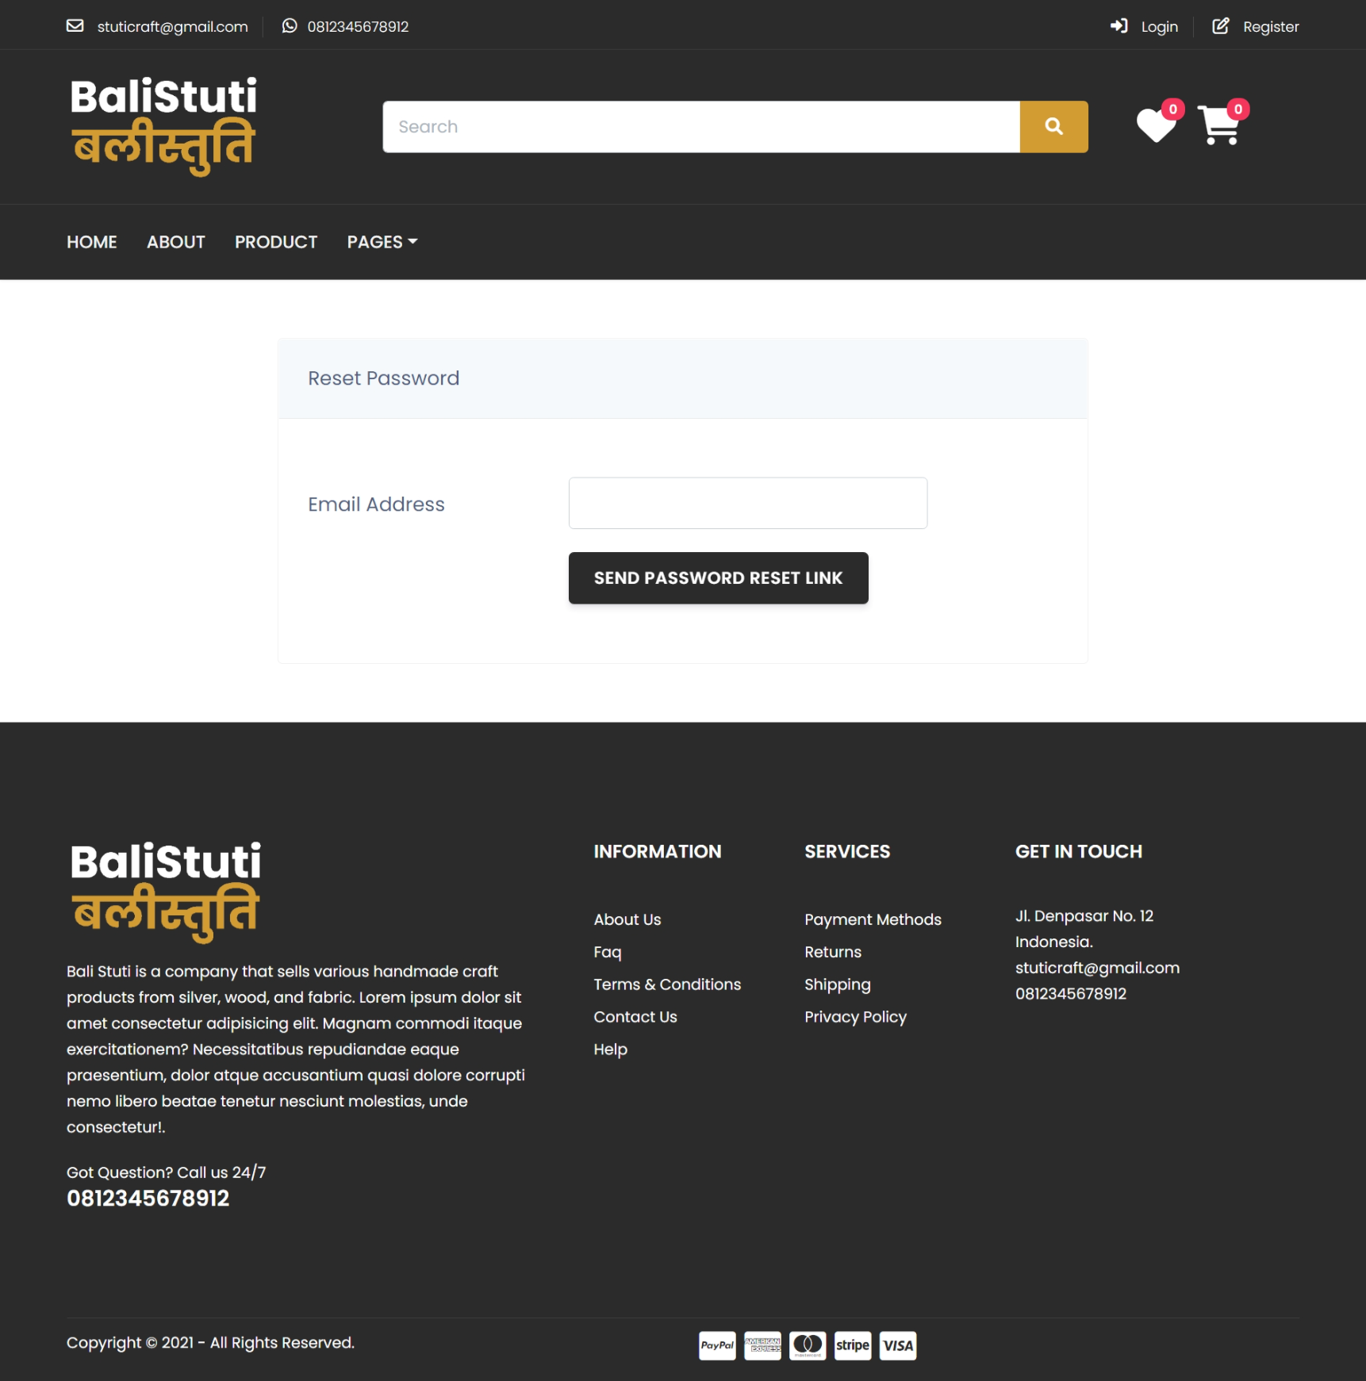

**Figure 4. 10 BaliStuti Forget Password Page**

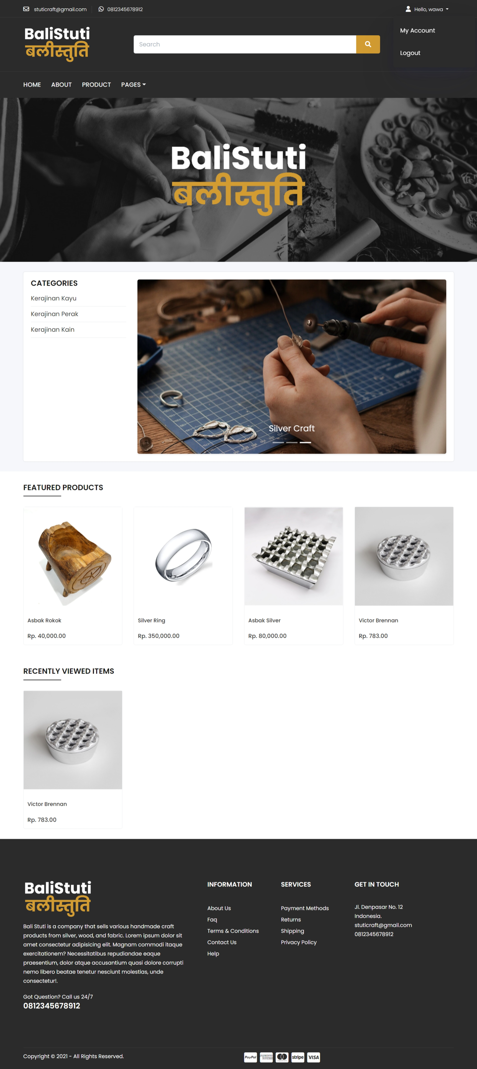

**Figure 4. 11 BaliStuti Log Out View**

### **4.2.9 Implementation and Testing**

#### **Implementation**

Developing the BaliStuti e-commerce website system using the Iterative methodology will provide flexibility and flexibility in the development process for BaliStuti developers. The tools used to develop the BaliStuti system are Laravel 8 and use the PHP 7.3 programming language. BaliStuti developer also uses MySQL as a database to develop this project system. We encountered difficulties because we were just learning to use the laravel IDE which in our opinion, we were not used to using laravel and because during the time we learned more android programming languages such as java and C++. However, we don't need to worry and we are quite challenged because the complete tutorial has been found on the youtube platform and other articles.

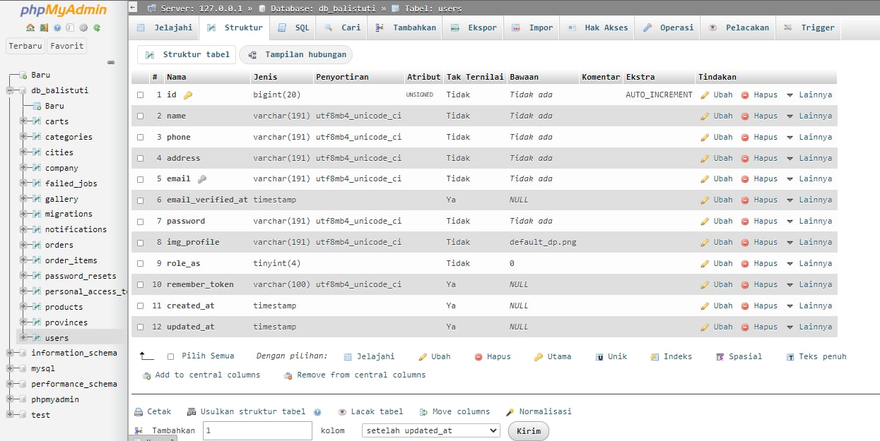

**Figure 4. 12 BaliStuti Database User**

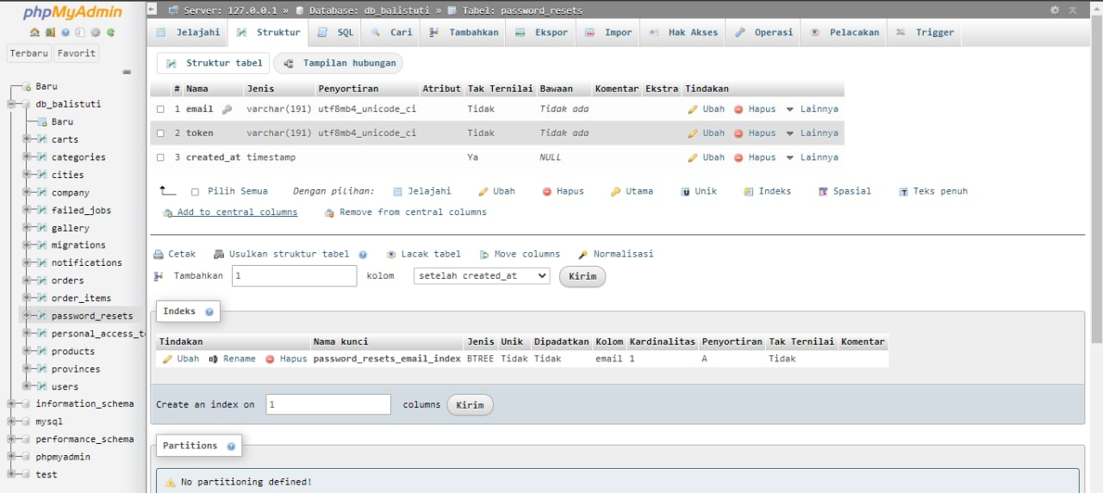

**Figure 4. 13 BaliStuti Database Password_Reset**

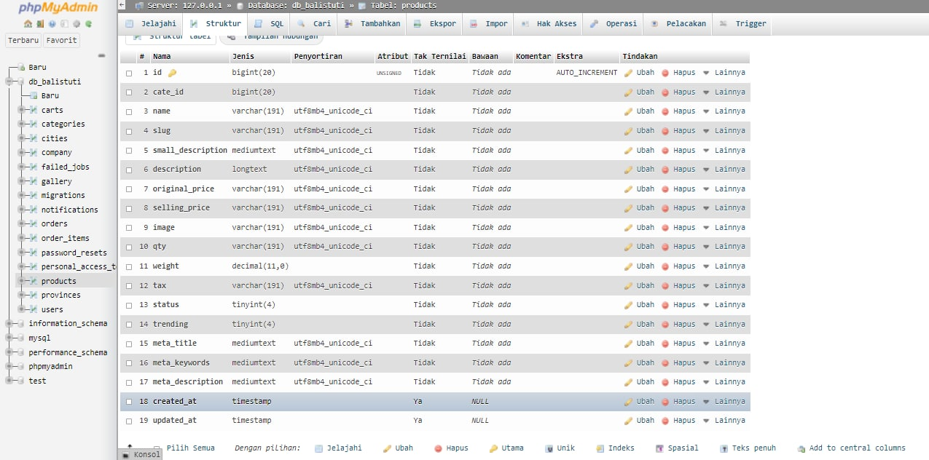

**Figure 4. 14 BaliStuti Database Products**

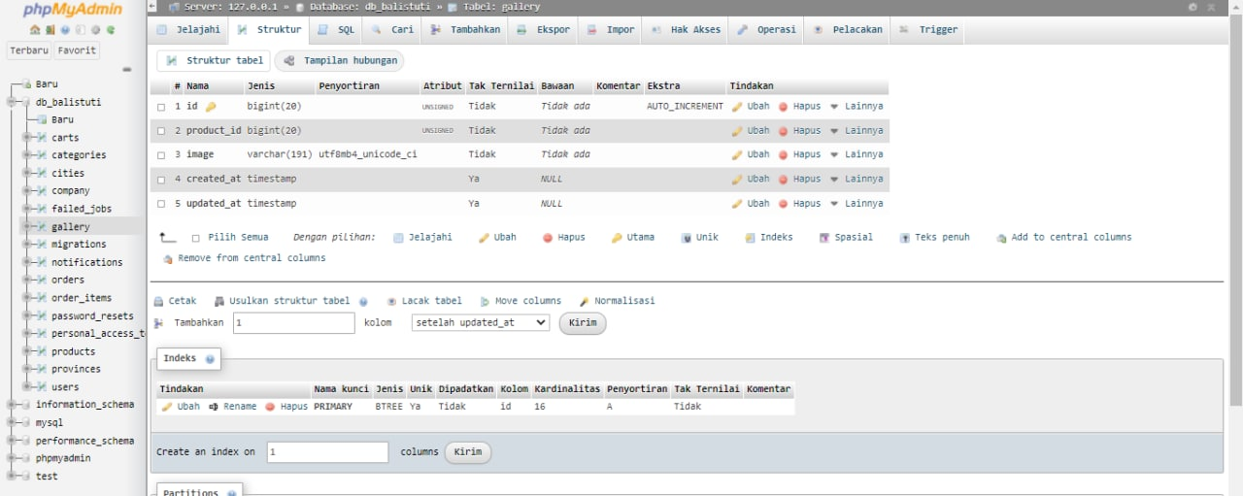

**Figure 4. 15 BaliStuti Database Gallery**

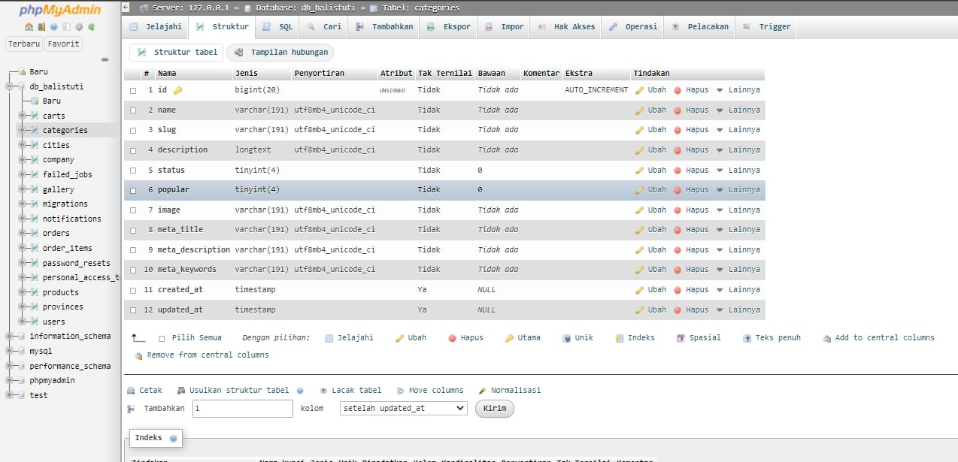

**Figure 4. 16 BaliStuti Database Category**

#### **Testing**

System testing is needed by every developer to determine the final result of the system that has been developed. The system needs to be tested whether it complies with the requirements that have been previously set or not. So that a definite result is obtained regarding the final result of the system. The use cases that I developed in iteration 1 are Sign Up, Forget Password and Log Out. Testing the BaliStuti system is to use the Laravel IDE and Google Chrome or Microsoft Edge. In testing, we use the appropriate data types in the database, then we use data types that do not match the database to ensure that the system is running well as expected.

##### **Functional Testing**

###### **Unit Testing**

**Table 4. 21 Unit Test Plan – Sign Up**

| **Unit Test Plan** | |
| --- | --- |
| Module Name/ID: Sign Up | Program Name/ID: BaliStuti |
| **1. Module Overview** | |
| Allow customers to sign up in BaliStuti website | |
|  | |
| **1.1 Inputs to Module** | |
| * name (varchar) * email address(varchar) * phone number(varchar) * address(varchar) * password(varchar) * confirm password(varchar) | |
| **1.2 Outputs from Module** | |
| Customers will be able to registrate their self in BaliStuti website and their data inputted will be stored in the database | |
|  | |
| **1.3 Logic Flow Diagram/Segment of Code** | |
| use RegistersUsers;  /**  * Where to redirect users after registration.  *  * @var string  */  protected $redirectTo = RouteServiceProvider::HOME;  /**  * Create a new controller instance.  *  * @return void  */  public function __construct()  {  $this->middleware('guest');  }  /**  * Get a validator for an incoming registration request.  *  * @param array $data  * @return \Illuminate\Contracts\Validation\Validator  */  protected function validator(array $data)  {  return Validator::make($data, [  'name' => ['required', 'string', 'max:255'],  'email' => ['required', 'string', 'email', 'max:255', 'unique:users'],  'phone' => ['required', 'numeric'],  'address' => ['required', 'string', 'max:255'],  'password' => ['required', 'string', 'min:8', 'confirmed'],  ]);  }  /**  * Create a new user instance after a valid registration.  *  * @param array $data  * @return \App\Models\User  */  protected function create(array $data)  {  return User::create([  'name' => $data['name'],  'email' => $data['email'],  'phone' => $data['phone'],  'address' => $data['address'],  'password' => Hash::make($data['password']),  ]);  }  use RedirectsUsers;  /**  * Show the application registration form.  *  * @return \Illuminate\View\View  */  public function showRegistrationForm()  {  return view('auth.register');  }  /**  * Handle a registration request for the application.  *  * @param \Illuminate\Http\Request $request  * @return \Illuminate\Http\RedirectResponse|\Illuminate\Http\JsonResponse  */  public function register(Request $request)  {  $this->validator($request->all())->validate();  event(new Registered($user = $this->create($request->all())));  $this->guard()->login($user);  if ($response = $this->registered($request, $user)) {  return $response;  }  return $request->wantsJson()  ? new JsonResponse([], 201)  : redirect($this->redirectPath());  }  /**  * Get the guard to be used during registration.  *  * @return \Illuminate\Contracts\Auth\StatefulGuard  */  protected function guard()  {  return Auth::guard();  }  /**  * The user has been registered.  *  * @param \Illuminate\Http\Request $request  * @param mixed $user  * @return mixed  */  protected function registered(Request $request, $user)  {  //  } | |
| **2. Test Data** | |
| * Valid Data: * name: hannah * email address: hannahsweet434@gmail.com * phone number: 081123456787 * address: Jl. Raya Puputan * password: myPassword9898 * confirm password: myPassword9898 * Invalid Data: * name: hannah * email address: hannahsweet434@gmail.com * phone number: *null* * address: Jl. Raya Puputan * password: pass * confirm password: pass | |
| **2.1 Positive Test Cases** | |
| 1. Positive Test Case 1 - Valid Data Input  * name: hannah * email address: hannahsweet434@gmail.com * phone number: 081123456787 * address: Jl. Raya Puputan * password: myPassword9898 * confirm password: myPassword9898   The data above is valid data. If the user inputs the data correctly as above, then the data that the user input will be successfully entered into the database and then continued by the system to create a new account. | |
|  | |
| **2.2 Negative Test Cases** | |
| 1. Negative Test Case 1 – Unfilled data by user  * name: hannah * email address: hannahsweet434@gmail.com * phone number: 081123456787 * address: *null* * password: myPassword9898 * confirm password: myPassword9898  1. Negative Test Case 2 – Using the taken email address  * name: hannah * email address: hannahsweet434@gmail.com * phone number: 081123456787 * address: *Jl.Raya Puputan* * password: myPassword9898 * confirm password: myPassword9898  1. Negative Test Case 3 – password less than 8 characters  * name: hannah * email address: hannahsweet434@gmail.com * phone number: 081123456787 * address: *null* * password: pas * confirm password: pas   The data above is an example of invalid input made by the user. Negative Test Case 1 shows that the user did not fill in the provided field so that the system will notify that the empty field must be filled. Negative Test Case 2 shows that the email entered by the user has been used to create an account at BaliStuti, therefore it is required to use a different email. The system will give a notification "The email has already been taken.". Negative Test Case 3 shows that the password created by the user is less than 8 characters. The system will give a notification "The password must be at least 8 characters." So, it takes a password that is more than 8 characters or the same to be able to sign up. | |
|  | |
| **3. Interface Modules** | |
| 1. Positive Test Case – User Valid Data Input     **Figure 4. 17 User input the valid data in sign up form provided**    **Figure 4. 18 System send the verification link through email**    **Figure 4. 19 Email sent by the BaliStuti system**    **Figure 4. 20 After doing the verification, system will direct user to the login page**   1. Negative Test Case – User Invalid Data Input     **Figure 4. 21 Invalid data inputted by user (blank fields & password under 8 characters)**    **Figure 4. 22 Invalid Data Inputted by User (using the taken email)** | |
| **4. Test Tools** | |
| BaliStuti system is tested using Laravel IDE and google Chrome or Microsoft Edge | |
| **Table 4. 22 Unit Test Plan – Forget Password**   | **Unit Test Plan** | | | --- | --- | | Module Name/ID: Forget Password | Program Name/ID: BaliStuti | | **1. Module Overview** | | | Allow customer to change their forgotten password | | |  | | | **1.1 Inputs to Module** | | | Email Address (varchar)   * Email Address(varchar) * Password (varchar) * Confirm Password (varchar) | | |  | | | **1.2 Outputs from Module** | | | Customers will be sent an email from BaliStuti system, containing a link to change the old password to a new one | | | **1.3 Logic Flow Diagram/Segment of Code** | | | <?php  namespace Illuminate\Foundation\Auth;  use Illuminate\Http\JsonResponse;  use Illuminate\Http\Request;  use Illuminate\Support\Facades\Password;  use Illuminate\Validation\ValidationException;  trait SendsPasswordResetEmails  {  /**  * Display the form to request a password reset link.  *  * @return \Illuminate\View\View  */  public function showLinkRequestForm()  {  return view('auth.passwords.email');  }  /**  * Send a reset link to the given user.  *  * @param \Illuminate\Http\Request $request  *@return \Illuminate\Http\RedirectResponse|\Illuminate\Http\JsonResponse  */  public function sendResetLinkEmail(Request $request)  {  $this->validateEmail($request);  // We will send the password reset link to this user. Once  we have attempted  // to send the link, we will examine the response then see  the message we  // need to show to the user. Finally, we'll send out a  proper response.  $response = $this->broker()->sendResetLink(  $this->credentials($request)  );  return $response == Password::RESET_LINK_SENT  ? $this->sendResetLinkResponse  ($request, $response)  : $this->sendResetLinkFailedResponse  ($request, $response);  }  /**  * Validate the email for the given request.  *  * @param \Illuminate\Http\Request $request  * @return void  */  protected function validateEmail(Request $request)  {  $request->validate(['email' => 'required|email']);  }  /**  * Get the needed authentication credentials from the request.  *  * @param \Illuminate\Http\Request $request  * @return array  */  protected function credentials(Request $request)  {  return $request->only('email');  }  /**  * Get the response for a successful password reset link.  *  * @param \Illuminate\Http\Request $request  * @param string $response  *  @return \Illuminate\Http\RedirectResponse|\Illuminate\Http\JsonResponse  */  protected function sendResetLinkResponse(Request  $request, $response)  {  return $request->wantsJson()  ? new JsonResponse(['message' => trans($response)], 200)  : back()->with('status', trans($response));  }  /**  * Get the response for a failed password reset link.  *  * @param \Illuminate\Http\Request $request  * @param string $response  * @return \Illuminate\Http\RedirectResponse  *  * @throws \Illuminate\Validation\ValidationException  */  protected function sendResetLinkFailedResponse  (Request $request, $response)  {  if ($request->wantsJson()) {  throw ValidationException::withMessages([  'email' => [trans($response)],  ]);  }  return back()  ->withInput($request->only('email'))  ->withErrors(['email' => trans($response)]);  }  /**  * Get the broker to be used during password reset.  *  * @return \Illuminate\Contracts\Auth\PasswordBroker  */  public function broker()  {  return Password::broker();  }  }  <?php  namespace App\Http\Controllers\Auth;  use App\Http\Controllers\Controller;  use Illuminate\Foundation\Auth\SendsPasswordResetEmails;  class ForgotPasswordController extends Controller  {  /*  |--------------------------------------------------------------------------  | Password Reset Controller  |--------------------------------------------------------------------------  |  | This controller is responsible for handling password reset  emails and  | includes a trait which assists in sending these  notifications from  | your application to your users. Feel free to explore this  trait.  |  */  use SendsPasswordResetEmails;  } | | | **2. Test Data** | | | 1. Valid Data  * Email Address: hannahsweet434@gmail.com * Password: hanahana123 * Confirm Password: hanahana123  1. Invalid Data  * Email Address: hunyan@gmail.com * Password: hun * Confirm Password: hun | | | **2.1 Positive Test Cases** | | | 1. Positive Test Case 1 – Valid Data Input  * Email Address: hannahsweet434@gmail.com * Password: hanahana123 * Confirm Password: hanahana123   An example of data that has been inputted by the user as above is a valid input data. If the user enters the correct data in the format as above in the forget password form, a new password will be generated in the BaliStuti website system. | | | **2.2 Negative Test Cases** | | | 1. Negative Test Case 1 – Unregistered Email Inputted  * Email Address: hunyan@gmail.com * Password: hunyan12345 * Confirm Password: hunyan12345  1. Negative Test Case 2 – Invalid Password Input  * Email Address: hunyan@gmail.com * Password: hunyan12345 * Confirm Password: hunyan12345   The two examples of input data above are invalid input data. Negative Test Case 1 shows that the email entered was never registered on the BaliStuti website so the system will send a notification "we can't find a user with that email". Meanwhile, Negative Test Case 2 shows that the character entered in the password form is less than 8 characters. | | |  | | | **3. Interface Modules** | | | 1. Positive Test Case – Valid Input     **Figure 4. 23 Valid Email Address Input**    **Figure 4. 24 Success Link Sent Notification**    **Figure 4. 25 Email reset password receive**    **Figure 4. 26 Valid Data Inputted (reset password)**   1. Negative Test Case 1 – Unregistered Email Inputted     **Figure 4. 27 Invalid Data Inputted by User (using the unregistered email)**   1. Negative Test Case 2 – Invalid Password Input     **Figure 4. 28 Invalid Data Inputted by User (password less than 8 characters)** | | |  | | | **4. Test Tools** | | | BaliStuti system is tested using Laravel IDE and google Chrome or Microsoft Edge | | | **Table 4. 23 Unit Test Plan – Log Out** | | | **Unit Test Plan** | | | Module Name/ID: Log Out | Program Name/ID: BaliStuti | | **1. Module Overview** | | | Allow user to log out and end their session in BaliStuti website | | |  | | | **1.1 Inputs to Module** | | | User has to click on “log out” button | | |  | | | **1.2 Outputs from Module** | | | the system will directed to the home page after user click on logout button | | | **1.3 Logic Flow Diagram/Segment of Code** | | | public function logout(Request $request)  {  $this->guard()->logout();  $request->session()->invalidate();  $request->session()->regenerateToken();  if ($response = $this->loggedOut($request)) {  return $response;  }  return $request->wantsJson()  ? new JsonResponse([], 204)  : redirect('/');  } | | |  | | | **2. Test Data** | | | User click on “log out” button in the drop-down menu at the top right corner website BaliStuti | | | **2.1 Positive Test Cases** | | | When the user clicks the log out button, the system will immediately direct the user to the BaliStuti home page and their session using the account will immediately end. | | |  | | | **2.2 Negative Test Cases** | | | The user will immediately log out of their session when they click the log out button. They will be directly directed to the home page as a guest. There are no other conditions that make it possible to log out or exit the system except clicking the log out button. | | |  | | | **3. Interface Modules** | | | Positive Test Case    **Figure 4. 29 Log Out Click Button**    **Figure 4. 30 Directed to Home Page** | | |  | | | **4. Test Tools** | | | BaliStuti system is tested using Laravel IDE and google Chrome or Microsoft Edge | | |  | | | |

###### **System Testing**

**Table 4. 24 System Testing – Sign Up**

| **Use Case Tested:** | | Sign Up | | | |
| --- | --- | --- | --- | --- | --- |
| **Test Description:** | | Test to make sure that customer is able to make a new account in BaliStuti website. | | | |
| **Pre-conditions** | | Customer has to fill all the sign-up form provided by BaliStuti website | | | |
| **Post-conditions** | | The customer will be sent an email containing verification regarding valid data created by the user. Once the user clicks on the verification, the BaliStuti system will store customer data in the database. | | | |
| **Notes:** | |  | | | |
| **Result (Pass/Fail/Warning/Incomplete)** | | **Pass** | | | |
|  | **TEST STEP** | | **EXPECTED TEST RESULTS** | P | F |
|  | Customer click on “register” button | | The system provided the sign-up form | ✓ |  |
|  | Customer fill all field form to complete sign up process and then click on “register” button | | The system will be directing to the dashboard customer and display some description for the activation account by customer | ✓ |  |
|  | Customer didn’t fill one of or all the field provided, or customer input the invalid data | | The system will show the warning notification in the field where customer wrong inputting data | ✓ |  |
|  | Customer get the verification email to activate the account | | After click on “verify email address”, the customer will be directed to login page | ✓ |  |

**Table 4. 25 System Testing – Forget Password**

| **Use Case Tested:** | | Forget Password | | | |
| --- | --- | --- | --- | --- | --- |
| **Test Description:** | | Test to allow user who forget their password can access BaliStuti website by doing reset password and make the new password | | | |
| **Pre-conditions** | | Customer must already have an account first  Customer must click on “forget password” beside the login button to make reset password process  Customer must fill the email address related to the account | | | |
| **Post-conditions** | | Customer will get the reset form through massage sent via email  Customer can fill the form to reset the password and make their new password | | | |
| **Notes:** | |  | | | |
| **Result (Pass/Fail/Warning/Incomplete)** | | **Pass** | | | |
|  | **TEST STEP** | | **EXPECTED TEST RESULTS** | P | F |
|  | Customer click on “forget password” | | The system will provide form to inputting the customer’s email address | ✓ |  |
|  | Customer fill the form using their related-account email | | The system will send an email to the email address inputted by customers | ✓ |  |
|  | Customer fill the form using a wrong email | | The system will show the warning notification | ✓ |  |
|  | Customer fill the form provided with the valid data to reset their password | | The system will send the customer’s updated data to the database | ✓ |  |
|  | Customer fill the form provided with the invalid data to reset their password | | The system will show the warning notification | ✓ |  |

**Table 4. 26 System Testing – Log Out**

| **Use Case Tested:** | | Log Out | | | |
| --- | --- | --- | --- | --- | --- |
| **Test Description:** | | Test to be done to allow user end their session in BaliStuti website, or want to change to another account. | | | |
| **Pre-conditions** | | User must already an account first  User must have logged in on the BaliStuti website | | | |
| **Post-conditions** | | User logged out from the system | | | |
| **Notes:** | |  | | | |
| **Result (Pass/Fail/Warning/Incomplete)** | | **Pass** | | | |
|  | **TEST STEP** | | **EXPECTED TEST RESULTS** | P | F |
|  | User is currently logged in on the BaliStuti website | | The system shows the user’s name in the top right corner which means that user is currently logged in on the system | ✓ |  |
|  | User click on the text with profile symbol in the right top corner of the windows | | The system shows drop-down menu | ✓ |  |
|  | User click on the “log out” button | | The system will directed to the home page, means that user has already logged out. | ✓ |  |

##### **Non-Functional Testing**

1. **Technical Testing**

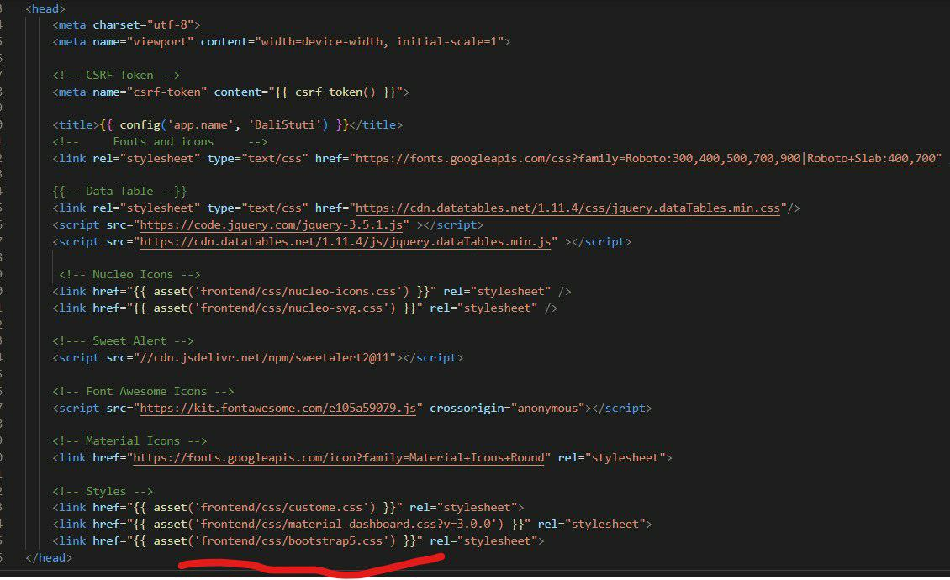

**Figure 4. 31 Responsive Bootstrap Code**

The figure above is a snippet of code that shows that the BaliStuti system is responsive (flexible if opened on any device)

1. **Usability Testing**

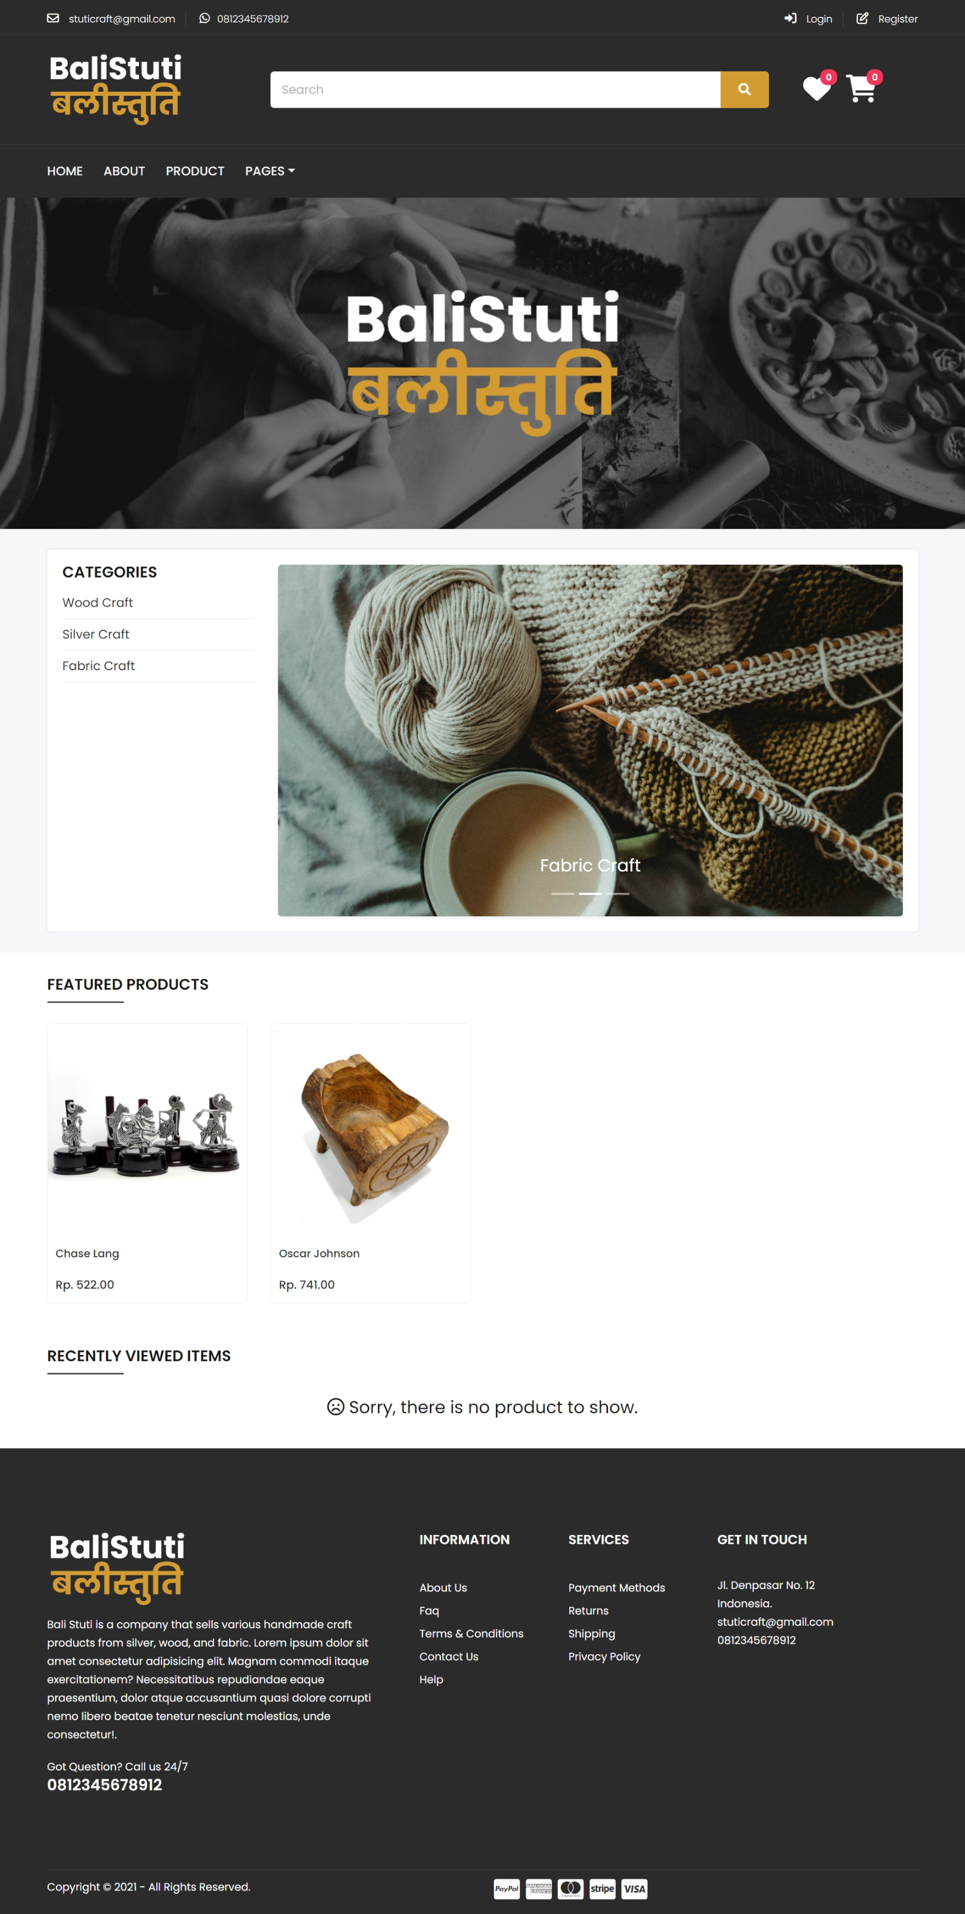

**Figure 4. 32 Home Page with the fiture**

The parts circled in red in the image are the buttons and information provided by the BaliStuti website with the aim of making it easy and familiar for users to use and navigate each feature without having to be confused (user friendly). Usability Testing is done on Microsoft Edge and Google Chrome to check whether the expected features work well

1. **Reliability Testing**

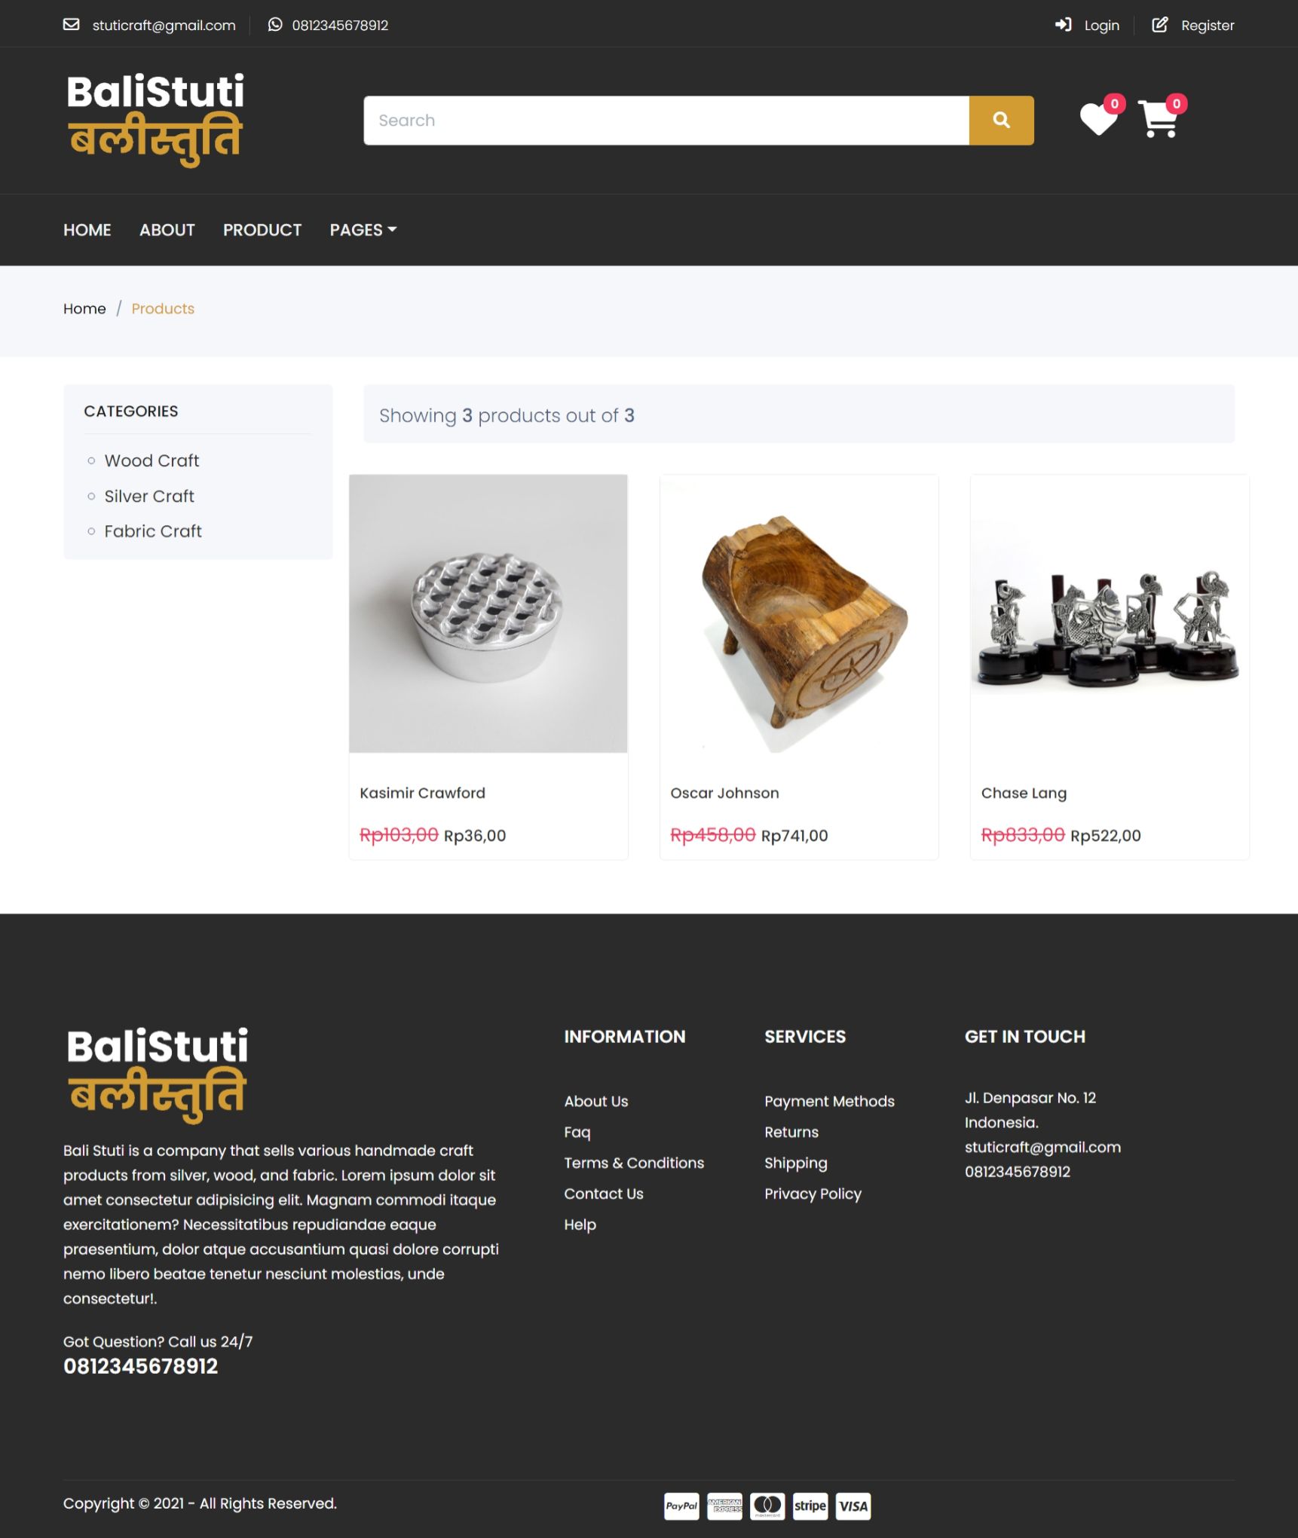

**Figure 4. 33 Reliability**

In Reliability Testing, it shows that the system can be accessed for 24 hours a day without errors. It is tested via Goggle Chrome or Microsoft Edge at any time for 24 hours. It means that whenever the user wants to access the website, then BaliStuti doesn’t has any accessing time to log in of access BaliStuti website.

1. **Security Testing**

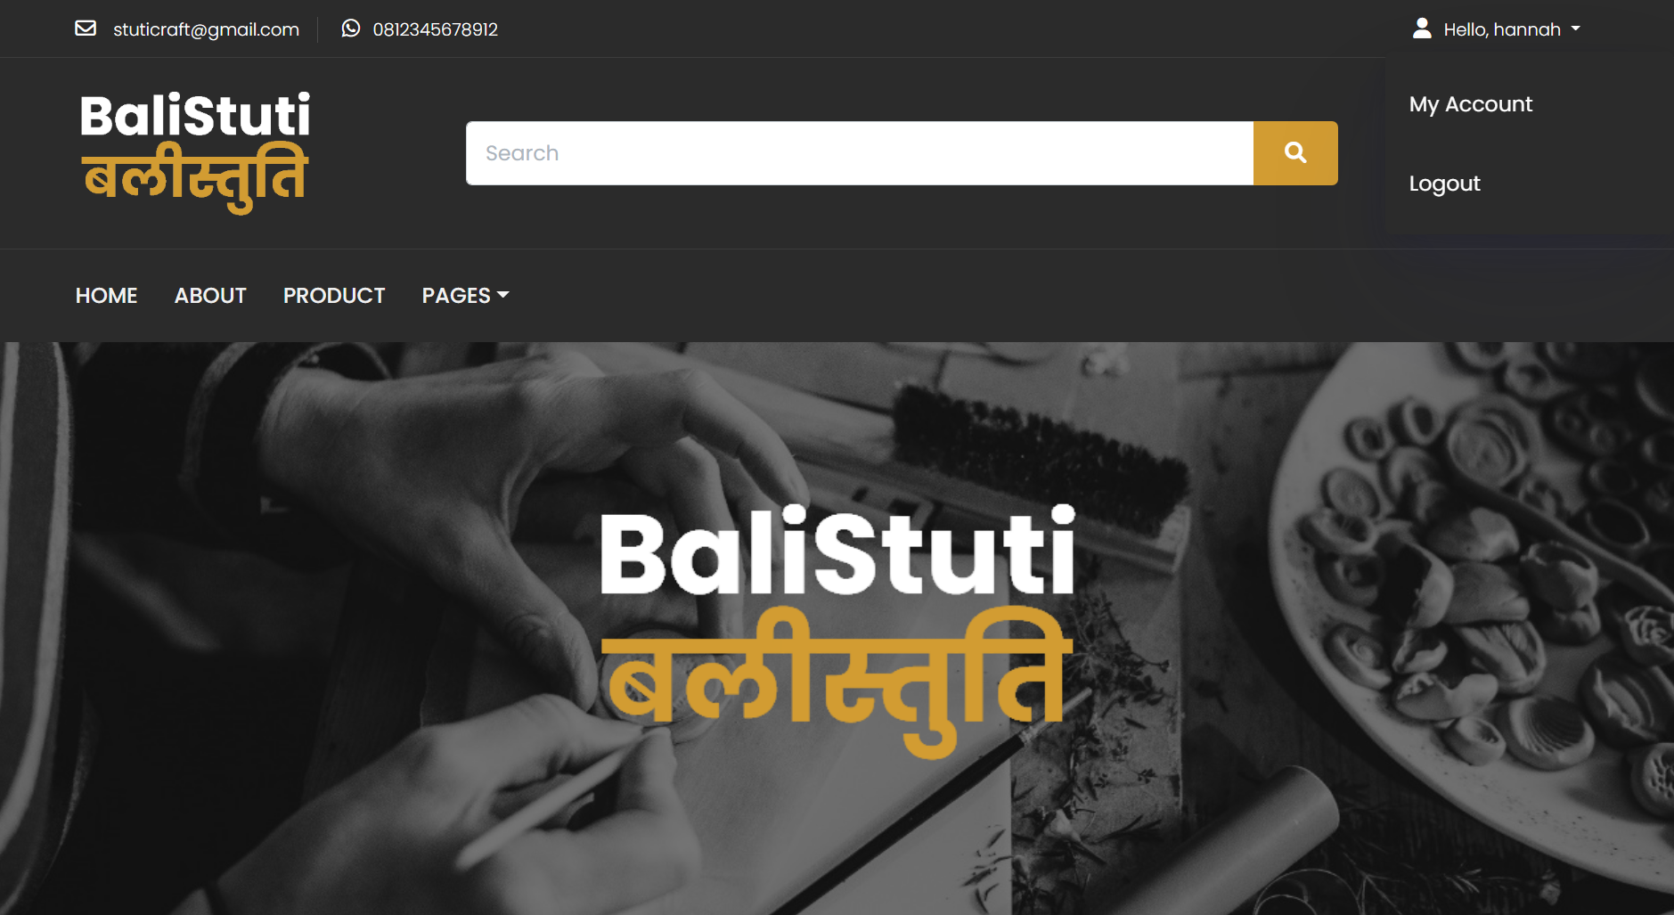

**Figure 4. 34 BaliStuti’s System Security Using Log Out**

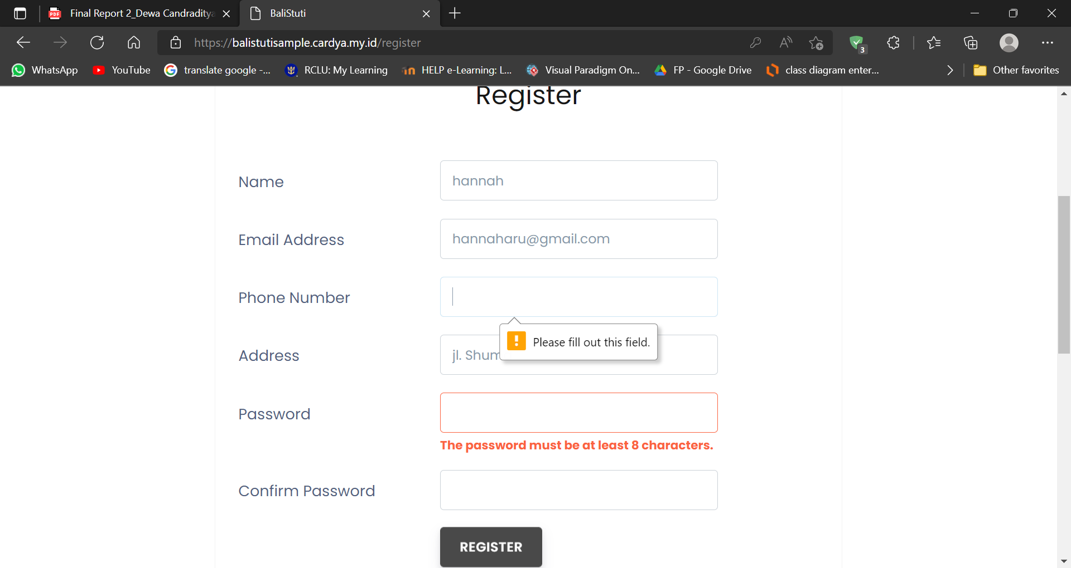

**Figure 4. 35 BaliStuti’s System needed strong character to make a the password**

From figures 4.34 and 4.35 above, it can be seen that the way to increase system security is to log out the available feature and create a strong password so that it will be difficult to crack. Both of these things will increase the user's feeling of security to trust BaliStuti to store personal data needed in the buying and selling transaction process

### **4.2.10 Iteration Review and Evaluation**

We managed to work on iteration 1 well based on the schedule we made previously and also adjusting to the submission date given. In the process of Iteration 1, we encountered several obstacles which we have successfully overcome. The problem came from one of our project members, Dewa Ayu, who fell ill during the construction process so we had to re-schedule and take extra working hours to cover the unfinished work due to the incident that occurred so that the development process could run according to the scheduled time. For budgeting, we don't spend money on developing this project because we use free and existing resources. Moreover, the project work is digitized for almost entirely so we only need a computer, smartphone and open-source software to complete this project.

We managed to match our actual time in Iteration 1 creation and development with the Gantt Chart. Although there are some time differences caused by factors such as a member's illness, schedule conflicts, and so on, but because we use Iterative Methodologies, it allows us to review and correct any errors that occur or that we have just realized. We have a lot of flexibility in improving and modifying work that our supervisors think does not fit into the project documentation.

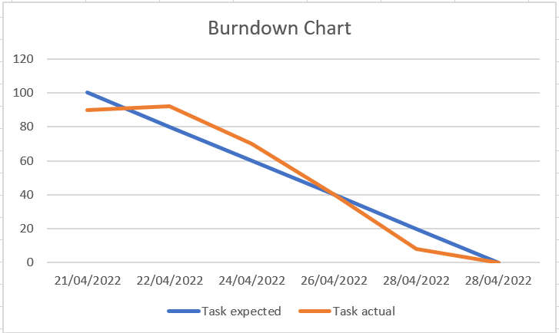

**Figure 4. 36 Burndown Chart**

## **4.3 Iteration 2**

**Table 4. 27 Iteration Plan 2**

|  |  |  |  |
| --- | --- | --- | --- |
| **Iteration** | **Use Cases** | **Proposed Started Date** | **Proposed End Date** |
| 2 | Manage Item in Product Catalogue | 4th October 2022  (Final Project II) | 7th October 2022  (Final Project II) |
| 2 | View Profile Company | 8th October 2022  (Final Project II) | 9th October 2022  (Final Project II) |
| 2 | Manage Profile Company | 9th October 2022  (Final Project II) | 11th October 2022  (Final Project II) |
| 2 | Search Item | 12th October 2022  (Final Project II) | 14th October 2022  (Final Project II) |
| 2 | Request Custom Item | 15th October 2022  (Final Project II) | 20th October 2022  (Final Project II) |
| 2 | View Recently Viewed Product | 21st October 2022  (Final Project II) | 23rd October 2022  (Final Project II) |
| 2 | Add To Cart | 24th October 2022  (Final Project II) | 28th October 2022  (Final Project II) |
| 2 | Manage Order | 29th October 2022  (Final Project II) | 1st November 2022  (Final Project II) |

### **4.3.1 Introduction**

The basic goals for the Iteration 2 of Final Project 2 (BIT 305) are to successfully develop, run, and test the use cases that have been planned to work on in iteration 2, namely Manage Items in Product Catalogue, View Company Profile, Manage Company Profile, Search Item, Request Custom Item, View Recently Viewed Product, Add to Cart, Manage Order, View User Profile Information, View Order Detail. Goals in Iteration 2 are also to ensure that the ten use cases are successfully executed based on their functions, both functional and non-functional requirements that have been planned. Iteration 2 will start on October 4, 2022 and will finish on November 1, 2022.

### **4.3.2 Purpose**

### **4.3.3 Context**

### **4.3.4 Schedule of Iteration Workflows**

### **4.3.5 Iteration Schedule Breakdown**

### **4.3.6 Resource Summary**

### **4.3.7 Evaluation Criteria**

### **4.3.8 Analysis and Design Artefact**

#### **Analysis Class Diagram**

#### **Expanded Use Case**

#### **System Sequences Diagram**

#### **Database Design**

#### **Structural Design**

#### **User Interface Design**

### **4.3.9 Implementation and Testing**

#### **Implementation**

#### **Testing**

##### **Functional Testing**

###### **Unit Testing**

###### **System Testing**

##### **Non-Functional Testing**

### **4.3.10 Iteration Review and Evaluation**

## **4.4 Iteration 3**

**Table 4. 28 Iteration Plan 3**

|  |  |  |  |
| --- | --- | --- | --- |
| **Iteration** | **Use Cases** | **Proposed Started Date** | **Proposed End Date** |
| 3 | Live Chat | 2nd November 2022  (Final Project II) | 6th November 2022  (Final Project II) |
| 3 | Payment Gateway | 7th November 2022  (Final Project II) | 12th November 2022  (Final Project II) |
| 3 | Convert Currency in Total Payment | 12th November 2022  (Final Project II) | 14th November 2022  (Final Project II) |
| 3 | View Status Transaction | 15th November 2022  (Final Project II) | 17th November 2022  (Final Project II) |
| 3 | Review Item | 17th November 2022  (Final Project II) | 20th November 2022  (Final Project II) |
| 3 | Shipping | 20th November 2022  (Final Project II) | 29th November 2022  (Final Project II) |
| 3 | View History of All Transaction | 30th November 2022  (Final Project II) | 2nd December 2022  (Final Project II) |
| 3 | Convert History of All Transaction to Excel | 3rd December 2022  (Final Project II) | 10th December2022  (Final Project II) |
| 3 | Notification | 11th December 2022  (Final Project II) | 20th December 2022  (Final Project II) |

### **4.4.1 Introduction**

### **4.4.2 Purpose**

### **4.4.3 Context**

### **4.4.4 Schedule of Iteration Workflows**

### **4.4.5 Iteration Schedule Breakdown**

### **4.4.6 Resource Summary**

### **4.4.7 Evaluation Criteria**

### **4.4.8 Analysis and Design Artefact**

#### **Analysis Class Diagram**

#### **Expanded Use Case**

#### **System Sequences Diagram**

#### **Database Design**

#### **Structural Design**

#### **User Interface Design**

### **4.4.9 Implementation and Testing**

#### **Implementation**

#### **Testing**

##### **Functional Testing**

###### **Unit Testing**

###### **System Testing**

##### **Non-Functional Testing**

### **4.4.10 Iteration Review and Evaluation**

# **CHAPTER 5: CONCLUSION**

## **5.1 Introduction**

In approximately 4 months of working on the BaliStuti project, we have completed each task according to the milestones and schedule that had been set at the beginning. We have also completed Iteration 1 and plan to complete Iteration 2 in the Final semester of Project 2 BIT 305. In this chapter, all things about challenges, limitations, and all problems along with how project members solve these problems during the working of BaliStuti project will be discussed.

## **5.2 Challenges, Limitations and Problems**

At the beginning of this semester, we tried to learn how to develop a web to be applied in the project we are planning so that we are not overwhelmed when we reach the Iteration 1 stage. We, who are just learning how to code views on the web, feel that we have to learn programming for the logic so that programs can be generated. which is not simple and fulfills to serve as a final project. Then, in the middle of the reporting process, one of our members fell ill for a few days so our work was delayed a bit because of it. Due to the tight schedule that was done at the beginning, we were a bit difficult to manage time to catch up. In the process of making Iteration 1, we also faced several problems such as lack of time due to the busy schedule of each team member so that we rarely had to hold meetings to discuss the next stage of working on Iteration 1. The number of sub-tasks in Iteration 1 also made us quite anxious. We were overwhelmed especially we developed 6 use cases so that in the testing section it becomes quite complicated when testing the program.

## **5.3 How Solve the Problem**

With many tutorials in various sources on how to develop a good and right website, we study hard and practice for the use cases that we propose. We also got help from various friends who were always able to answer our questions about system development so that we could finish Iteration 1 well. Then, we also managed to rearrange the schedule and take additional working hours to catch up on delays so that all work was successfully followed up and collected on time. We also managed to take time at night to hold meetings related to the progress of project work and discussions that must be carried out. With good time management and hard work among team members, we managed to develop the six use cases in a timely manner along with testing for each use case and non-functional requirement. With the experience we got in working on Final Project 1, our insight and experience on developing websites and making good documentation reports increased.

# **Bibliography**

*Iterative Methodology | Iterative Methodology Phases | Importance*. (n.d.). EDUCBA. Retrieved March 4, 2022, from <https://www.educba.com/iterative-methodology/>

Log In Visual Paradigm Online. (n.d.-b). Retrieved April 16, 2022, from <https://online.visual-paradigm.com/login.jsp?t=diagrams>

*Lucid Visual Collaboration Suite: Log In*. (n.d.). Retrieved May 11, 2022, from [https://lucid.app/lucidchart/b3b3b562-da42-4ec5-871f-1f202c61e02f/edit?beaconFlowId=7457A6EA44385872&invitationId=inv_94985c8d-843a-435e-9551-3feb89d06524&page=0_0#](https://lucid.app/lucidchart/b3b3b562-da42-4ec5-871f-1f202c61e02f/edit?beaconFlowId=7457A6EA44385872&invitationId=inv_94985c8d-843a-435e-9551-3feb89d06524&page=0_0)

*Products – Bali-Crafts.com*. (n.d.). Bali-Crafts.Com. Retrieved March 4, 2022, from <https://bali-crafts.com/shop/>

*SOUQ Store - INTERIORS FURNITURE & HOMEWARES*. (n.d.). Souqstoreonline. Retrieved March 4, 2022, from <https://www.souqstore.co/>

*Visual Paradigm Online*. (n.d.). Retrieved March 4, 2022, from <https://online.visual-paradigm.com/drive/#diagramlist:proj=0&new=UseCaseDiagram>

# **Appendix A: Gantt Charts**



# **Appendix B: Progress Report**



**Bachelor of Information Technology**

**(HONS)**

**BIT304**

**Final Year Project I**

**March 2022**

**PROJECT PROGRESS REPORT**

**1. PROJECT TITLE**

BaliStuti – A Web-based e-Commerce Made in Bali

**2. STUDENT NAMES**

Ni Putu Indah Winda Pangestika

**3. PERIOD COVERED**

14/02/2022 to 05/03/2022

**4. KEY ACCOMPLISHMENTS**

Project Theme Consultation

Chapter I: Submission of Project Plan

**5. PROJECT STATUS**

√

Mark as appropriate: on schedule ahead behind

**6. ISSUES/CONCERNS**

During the first stages of working on Final Project 1, we encountered several difficult decisions in in determining the theme of the project that we will work on. Initially, we submitted 2 titles to our supervisor. But in the end, we managed to determine the theme that we will work on for the final project 1. Then, after our supervisor approved the title that we submitted with some suggestions and conditions, we continued the work until the collection of chapters 1: Project Plan.

**7. Signatures**



**Ni Putu Indah Winda Pangestika**

**Date:** Saturday, 5th March 2022

**Appendix A: Gantt Chart**

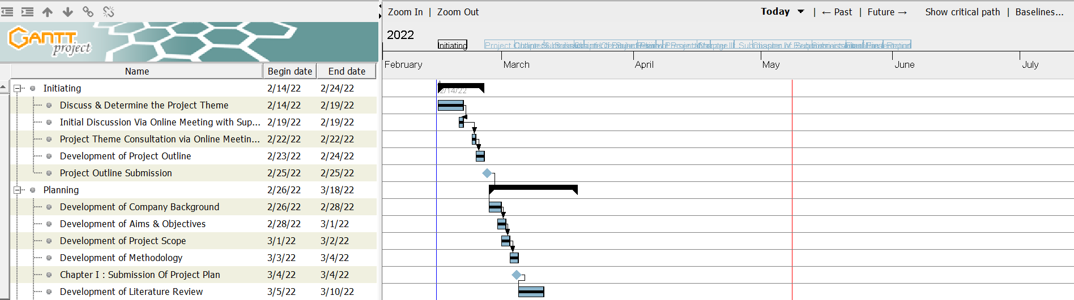



**Bachelor of Information Technology**

**(HONS)**

**BIT304**

**Final Year Project I**

**April 2022**

**PROJECT PROGRESS REPORT**

**1. PROJECT TITLE**

BaliStuti – A Web-based e-Commerce Made in Bali

**2. STUDENT NAMES**

Ni Putu Indah Winda Pangestika

**3. PERIOD COVERED**

11/03/2022 to 02/04/2022

**4. KEY ACCOMPLISHMENTS**

Submission of Literature Review

Chapter II: Project Management Plan Submission

Interim Presentation

**5. PROJECT STATUS**

√

Mark as appropriate: on schedule ahead behind

**6. ISSUES/CONCERNS**

Just before we submitted Assignment 1 - Literature Review, we (the BaliStuti project team member) thought about changing the first title we submitted to the current title. We discussed a lot and finally consulted with our supervisor. And finally, after the new title was approved, we changed the title to permanent and then implemented it in Assignment 1 - Literature Review and the subsequent assignments. After that, the submission of Chapter II: Project Management Plan went well without any obstacle, as well as the Interim Presentation which was carried out on time and according to the schedule given by the university and the supervisor.

**7. Signatures**



**Ni Putu Indah Winda Pangestika**

**Date:** Saturday, 2nd April 2022

**Appendix A: Gantt Chart**

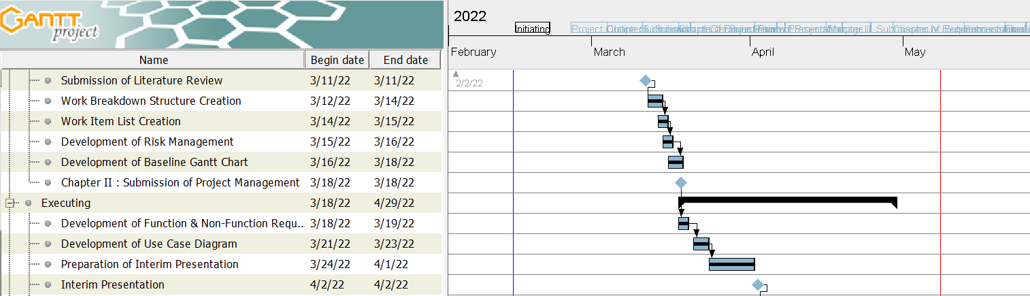



**Bachelor of Information Technology**

**(HONS)**

**BIT304**

**Final Year Project I**

**April 2022**

**PROJECT PROGRESS REPORT**

**1. PROJECT TITLE**

BaliStuti – A Web-based e-Commerce Made in Bali

**2. STUDENT NAMES**

Ni Putu Indah Winda Pangestika

**3. PERIOD COVERED**

03/04/2022 to 29/04/2022

**4. KEY ACCOMPLISHMENTS**

Chapter III: Submission of Requirement Analysis

Chapter IV: Submission of Iteration 1

**5. PROJECT STATUS**

√

Mark as appropriate: on schedule ahead behind

**6. ISSUES/CONCERNS**

In the third period of working on the final project 1, we are concerned about several things, such as whether we are able to complete many sub-tasks with relatively little processing time. We then decided to develop a simple and uncomplicated use case to catch up with the due date. In the end, we were able to develop 6 use cases and document reports properly and on time.

**7. Signatures**



**Ni Putu Indah Winda Pangestika**

**Date:** Friday, 29th April 2022

**Appendix A: Gantt Chart**

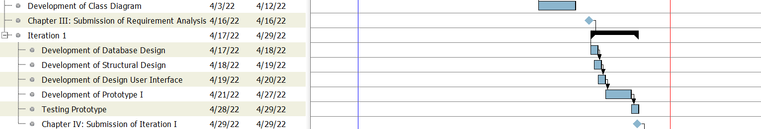



**Bachelor of Information Technology**

**(HONS)**

**BIT304**

**Final Year Project I**

**MAY 2022**

**PROJECT PROGRESS REPORT**

**1. PROJECT TITLE**

BaliStuti – A Web-based e-Commerce Made in Bali

**2. STUDENT NAMES**

Ni Putu Indah Winda Pangestika

**3. PERIOD COVERED**

30/04/2022 to 12/05/2022

**4. KEY ACCOMPLISHMENTS**

Submission of Final Report

**5. PROJECT STATUS**

√

Mark as appropriate: on schedule ahead behind

**6. ISSUES/CONCERNS**

The last period of working on the final project 1 went well without any issues. We are working on unfinished parts such as Chapter V, Appendix, creating table of content, and others. We also fix all parts that according to our supervisor are inaccurate or need to be added with the evaluation given by him.

**7. Signatures**



**Ni Putu Indah Winda Pangestika**

**Date:** Thursday, 12 May 2022

**Appendix A: Gantt Chart**



# **Appendix C: Supervisor Meeting Report**



**BIT304 MEETING REPORT**

|  |  |
| --- | --- |
| Semester & Year: Semester 8, Year 4 | |
| Project Title: BaliStuti – A Web-based e-Commerce Made in Bali | |
| Supervisor Name: Yudi Agusta, Ph.D. | |
| Student Names & IDs: | 1) Ni Putu Indah Winda Pangestika (e1800191)  2) Dewa Ayu Nyoman Widya Astuti (e1800162) |
| Date & Start time – End Time: Saturday, February 19th 2022 from 9.30am – 11.00am | |
| Punctual (Y/N): Y | |

1. Progress from previous meeting

This is the first meeting between Supervisor and us. We propose two project themes which will be assessed and given advice by the supervisor

1. Project Management – Check Gantt Chart and tasks completed based on timelines

At the first meeting, we were not making any progress about Project Management yet

1. Prototype Development – Check progress for prototype development

At the first meeting, we were not making any progress about Prototype Development yet

1. Work required by next meeting

The work that must be done at the next meeting is to come up with the theme and title of the project that will be done in the final project 1

Student(s)’ Signature Supervisor’s Signature

 

Indah Winda – Dewa Ayu Yudi Agusta, Ph.D.

Date: February 19th 2022 Date: February 19th 2022



**BIT304 MEETING REPORT**

|  |  |
| --- | --- |
| Semester & Year: Semester 8, Year 4 | |
| Project Title: BaliStuti – A Web-based e-Commerce Made in Bali | |
| Supervisor Name: Yudi Agusta, Ph.D. | |
| Student Names & IDs: | 1) Ni Putu Indah Winda Pangestika (e1800191)  2) Dewa Ayu Nyoman Widya Astuti (e1800162) |
| Date & Start time – End Time: Saturday, February 22nd 2022 from 01.00pm – 01.30pm | |
| Punctual (Y/N): Y | |

1. Progress from previous meeting

At the second meeting with this supervisor, we presented the ideas we had along with the use cases we wanted to use in our system, according to the discussion at the first meeting and asking for the approval for our title.

1. Project Management – Check Gantt Chart and tasks completed based on timelines

At the second meeting, we were not making any progress about Project Management yet

1. Prototype Development – Check progress for prototype development

At the second meeting, we were not making any progress about Prototype Development yet

1. Work required by next meeting

Preparation for project outline submission

Student(s)’ Signature Supervisor’s Signature

 

Indah Winda – Dewa Ayu Yudi Agusta, Ph.D.

Date: February 22nd 2022 Date: February 22nd 2022



**BIT304 MEETING REPORT**

|  |  |
| --- | --- |
| Semester & Year: Semester 8, Year 4 | |
| Project Title: BaliStuti – A Web-based e-Commerce Made in Bali | |
| Supervisor Name: Yudi Agusta, Ph.D. | |
| Student Names & IDs: | 1) Ni Putu Indah Winda Pangestika (e1800191)  2) Dewa Ayu Nyoman Widya Astuti (e1800162) |
| Date & Start time – End Time: Saturday, February 26th 2022 from 10.00am – 10.30am | |
| Punctual (Y/N): Y | |

1. Progress from previous meeting

At this meeting, we discussed the Literature Review and the rules to create a good Literature Review.

1. Project Management – Check Gantt Chart and tasks completed based on timelines

At this meeting, we were not making any progress about Project Management yet

1. Prototype Development – Check progress for prototype development

At this meeting, we were not making any progress about Prototype Development yet

1. Work required by next meeting

The work required for the next meeting is submit the Literature Review

Student(s)’ Signature Supervisor’s Signature

 

Indah Winda – Dewa Ayu Yudi Agusta, Ph.D.

Date: February 26th 2022 Date: February 26th 2022



**BIT304 MEETING REPORT**

|  |  |
| --- | --- |
| Semester & Year: Semester 8, Year 4 | |
| Project Title: BaliStuti – A Web-based e-Commerce Made in Bali | |
| Supervisor Name: Yudi Agusta, Ph.D. | |
| Student Names & IDs: | 1) Ni Putu Indah Winda Pangestika (e1800191)  2) Dewa Ayu Nyoman Widya Astuti (e1800162) |
| Date & Start time – End Time: Tuesday, March 8th 2022 from 13.00pm – 13.30pm | |
| Punctual (Y/N): Y | |

1. Progress from previous meeting

In this fourth meeting, we discussed the methodology that we will use to develop the BaliStuti project. We also discussed the Project Plan which we have developed from the explanation of the project outline in the previous meeting.

1. Project Management – Check Gantt Chart and tasks completed based on timelines

At the fourth meeting, we have already developed some tasks provided in Project Plan and already make some milestone such as Submission of the Project Outline and Chapter I: Project Plan.

1. Prototype Development – Check progress for prototype development

At the fourth meeting, we were not making any progress about Prototype Development yet

1. Work required by next meeting

The work that must be done at the next meeting is to come up with the Project Management Plan.

Student(s)’ Signature Supervisor’s Signature

 

Indah Winda – Dewa Ayu Yudi Agusta, Ph.D.

Date: March 8th 2022 Date: March 8th 2022



**BIT304 MEETING REPORT**

|  |  |
| --- | --- |
| Semester & Year: Semester 8, Year 4 | |
| Project Title: BaliStuti – A Web-based e-Commerce Made in Bali | |
| Supervisor Name: Yudi Agusta, Ph.D. | |
| Student Names & IDs: | 1) Ni Putu Indah Winda Pangestika  2) Dewa Ayu Nyoman Widya Astuti |
| Date & Start time – End Time: Sunday, April 3rd 2022 from 09.00 am – 10.45 am | |
| Punctual (Y/N): Y | |

1. Progress from previous meeting

At this meeting, we conduct the Interim Presentation, presented by our groups and another groups that takes BIT 304 Subject and assessed by supervisor.

1. Project Management – Check Gantt Chart and tasks completed based on timelines

At this meeting, we had already developed Gantt Chart and any task in Project Management to be presented in the Interim Presentation

1. Prototype Development – Check progress for prototype development

At the first meeting, we were not making any progress about Prototype Development in the Iteration 1 yet

1. Work required by next meeting

The work that must be done at the next meeting is develop and prepare for the submission of Requirement Analysis

Student(s)’ Signature Supervisor’s Signature

 

Indah Winda – Dewa Ayu Yudi Agusta, Ph.D.

Date: April 3rd 2022 Date: April 3rd 2022



**BIT304 MEETING REPORT**

|  |  |
| --- | --- |
| Semester & Year: Semester 8, Year 4 | |
| Project Title: BaliStuti – A Web-based e-Commerce Made in Bali | |
| Supervisor Name: Yudi Agusta, Ph.D. | |
| Student Names & IDs: | 1) Ni Putu Indah Winda Pangestika  2) Dewa Ayu Nyoman Widya Astuti |
| Date & Start time – End Time: Friday, April 8th 2022 from 13.00pm – 13.30pm | |
| Punctual (Y/N): Y | |

1. Progress from previous meeting

At this meeting, we discussed about the evaluation given by the supervisor who commented on the timeline on the Gantt chart that we had developed

1. Project Management – Check Gantt Chart and tasks completed based on timelines

At the fifth meeting, we have developed Gantt Chart and the supervisor has already give us the evaluation regarding the submitted chapters.

1. Prototype Development – Check progress for prototype development

At the fifth meeting, we were not making any progress about Prototype Development yet

1. Work required by next meeting

The work that must be done at the next meeting is Submission of Requirement Analysis and preparing for develop Iteration 1

Student(s)’ Signature Supervisor’s Signature

 

Indah Winda – Dewa Ayu Yudi Agusta, Ph.D.

Date: April 8th 2022 Date: April 8th 2022



**BIT304 MEETING REPORT**

|  |  |
| --- | --- |
| Semester & Year: Semester 8, Year 4 | |
| Project Title: BaliStuti – A Web-based e-Commerce Made in Bali | |
| Supervisor Name: Yudi Agusta, Ph.D. | |
| Student Names & IDs: | 1) Ni Putu Indah Winda Pangestika  2) Dewa Ayu Nyoman Widya Astuti |
| Date & Start time – End Time: Tuesday, May 10, 2022 from 10.00am – 10.30am | |
| Punctual (Y/N): Y | |

1. Progress from previous meeting

At this meeting, we discussed the evaluation feedback given by the supervisor regarding the Final Report format

1. Project Management – Check Gantt Chart and tasks completed based on timelines

At this meeting, we have developed Gantt Chart and the supervisor has already give us the evaluation regarding the submitted chapters. Also, we already fixed any issue commented and adding any advices by supervisor.

1. Prototype Development – Check progress for prototype development

At this meeting, we have made the progress regarding the development of prototyping Iteration 1

1. Work required by next meeting

The work that must be done at the next meeting is Submission of Final Report and meeting for Final Presentation of Final Project 1.

Student(s)’ Signature Supervisor’s Signature

 

Indah Winda – Dewa Ayu Yudi Agusta, Ph.D.

Date: May 10th 2022 Date: May 10th 2022

# **Appendix D: Minutes of Meetings**

BIT304 Final Year Project I

BaliStuti – A Web-based e-Commerce Made in Bali

**Minutes No. 1**

Date : Monday, February 14th 2022

Time : 11.00am – 02.00pm

Venue : Online Meeting Via Teams

Present :

Ni Putu Indah Winda Pangestika *Chairperson*

Dewa Ayu Nyoman Widya Astuti *Secretary*

Absent with apologies: - Represented by: -

|  |  |  |
| --- | --- | --- |
| No. | Matters Discussed | Action By |
| **1.0** | **Topic 1: Determine the Theme of the Project** | All Member |
| 1.1 | The first meeting we held was to discuss the theme of this project by conducting research on the current development and situation in the apparel and handicraft sector. |  |
| 1.2 | We researched the economic developments that occurred due to the impact of the pandemic and discussed our target market |  |
| **2.0** | **Topic 2 : Determine the Platform for the Project** | All Member |
| 2.1 | We compare platforms that are more suitable for the theme we choose so that it will be more suitable for use by our target market |  |
| **3.0** | **AOB** |  |
|  | There being no other matters, the meeting concluded at 02.00pm |  |

Minuted by: Ni Putu Indah Winda Pangestika

Verified by: Dewa Ayu Nyoman Widya Astuti

BIT304 Final Year Project I

BaliStuti – A Web-based e-Commerce Made in Bali

**Minutes No. 2**

Date : Friday, February 18th 2022

Time : 11.00am – 02.00pm

Venue : Online Meeting Via Teams

Present :

Ni Putu Indah Winda Pangestika *Chairperson*

Dewa Ayu Nyoman Widya Astuti *Secretary*

Absent with apologies: - Represented by: -

|  |  |  |
| --- | --- | --- |
| No. | Matters Discussed | Action By |
| **1.0** | **Topic 1: Define the Project’s Title** | All Member |
| 1.1 | After discussing the theme for the project, we decided to make "StutiApparel&Handicraft" the title for this project |  |
| **2.0** | **Topic 2 : Discuss the Project Aim and Objective** | All Member |
| 2.1 | We discussed the aims and objectives for this project |  |
| **3.0** | **Topic 3: Decide the Required Facilities** | All Member |
| 3.1 | We decide what facilities will be used in the development of this project |  |
| **4.0** | **AOB** |  |
|  | There being no other matters, the meeting concluded at 02.00pm |  |

Minuted by: Ni Putu Indah Winda Pangestika

Verified by: Dewa Ayu Nyoman Widya Astuti

BIT304 Final Year Project I

BaliStuti – A Web-based e-Commerce Made in Bali

**Minutes No. 3**

Date : Wednesday, March 2nd 2022

Time : 01.00am – 04.00pm

Venue : Online Meeting Via Teams

Present :

Ni Putu Indah Winda Pangestika *Chairperson*

Dewa Ayu Nyoman Widya Astuti *Secretary*

Absent with apologies: - Represented by: -

|  |  |  |
| --- | --- | --- |
| No. | Matters Discussed | Action By |
| **1.0** | **Topic 1: Discussion about the Existing System by Competitors and How to Overcome it** | All Member |
| 1.1 | Discussion and research on existing systems, competitors and how to make this project better |  |
| 1.2 | Sorting and selecting the right competitors to be used as project references |  |
| **2.0** | **Topic 2 : Decide Project Methodologies** | All Member |
| 2.1 | Discuss and decide the methodologies used for the project |  |
| **3.0** | **Topic 3: Discuss on the Title Change** | All Member |
| 3.1 | Discussion about changing the title from "StutiApparel&Handicraft" to "BaliStuti". The theme used remains the same, only the title is changed. |  |
| **4.0** | **AOB** |  |
|  | There being no other matters, the meeting concluded at 04.00pm |  |

Minuted by: Ni Putu Indah Winda Pangestika

Verified by: Dewa Ayu Nyoman Widya Astuti

BIT304 Final Year Project I

BaliStuti – A Web-based e-Commerce Made in Bali

**Minutes No. 4**

Date : Saturday, March 5th 2022

Time : 07.00pm – 10.00pm

Venue : Online Meeting Via Teams

Present :

Ni Putu Indah Winda Pangestika *Chairperson*

Dewa Ayu Nyoman Widya Astuti *Secretary*

Absent with apologies: - Represented by: -

|  |  |  |
| --- | --- | --- |
| No. | Matters Discussed | Action By |
| **1.0** | **Topic 1: Disscussion about Literature Review** | All Member |
| 1.1 | Discussion on the Literature Review and sharing the references found |  |
| **2.0** | **Topic 2 : Discuss on the Structure of Work Breakdown** | All Member |
| 2.1 | Discuss and decide the schedules calendars and activities that will later be used in the Gantt Chart |  |
| **3.0** | **Topic 3: Discuss on the Work Item List and Gantt Chart** | All Member |
|  | Discussion about work item list and discussion about making Gantt Chart |  |
| **4.0** | **Topic 4: Risk Management Determination** | All Member |
| 4.1 | Discussion of the risks that may occur during project work. And, giving the order of the highest and lowest risk that we think might happen |  |
| **5.0** | **AOB** |  |
|  | There being no other matters, the meeting concluded at 10.00pm |  |

Minuted by: Ni Putu Indah Winda Pangestika

Verified by: Dewa Ayu Nyoman Widya Astuti

BIT304 Final Year Project I

BaliStuti – A Web-based e-Commerce Made in Bali

**Minutes No. 5**

Date : Wednesday, March 18th 2022

Time : 11.00am – 02.00pm

Venue : Online Meeting Via Teams

Present :

Ni Putu Indah Winda Pangestika *Chairperson*

Dewa Ayu Nyoman Widya Astuti *Secretary*

Absent with apologies: - Represented by: -

|  |  |  |
| --- | --- | --- |
| No. | Matters Discussed | Action By |
| **1.0** | **Topic 1: Identify Functional & Non Functional Requirements** | All Member |
| 1.1 | Discussion of the Functional Requirements for the BaliStuti use case to be developed |  |
| 1.2 | Discussion of the Non-Functional Requirement of BaliStuti system |  |
| **2.0** | **Topic 2 : Discuss Use Case Diagram and Class Diagram** | All Member |
| 2.1 | Discuss on the Use Case Diagram that will be developed in BaliStuti’s system. |  |
| **3.0** | **Topic 3: Discuss on the Preparation of Interim Presentation** | All Member |
| 3.1 | The last topic that we discussed was the preparation of Interim Presentation. Such as choosing slides, the content of each slides and others. |  |
| **4.0** | **AOB** |  |
|  | There being no other matters, the meeting concluded at 04.00pm |  |

Minuted by: Ni Putu Indah Winda Pangestika

Verified by: Dewa Ayu Nyoman Widya Astuti

BIT304 Final Year Project I

BaliStuti – A Web-based e-Commerce Made in Bali

**Minutes No. 6**

Date : Sunday, April 17th 2022

Time : 06.00pm – 09.00pm

Venue : Online Meeting Via Teams

Present :

Ni Putu Indah Winda Pangestika *Chairperson*

Dewa Ayu Nyoman Widya Astuti *Secretary*

Absent with apologies: - Represented by: -

|  |  |  |
| --- | --- | --- |
| No. | Matters Discussed | Action By |
| **1.0** | **Topic 1: Discussion of scheduling for creation of iteration 1** | All Member |
| 1.1 | The first thing that was discussed in this meeting was the tight schedule for making Iteration 1 |  |
| 1.2 | Discussion of the explanation sub-section of making iteration 1 |  |
| **2.0** | **Topic 2 : Define the Division of Use Case to be Develop** | All Member |
| 2.1 | Determining the division of use cases to be developed by each project member |  |
| **3.0** | **Topic 3: Discussion on Design Artifact Creation** | All Member |
| 3.1 | Discussion about design artifacts to be made such as expanded use cases, sequence diagrams, database designs, interface designs, and others |  |
| **4.0** | **AOB** |  |
|  | There being no other matters, the meeting concluded at 09.00pm |  |

Minuted by: Ni Putu Indah Winda Pangestika

Verified by: Dewa Ayu Nyoman Widya Astuti

BIT304 Final Year Project I

BaliStuti – A Web-based e-Commerce Made in Bali

**Minutes No. 7**

Date : Monday, May 9th 2022

Time : 11.00am – 02.00pm

Venue : Online Discussion Via Telegram

Present :

Ni Putu Indah Winda Pangestika *Chairperson*

Dewa Ayu Nyoman Widya Astuti *Secretary*

Absent with apologies: - Represented by: -

|  |  |  |
| --- | --- | --- |
| No. | Matters Discussed | Action By |
| **1.0** | **Topic 1: Discussion on the Preparation of Final Report** | All Member |
| 1.1 | We discussed the finishing of the project documentation report that we had done |  |
| **2.0** | **AOB** |  |
|  | There being no other matters, the meeting concluded at 02.00pm |  |

Minuted by: Ni Putu Indah Winda Pangestika

Verified by: Dewa Ayu Nyoman Widya Astuti

# **Appendix E: Project Evaluation**



**BaliStuti – A Web-based e-Commerce Made in Bali**

**PROJECT EVALUATION**

**E1800191**

**Ni Putu Indah Winda Pangestika**

**Submitted to the**

**FACULTY OF COMPUTING AND DIGITAL TECHNOLOGY**

**(SCHOOL OF INFORMATION AND COMMUNICATION TECHNOLOGY)**

**In partial fulfilment of the requirements**

**for the degree of**

**BACHELOR OF INFORMATION TECHNOLOGY (HONS)**

**HELP UNIVERSITY**

**February 2022**

**Project Evaluation**

**1 Introduction**

The main purpose of this project is to develop a website-based BaliStuti e-commerce to digitize offline stores that have been established in Bali. In addition, it helps improve the standard of living of local residents by providing jobs provided by BaliStuti. Based on the Iteration Plan, we plan to develop 6 use cases, each member developing 3 use cases. I have successfully developed, tested and reported the Sign Up, Forget Password and Log Out use cases in the report documentation. We have succeeded in developing functional and non-functional requirements that we have planned in the Requirement Analysis Chapter. We have successfully completed Iteration 1 of the project we had planned on time and produced a system that met expectations.

**2 Evaluation of Objectives**

The Objectives of BaliStuti that mentioned in Project Plan are:

* To create a user-friendly website so that it can cover most of the people who use it.
* To provide information related to the products we have
* To facilitate buyers who want to inquire further about product details or ordering
* To facilitate buyers regarding easier payments
* To facilitate buyers who want to request a product from our store
* To provide job opportunities for those in need to become employees in our business

From the objectives above, we have been able to fulfil several objective points from Iteration 1 that we have developed, namely the first and second points. We have succeeded in making the function of the buttons on our system work well and designed to be familiar to the user so that it is user friendly and we provide information in product details for each product that we install in the storefront catalog. For the remaining points, we can't be sure because we haven't finished all the use cases that we will do in Iteration 2.

We encountered several problems while developing the BaliStuti system such as a lack of knowledge in the field of developing a web system and a schedule mismatch due to the illness of one of the team members. But we have managed to overcome this by self-taught, watching learning videos and studying on open-source sources. We also managed to overcome delays by taking extra hours and re-scheduling for future task.

**3 Further Improvement**

Issues found during the analysis and design work phases were inaccuracies in writing report documentation, such as some sections being left out or not in the proper format, so they had to be more careful in the future, especially for Iteration 2. Repeated checking, and ensuring the final report with team members to review the work again is the right way to reduce issues that may be found in the future

**4 Future Work**

In the future work that will be done later, we will complete all the Iteration 2 development processes that we have planned to do in Final Project 2. We also have to meet every expectation that we mentioned in the report such as functional requirements and non-functional requirements which we will test. on every function of the system that we develop.

**5 Conclusion**

At the beginning of taking this project, I got a lot of experience to write well, professionally, responsible for every source that I saw with the aim of appreciating the original authors about their published work, and much more. I was trained to think quickly for every condition and possibility that occurs and how to anticipate it. I also learned how to manage time to fit in with the other works that I have to do, and to stay in line with the time given by the university and supervisor. Lastly, I learned how to develop a web system so that it could contain all the expected functionality along with the database and how to test it.

**BIT304 Assignment 4 Marking Scheme (65%)**

**Student ID : E1800191**

**Student Name : Ni Putu Indah Winda Pangestika**

**A. Project Plan (CLO1)**

|  |  |  |  |  |  |
| --- | --- | --- | --- | --- | --- |
| **Assessment Area (Group)** | **Poor** | **Satisfactory** | **Good** | **Excellent** | **Marks** |
| Project Significance (Project background, aims and objectives) (4) |  |  |  |  |  |
| Strategic Plan (Methodology and development techniques) (4) |  |  |  |  |  |
| Work Plan (Work item list and Gantt chart) (4) |  |  |  |  |  |
| Resource Plan (Technical requirements, resource requirements) (2) |  |  |  |  |  |
| Risk Management Plan (2) |  |  |  |  |  |
|  | **Sub-total (/18 marks)** | | | |  |

**B. Requirements Analysis (CLO2)**

|  |  |  |  |  |  |
| --- | --- | --- | --- | --- | --- |
| **Assessment Area (Group)** | **Poor** | **Satisfactory** | **Good** | **Excellent** | **Marks** |
| Functional Requirements (3) |  |  |  |  |  |
| Non-Functional Requirements (3) |  |  |  |  |  |
|  | **Sub-total (/6 marks)** | | | |  |

**C. Iterations (CLO2)**

|  |  |  |  |  |  |
| --- | --- | --- | --- | --- | --- |
| **Assessment Area (Individual)** | **Poor** | **Satisfactory** | **Good** | **Excellent** | **Marks** |
| Iteration Plans (4) |  |  |  |  |  |
| Analysis Artefacts e.g. High Level Use Cases, Expanded Use Cases, Analysis Class Diagram/ Context Diagram, etc. (6) |  |  |  |  |  |
| Design Artefacts e.g. Sequence Diagrams/Data Flow Diagrams, Database design, Web-based structural design, Interface design (6) |  |  |  |  |  |
|  | **Sub-total (/16 marks)** | | | |  |

**D. Implementation/Testing (CLO2)**

|  |  |  |  |  |  |
| --- | --- | --- | --- | --- | --- |
| **Assessment Area (Individual)** | **Poor** | **Satisfactory** | **Good** | **Excellent** | **Marks** |
| Implementation & Prototype Development (14)  (Reliability, Usability, Performance) |  |  |  |  |  |
| Testing (10) |  |  |  |  |  |
| Iteration Progress, Review and Evaluation (8) |  |  |  |  |  |
| Complexity[1] (6) |  |  |  |  |  |
|  | **Sub-total (/38 marks)** | | | |  |

**E. Project Evaluation (CLO2)**

|  |  |  |  |  |  |
| --- | --- | --- | --- | --- | --- |
| **Assessment Area (Individual)** | **Poor** | **Satisfactory** | **Good** | **Excellent** | **Marks** |
| Evaluation of objectives, list of challenges, limitations and issues highlighted (4) |  |  |  |  |  |
| Solutions - corresponding solutions to  overcome problems, further improvements and future works (4) |  |  |  |  |  |
|  | **Sub-total (/8 marks)** | | | |  |

**F. Reports (CLO3)**

|  |  |  |  |  |  |
| --- | --- | --- | --- | --- | --- |
| **Assessment Area (Group)** | **Poor** | **Satisfactory** | **Good** | **Excellent** | **Marks** |
| Abstract (2) |  |  |  |  |  |
| Monthly Progress reports (2) |  |  |  |  |  |
| Minutes of meetings (2) |  |  |  |  |  |
| Supervisor Meeting Reports (2) |  |  |  |  |  |
|  | **Sub-total (/8 marks)** | | | |  |

**G. Documentation & Formatting (CLO3)**

|  |  |  |  |  |  |
| --- | --- | --- | --- | --- | --- |
| **Assessment Area (Group)** | **Poor** | **Satisfactory** | **Good** | **Excellent** | **Marks** |
| Table of Contents  List of Tables  List of Figures  List of Symbols and Abbreviations (1) |  |  |  |  |  |
| Formatting of report (1) |  |  |  |  |  |
| Bibliography (6) |  |  |  |  |  |
|  | **Sub-total (/8 marks)** | | | |  |

|  |  |  |
| --- | --- | --- |
|  | **Total (A + B + C + D + E + F + G)** |  |
|  | **Late submission** |  |
|  | **Final Total (/100 marks)** |  |
|  | **Total (65%)** |  |

1. Based on use case worked by students. Complexity of the system developed depends on the functionalities, algorithms and technologies incorporated in developing the system. System with only CRUD (Create, Read, Update, Delete) functionalities is not considered to be complex.